CYBERSECURITY AND CYBER THREATS AND ATTACKS
LEARNER GUIDE

Module Code | 252901001-KM-03
NQF Level | 5
Credits | 12
Curriculum Code | 252901001
Qualification Title | Occupational Certificate: Cybersecurity Analyst
SAQA QUAL ID | 118986

Name
Contact Address
Telephone (H)
Telephone (W)
Facsimile
Cellular
E-mail

Note to the learner
This Learner Guide provides a comprehensive overview of the module. It is designed to improve the skills and knowledge of learners, and thus enabling them to effectively and efficiently complete specific tasks.
Entry Requirements

- NQF 4
Provider Accreditation Requirements for the Knowledge Module

Physical Requirements
- The provider must have lesson plans and structured learning material or provide learners with access to structured learning material that addresses all the topics in all the knowledge modules as well as the applied knowledge in the practical skills.
- QCTO/ MICT SETA requirements

Human Resource Requirements:
- Lecturer/learner ratio of 1:20 (Maximum)
- Qualification of lecturer (SME):
    - NQF 6 in industry recognised qualifications with 1 years’ experience in the IT industry
    - CYBERSECURITY vendor certification
- Assessors and moderators: accredited by the MICT SETA
Legal Requirements
- Legal (product) licences to use the software for learning and training
- OHS compliance certificate
- Ethical clearance (where necessary)
Module Purpose
The main focus of the learning in this knowledge module is to build an understanding of principles of cybersecurity and Ethical Hacking and the types of threats and attacks and the respective risk

Topic elements to be covered include
The learning will enable learners to demonstrate an understanding of:
- KM-03-KT01: Information security Governance and compliance
- KM-03-KT02: Information security
- KM-03-KT03: Foot printing and Reconnaissance
- KM-03-KT04: Scanning Networks
- KM-03-KT05: Enumeration
- KM-03-KT06: Vulnerability Analysis
- KM-03-KT07: System Hacking
- KM-03-KT08: Malware Threats
- KM-03-KT09: Sniffing
- KM-03-KT10: Social Engineering
- KM-03-KT11: Denial-of-Service
- KM-03-KT12: Session Hijacking
- KM-03-KT13: Evading IDS, Firewalls, and Honeypots
- KM-03-KT14: Hacking Web Servers
- KM-03-KT15:SQL Injection
- KM-03-KT16: Hacking Wireless Networks
- KM-03-KT17: Hacking Mobile Platforms
- KM-03-KT18: IoT Hacking
- KM-03-KT19: Cloud Computing
- KM-03-KT20: Cryptography
- KM-03-KT21: Cyber incident response and management

Venue, Date and Time:
Consult your facilitator should there be any changes to the venue, date and/or time.
Refer to your timetable
Assessments

The only way to establish whether you are competent and have accomplished the learning outcomes is through continuous assessments. This assessment process involves interpreting evidence about your ability to perform certain tasks. You will be required to perform certain procedures and tasks during the training programmer and will be assessed on them to certify your competence.

This module includes assessments in the form of self-evaluations/activities and exercises. The exercises, activities and self-assessments will be done in pairs, groups or on your own. These exercises/activities or self-assessments (Learner workbook) must be handed to the facilitator. It will be added to your portfolio of evidence, which will be proof signed by your facilitator that you have successfully performed these tasks.

Listen carefully to the instructions of the facilitator and do the given activities in the time given to you.

KM-03-KT01: Information security Governance and compliance
Topic elements to be covered include:
- KT0101Governance and legislation
- KT0102Need for data protection
- KT0103Computer network and defense fundamentals
- KT0104Network security policy design and implementation
- KT0105Information security laws and standards

KT0101 Governance and legislation
What Is Information Security Governance?
Information security governance is defined as “a subset of enterprise governance that provides strategic direction, ensures that objectives are achieved, manages risk appropriately, uses organizational resources responsibly, and monitors the success or failure of the enterprise security program,”
What is information security governance and compliance?
When it comes to your information security strategy, an information security governance framework is how security is implemented and managed within an organization. Compliance can be thought of as the “what” – as in what requirements you are obligated or trying to achieve
Why Do You Need an Information Security Governance Framework?
While the definition sounds complex, it can be simplified. An information security governance framework helps you prepare for risks or events before they occur by forcing you to continually reevaluate critical IT and business functions through:
- Integrated risk management functions
- Threat and vulnerability analysis
- Data governance and threat protection
- Aligning business strategy with IT strategy
Reactive Versus Proactive
Information security governance also helps an organization move from a reactive approach to cybersecurity to a proactive approach. It allows you to:
- Categorize and mitigate risks and threats
- Prepare an organization for identifying, remediating, and recovering from a cyberattack or breach
- Provide a method for executive leadership to understand their risk posture and maturity levels
- Outline a risk-based approach to the people, systems, and technology that are used every day
What Are the Main Components of Information Security Governance?
There are four main components to the information security governance framework:
- Strategy
- Implementation
- Operation
- Monitoring
Strategy
Information security should align with business objectives. IT strategic plans need to satisfy the current and future business requirements. The goal of information security governance is to align business and IT strategies with organizational objectives.
Implementation
Information security governance requires commitment, resources, assignment of responsibilities, and implementation of policies and procedures that address the controls within a chosen framework. Buy-in from senior management and above is critical to the implementation of the program.
Operation
It’s important that adequate resources are in place, projects that align with your overall strategy are deployed, and operational and technology risks are addressed and mitigated to appropriate levels.
Monitoring
Metrics and monitoring help document the effectiveness of the program, provide information to help management make decisions, address any compliance issues, and establish information security controls with a more proactive approach.
Top 5 Key Elements of an Information Security
1. Confidentiality
Data and information assets should be confine to individuals license to access and not be disclose to others; Confidentiality assurance that the information is accessible those who are authorize to have access. Confidentiality breaches may occur due to improper data handling or a hacking attempt. It controls include data classification, data encryption, and proper equipment disposal (i.e. of DVDs, CDs, etc.), Confidentiality is roughly adore privacy. Measures undertaken to confirm confidentiality are design to prevent sensitive data from reaching the incorrect people. Whereas ensuring the correct people will really get it: Access should be restricted those licensed look at information in question. It’s common for information to be categorize consistent with quantity and kind of injury might be done. It makes up unintended hands. A lot of or less rigorous measures will then be implemented according to those classes.
2. Integrity
Keeping the information intact, complete and correct, and IT systems operational; Integrity is the trustworthiness of data or resources in the prevention of improper and unauthoriz changes the assurance that information is sufficiently accurate for its purpose. Measures to maintain data integrity may include a checksum (a number produced by a mathematical function to verify that a given block of data is not changed) and access control (which ensures that only the authorized people can update, add, and delete data to protect its integrity). Integrity involves maintaining the consistency, accuracy, and trustworthiness of information over its entire life cycle.
Information should not be modified in transit, and steps should be taken to confirm that information can’t be altered by unauthorized people (for example, in a breach of confidentiality). These measures include file permissions and user access controls. Version management maybe won’t be able to prevent incorrect changes or accidental deletion by licensed users becoming a problem. Additionally, some means that should be in place to discover any changes in information that may occur as a result of non-human-caused events like an electromagnetic pulse (EMP) or server crash. Some information would possibly include checksum, even cryptographic checksum, for verification of integrity. Backups or redundancies should be offer to revive the affected information to its correct state.
3. Availability
An objective indicating that data or system is at disposal of license users once require. Availability is the assurance that the systems responsible for delivering, storing, and processing information are accessible when required by authorized users. Availability means data is accessible by licensed users.
If AN attacker isn’t able to compromise the primary components of data security (see above) they’ll try and execute attacks like denial of service that will bring down the server, creating the web site unavailable to legitimate users because of lack of availability. Measures to maintain data availability can include redundant systems’ disk arrays and clustered Machines, anti-virus software to stop malware from destroying networks, and distributed denial-of-service (DDoS) prevention systems.
4. Authenticity
A security policy includes a hierarchical pattern. It means inferior workers is typically certain to not share the small quantity of data they need unless explicitly approved. Conversely, a senior manager might have enough authority to create a choice what information is shared and with whom, which implies that they’re not tied down by an equivalent data security policy term. That the logic demands that ISP ought to address each basic position within the organization with specifications which will clarify their authoritative standing. Authenticity refers to the characteristic of a communication, document, or any data that ensures the quality of being genuine or corrupted. The major role of authentication is to confirm that a user is genuine, one who he / she claims to be. Controls such as bio metrics, smart cards, and digital certificates ensure the authenticity of data, transactions, communications, or documents.
The user should prove access rights and identity. Commonly, usernames and passwords are used for this method. However, this kind of authentication may be circumvented by hackers. a much better form of authentication is bio metrics, as a result of it depends on the user’s presence and biological features (retina or fingerprints). The PKI (Public Key Infrastructure) authentication methodology uses digital certificates to prove a user’s identity. Different authentication tools will be key cards or USB tokens. The best authentication threat occurs with unsecured emails that seem legitimate.
5. non-Repudiation
It is the assurance that somebody cannot deny the validity of one thing. It may be a legal thought that’s widely used in data security and refers to a service that provides proof of the origin of information and also the integrity of the information. In different words, non-repudiation makes it very difficult to successfully deny who/where a message came from also as the authenticity of that message. On-repudiation is a way to guarantee that the sender of a message cannot later deny having sent the message, and that the recipient cannot deny having received the message. Individuals and organization use digital signatures to ensure non-repudiation.
The Republic of South Africa has taken significant steps to implement laws and regulations relating to the protection of data and personal information. The COVID-19 pandemic has emphasised the need for laws that regulate the proliferation of data and personal information that have resulted from the utilisation of digital services. The Republic of South Africa has seen its first specific data protection law come into effect on 1 July 2021, joining the rest of the world in protecting the right to privacy in this digital age of the Fourth Industrial Revolution.
Key acts, regulations, directives, bills
The Constitution of the Republic of South Africa guarantees the right to privacy. Additionally, certain provisions within the Electronic Communications and Transactions Act, 2002 ('ECTA') regulate the electronic collection of personal information, although compliance with these provisions is voluntary. These provisions of the ECTA pertaining to the protection of personal information were repealed on 30 June 2021 (see below).
The Protection of Personal Information Act, 2013 (Act 4 of 2013) ('POPIA') was promulgated into law on 26 November 2013, following the President's signature. With the exception of Section 58, of POPIA became fully enforceable on 1 July 2021. Section 58, however, was staggered until 1 February 2022 before it became enforceable. POPIA is wide in its application and impacts all persons processing personal information within the country (or using means from within the country).
Data privacy must also be considered from the perspective of consumer protection law as the Consumer Protection Act, 2008 ('CPA') which was enacted in 2011 and applies to the direct marketing of goods as well as services to consumers telephonically. The provisions under the CPA on direct marketing and unsolicited communications may seemingly overlap with the provisions of POPIA, however, POPIA applies to the specific instance of unsolicited electronic communications.
On 26 May 2021, President Ramaphosa signed the Cybercrimes Bill into an Act of Parliament and a law of the Republic of South Africa as the Cybercrimes Act No. 19 of 2020 ('Cybercrimes Act'). The Cybercrimes Act became enforceable on 1 December 2021 and aims to both create new offences that, for example, criminalise the theft and interference of data, while also modernising existing criminal offences to cater for the particular nature with which many cybercrimes are committed. The objectives of the Cybercrimes Act are therefore to:
- create offences and impose sanctions that relate to cybercrime;
- criminalise the dissemination of harmful data messages; and
- further regulate law enforcement's jurisdiction over cybercrime by granting extensive powers to investigate, search, access and seize articles used in committing an offence, such as computers, databases or networks, etc.
Specific offences created under the Cybercrimes Act include a person's unlawful access – being the unlawful and intentional access to a computer system or a computer data storage medium (commonly referred to as 'hacking'); unlawful interception, interference or acquisition of data, a computer program, a computer data storage medium or a computer system. The 'modernised' criminal offences include cyber fraud – being fraud committed by means of data or a computer program or through any interference with data or a computer program, cyber forgery – being the creation of false data or a false computer program with the intention to defraud; cyber uttering – being the passing-off of false data or a false computer program with the intention to defraud; cyber extortion – being, inter alia, the unlawful and intentional interception of data for the purpose of obtaining any advantage from another person or compelling another person to perform or to abstain from performing any act; and the theft of incorporeal property. Of note, however, is the criminalisation of malicious or harmful communications. These are communications, or rather 'data messages', which:
- incite or threaten damage to property or violence;
- threaten persons with damage to property or violence; and
- disclose an intimate image.
The Promotion of Access to Information Act 2 of 2000 ('PAIA') regulates the access to information and it enables people to gain access to information held by both public and private bodies. In terms of PAIA, an IO ('IO') must be appointed within an organisation to manage the requirements to access information held by that organisation. IOs are appointed automatically by virtue of their position within a private or public entity. However, the advent of POPIA has now expanded the role of an IO, meaning the role of an IO within an organisation is now not only governed by the provisions of PAIA, but also by POPIA.
Guidelines
In accordance with its powers under POPIA, the Information Regulator published, in December 2018, the Protection of Personal Information Act, 2013 (Act No. 4 Of 2013): Regulations Relating to the Protection of Personal Information ('the Regulations'). The Regulations are mainly administrative in nature and prescribe a number of forms to be used in order to take certain types of action under POPIA including:
- the manner in which an objection to the processing of personal information can be made (Section 2 of the Regulations);
- requests for the correction or deletion of personal information or the destruction or deletion of a record of personal information (Section 3 of the Regulations);
- duties and responsibilities of IOs (to be appointed by each responsible party), which includes obligations relating to impact assessments to be undertaken (Section 4 of the Regulations);
- applications for the Information Regulator to issue industry codes of conduct (Section 5 of the Regulations);
- the manner in which consent is requested for the processing of personal information for direct marketing by means of unsolicited electronic communications (Section 6 of the Regulations);
- submission of complaints or grievances (Section 7 of the Regulations);
- the Information Regulator acting as a conciliator during an investigation (Section 8 of the Regulations);
- the notification requirements of the Information Regulator to provide notification and information to all affected parties to a complaint/investigation (Section 12 of the Regulations); and
- the notification requirements of the Information Regulator to provide notification to affected parties of its intention to carry out assessments or relating to a request by a third party to do so (Section 11 of the Regulations).
The Regulations also provide for various prescribed forms which are required to be utilised when requests or complaints are submitted.
The Information Regulator gazetted a Guideline to Develop Codes of Conduct on 26 February 2021. Chapter 7 of POPIA provides for the development of codes of conduct which may apply to certain types of personal information, specific industries, professions, bodies or specific types of activities.
The Guideline to Develop Codes of Conduct was published in order to explain the process for the development of codes of conduct by the relevant industry bodies in terms of section 65 of POPIA. The Guideline to Develop Codes of Conduct provides guidance to industry bodies on making and submitting an application for a code of conduct to be approved by the Information Regulator.

KT0102 Need for data protection

The importance of information security in organizations cannot be overstated. It is critical that companies take the needed steps to protect their priority information from data breaches, unauthorized access, and other disruptive data security threats to business and consumer data.
The cost of inaction is simply too great — here’s what you need to know about the importance of IT security in an organization.

What Is Information Security?
Through the National Institute of Standards and Technology, the US Department of Commerce defines Information Security as: “The protection of information and information systems from unauthorized access, use, disclosure, disruption, modification, or destruction in order to provide confidentiality, integrity and availability.” Information security — or infosec — is the protection of information by people and organizations in order to keep information safe for themselves, their company, and their clients.

Why Is Information Security Important?
Companies need to be confident that they have strong data security and that they can protect against cyber attacks and other unauthorized access and data breaches. Weak data security can lead to key information being lost or stolen, create a poor experience for customers that can lead to lost business, and reputational harm if a company does not implement sufficient protections over customer data and information security weaknesses are exploited by hackers. Solid infosec reduces the risks of attacks in information technology systems, applies security controls to prevent unauthorized access to sensitive data, prevents disruption of services via cyber attacks like denial-of-service (DoS attacks), and much more.

Why Is Information Security Needed Within an Organization?
Company core business integrity and client protections are critical, and the value and importance of information security in organizations make this a priority. All organizations need protection against cyber attacks and security threats, and investing in those protections is important. Data breaches are time-consuming, expensive, and bad for business. With strong infosec, a company reduces their risk of internal and external attacks on information technology systems. They also protect sensitive data, protect systems from cyber attacks, ensure business continuity, and provide all stakeholders peace of mind by keeping confidential information safe from security threats.

What Are the Top Information Security Threats?
Emphasizing the importance of information security in organizations and acting on it are key to countering the main threats to data security. The top six concerns in infosec are social engineering, third party exposure, patch management, ransomware, malware, and overall data vulnerabilities.

Social Engineering
Social attacks take place when criminals manipulate targets into taking certain actions such as skipping security measures or disclosing information in order to gain access to confidential information. Phishing attempts are one common example.

Third Party Exposure
Companies must be confident that any third party vendors are handling information securely and sensitively. If there are data breaches with a vendor, the main company that owns the consumer relationship is still considered responsible. The importance of information security in organizations must be held at the same high priority level for vendors as it is within your own company.

Patch Management
Cyber attacks will exploit any weakness. Patch management is one area that companies need to stay on top of, and make sure to always update to the most recent software releases to reduce vulnerabilities.

Ransomware
Ransomware attacks infect a network and hold data hostage until a ransom is paid. There can be financial damages and reputational damages from the ransom as well as lost productivity and data loss from the attack itself.

Malware
Malware is software that has malicious code for the purpose of causing damage to a company’s software, their data and information, and their ability to do business.

Overall Data Vulnerabilities
Lastly, cyber attacks can take place through any weakness in the system. Some risk factors include outdated equipment, unprotected networks, and human error through a lack of employee training. Another area of risk can be a lax company device policy, such as letting employees use personal devices for work that may not be properly protected. You can evaluate your own company’s level of possible exposure via a thoughtful risk assessment plan.

What Are the Advantages of Infosec?
All organizations — small, medium, and large — need protection from cyber attacks and digital security threats. The protection of information is crucial to the strength and growth of your business. Beyond the peace of mind that your company’s and all of your client data is secure, strong infosec keeps your business operating at full capacity and reduces your susceptibility to exploitation by hostile outside forces.
Start Protecting Your Organization’s Data and More
The level of importance of information security in organizations is a measure of how high they prioritize their business having a secure foundation. Protecting your company’s information and keeping your organizational and client data secure is fundamental to your company’s strength and growth.
Data breaches are bad for business, both in the short-term and the long-term. Company efficiency and solid data management work hand-in-hand, and secure handling of client information keeps your company’s brand reputation intact.
Infosec awareness is an important practice, and having the right technology will help you protect your company.

KT0103 Computer network and defense fundamentals
Computer Network Defense is defined as “Actions taken through the use of computer networks to protect, monitor, analyze, detect and respond to unauthorized activity within Department of Defense information systems and computer networks.” In the world of the military and government, information of a sensitive nature being exposed can have far greater consequences than mere financial loss.

Information housed by such agencies can include Operations Orders (OPORDERS), war plans, troop movements, technical specifications for weapons or intelligence collection systems, identities of undercover intelligence agents, and any number of other items critical to the functioning of military and government. When such information is accessed in an unauthorized fashion, lives can be lost on a large scale and the balance of power can be shifted significantly. Laws do exist to protect these types of information, but they are, in many cases, still a work in progress.

KT0104 Network security policy design and implementation
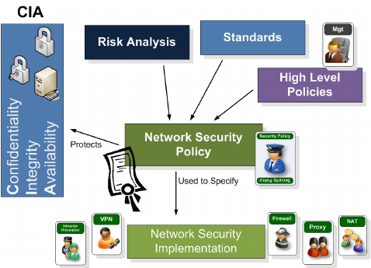
Companies are increasingly relying on computer networks for carrying out day-to-day operations. While doing things over the internet has made processes more convenient and cost-effective, it also leaves companies more vulnerable to network security threats. Network attacks, in particular, can be devastating and can result in the loss of high-priority data and personal information of customers and employees, plus allow unauthorized people access to sensitive information.
That’s why cybersecurity experts today urge companies to create network security policies, laying out their respective organization’s security expectations. From defining which network assets must be protected to describing the practices and guidelines that need to be implemented to protect the said assets, a well-drawn network security policy helps IT teams and network admins control their network environments and protect themselves against evolving security threats.
What is a Network Security Policy Anyway?
A network security policy is a formal document that outlines and defines guidelines on how a company plans to protect its personal IT assets. It goes into detail about the principles, procedures, and best practices to enforce, monitor, and manage organizational networks.
Here are the benefits of creating a network security policy:
- Provides the company with a blueprint for security purchases and implementations
- Details steps to follow in case of a security breach or cyber incident
- Explains what kind of technologies the company should use and cannot use to maintain effective network security. It also accounts for compatibility with the company’s existing tech stack
- Defines responsibility for every level of the organization—from the board to employees—for sanctioning, implementing, funding, supporting, monitoring, and auditing network security policies
- Creates a baseline for the next step in the evolution of network security
- Builds a basis for an enforceable legal course of action
Why is a Network Security Policy Important?
The whole point of a network security policy is to protect a company network from internal and external network security threats.
You’re responsible for your company’s customers and staff, physical assets, and data that travels across and lives within your networks. In order to protect them, you need to set security policies that describe detailed specific parameters like who and what is allowed to access which resources.
The security policies become guidelines for accessing computer networks, covering the enforcement of these policies. They also determine the operational architecture of your network, including policy application.
Once you finalize everything, your company will have integrated policies across the network, enabling consistency of service regardless of where your employees are, how they are connected, and what devices they will be using.
Think of it as taking effective measures to improve security and communicate your commitment to the protection of your company’s data assets. Even your company employees will become more aware of data security best practices and be vigilant when doing their jobs.

KT0105 Information security laws and standards
Security Standards
To make cybersecurity measures explicit, the written norms are required. These norms are known as cybersecurity standards: the generic sets of prescriptions for an ideal execution of certain measures. The standards may involve methods, guidelines, reference frameworks, etc. It ensures efficiency of security, facilitates integration and interoperability, enables meaningful comparison of measures, reduces complexity, and provide the structure for new developments.
A security standard is "a published specification that establishes a common language, and contains a technical specification or other precise criteria and is designed to be used consistently, as a rule, a guideline, or a definition." The goal of security standards is to improve the security of information technology (IT) systems, networks, and critical infrastructures. The Well-Written cybersecurity standards enable consistency among product developers and serve as a reliable standard for purchasing security products.
Security standards are generally provided for all organizations regardless of their size or the industry and sector in which they operate. This section includes information about each standard that is usually recognized as an essential component of any cybersecurity strategy.
ISO
ISO stands for International Organization for Standardization. International Standards make things to work. These standards provide a world-class specification for products, services and computers, to ensure quality, safety and efficiency. They are instrumental in facilitating international trade.
ISO standard is officially established On 23 February 1947. It is an independent, non-governmental international organization. Today, it has a membership of 162 national standards bodies and 784 technical committees and subcommittees to take care of standards development. ISO has published over 22336 International Standards and its related documents which covers almost every industry, from information technology, to food safety, to agriculture and healthcare.
ISO 27000 Series
It is the family of information security standards which is developed by the International Organization for Standardization and the International Electrotechnical Commission to provide a globally recognized framework for best information security management. It helps the organization to keep their information assets secure such as employee details, financial information, and intellectual property.
The need of ISO 27000 series arises because of the risk of cyber-attacks which the organization face. The cyber-attacks are growing day by day making hackers a constant threat to any industry that uses technology.
The ISO 27000 series can be categorized into many types. They are-
ISO 27001- This standard allows us to prove the clients and stakeholders of any organization to managing the best security of their confidential data and information. This standard involves a process-based approach for establishing, implementing, operating, monitoring, maintaining, and improving our ISMS.
ISO 27000- This standard provides an explanation of terminologies used in ISO 27001.
ISO 27002- This standard provides guidelines for organizational information security standards and information security management practices. It includes the selection, implementation, operating and management of controls taking into consideration the organization's information security risk environment(s).
ISO 27005- This standard supports the general concepts specified in 27001. It is designed to provide the guidelines for implementation of information security based on a risk management approach. To completely understand the ISO/IEC 27005, the knowledge of the concepts, models, processes, and terminologies described in ISO/IEC 27001 and ISO/IEC 27002 is required. This standard is capable for all kind of organizations such as non-government organization, government agencies, and commercial enterprises.
ISO 27032- It is the international Standard which focuses explicitly on cybersecurity. This Standard includes guidelines for protecting the information beyond the borders of an organization such as in collaborations, partnerships or other information sharing arrangements with clients and suppliers.
IT Act
The Information Technology Act also known as ITA-2000, or the IT Act main aims is to provide the legal infrastructure in India which deal with cybercrime and e-commerce. The IT Act is based on the United Nations Model Law on E-Commerce 1996 recommended by the General Assembly of United Nations. This act is also used to check misuse of cyber network and computer in India. It was officially passed in 2000 and amended in 2008. It has been designed to give the boost to Electronic commerce, e-transactions and related activities associated with commerce and trade. It also facilitate electronic governance by means of reliable electronic records.
IT Act 2000 has 13 chapters, 94 sections and 4 schedules. The first 14 sections concerning digital signatures and other sections deal with the certifying authorities who are licenced to issue digital signature certificates, sections 43 to 47 provides penalties and compensation, section 48 to 64 deal with appeal to high court, sections 65 to 79 deal with offences, and the remaining section 80 to 94 deal with miscellaneous of the act.

Copyright Act
The Copyright Act 1957 amended by the Copyright Amendment Act 2012 governs the subject of copyright law in India. This Act is applicable from 21 January 1958. Copyright is a legal term which describes the ownership of control of the rights to the authors of "original works of authorship" that are fixed in a tangible form of expression. An original work of authorship is a distribution of certain works of creative expression including books, video, movies, music, and computer programs. The copyright law has been enacted to balance the use and reuse of creative works against the desire of the creators of art, literature, music and monetize their work by controlling who can make and sell copies of the work.
The copyright act covers the following-
- Rights of copyright owners
- Works eligible for protection
- Duration of copyright
- Who can claim copyright
The copyright act does not covers the following-
- Ideas, procedures, methods, processes, concepts, systems, principles, or discoveries
- Works that are not fixed in a tangible form (such as a choreographic work that has not been notated or recorded or an improvisational speech that has not been written down)
- Familiar symbols or designs
- Titles, names, short phrases, and slogans
- Mere variations of typographic ornamentation, lettering, or coloring

4. Patent Law
Patent law is a law that deals with new inventions. Traditional patent law protect tangible scientific inventions, such as circuit boards, heating coils, car engines, or zippers. As time increases patent law have been used to protect a broader variety of inventions such as business practices, coding algorithms, or genetically modified organisms. It is the right to exclude others from making, using, selling, importing, inducing others to infringe, and offering a product specially adapted for practice of the patent.

Internal Assessment Criteria and Weight
- IAC0101The importance of compliance with governance framework is justified.

KM-03-KT02: Information security
Topic elements to be covered include:
- KT0201Information security overview
- KT0202Information security threats and attack vectors
- KT0203Penetration testing concepts
- KT0204Hacking concepts
- KT0205Ethical hacking concepts
- KT0206Information security controls

KT0201Information security overview
What is Information Security (InfoSec)?
Information security (sometimes referred to as InfoSec) covers the tools and processes that organizations use to protect information. This includes policy settings that prevent unauthorized people from accessing business or personal information. InfoSec is a growing and evolving field that covers a wide range of fields, from network and infrastructure security to testing and auditing.
Information security protects sensitive information from unauthorized activities, including inspection, modification, recording, and any disruption or destruction. The goal is to ensure the safety and privacy of critical data such as customer account details, financial data or intellectual property.
The consequences of security incidents include theft of private information, data tampering, and data deletion. Attacks can disrupt work processes and damage a company’s reputation, and also have a tangible cost.
Organizations must allocate funds for security and ensure that they are ready to detect, respond to, and proactively prevent, attacks such as phishing, malware, viruses, malicious insiders, and ransomware.
What are the 3 Principles of Information Security?
The basic tenets of information security are confidentiality, integrity and availability. Every element of the information security program must be designed to implement one or more of these principles. Together they are called the CIA Triad.
Confidentiality
Confidentiality measures are designed to prevent unauthorized disclosure of information. The purpose of the confidentiality principle is to keep personal information private and to ensure that it is visible and accessible only to those individuals who own it or need it to perform their organizational functions.
Integrity
Consistency includes protection against unauthorized changes (additions, deletions, alterations, etc.) to data. The principle of integrity ensures that data is accurate and reliable and is not modified incorrectly, whether accidentally or maliciously.
Availability
Availability is the protection of a system’s ability to make software systems and data fully available when a user needs it (or at a specified time). The purpose of availability is to make the technology infrastructure, the applications and the data available when they are needed for an organizational process or for an organization’s customers.
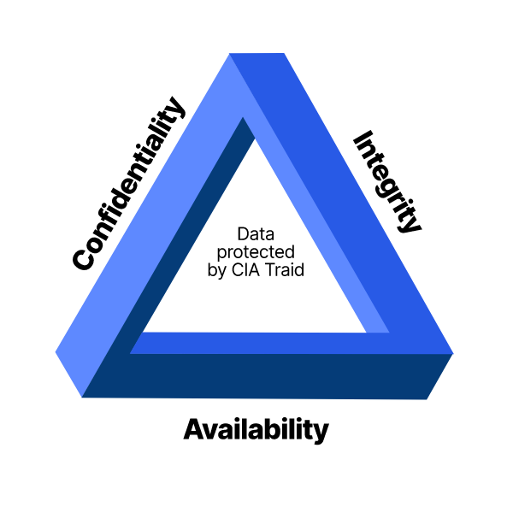
The CIA Triad defines three key principles of data security
Information Security vs Cybersecurity
Information security differs from cybersecurity in both scope and purpose. The two terms are often used interchangeably, but more accurately, cybersecurity is a subcategory of information security. Information security is a broad field that covers many areas such as physical security, endpoint security, data encryption, and network security. It is also closely related to information assurance, which protects information from threats such as natural disasters and server failures.
Cybersecurity primarily addresses technology-related threats, with practices and tools that can prevent or mitigate them. Another related category is data security, which focuses on protecting an organization’s data from accidental or malicious exposure to unauthorized parties.
Information Security Policy
An Information Security Policy (ISP) is a set of rules that guide individuals when using IT assets. Companies can create information security policies to ensure that employees and other users follow security protocols and procedures. Security policies are intended to ensure that only authorized users can access sensitive systems and information.
Creating an effective security policy and taking steps to ensure compliance is an important step towards preventing and mitigating security threats. To make your policy truly effective, update it frequently based on company changes, new threats, conclusions drawn from previous breaches, and changes to security systems and tools.
Make your information security strategy practical and reasonable. To meet the needs and urgency of different departments within the organization, it is necessary to deploy a system of exceptions, with an approval process, enabling departments or individuals to deviate from the rules in specific circumstances.
Top Information Security Threats
There are hundreds of categories of information security threats and millions of known threat vectors. Below we cover some of the key threats that are a priority for security teams at modern enterprises.
Unsecure or Poorly Secured Systems
The speed and technological development often leads to compromises in security measures. In other cases, systems are developed without security in mind, and remain in operation at an organization as legacy systems. Organizations must identify these poorly secured systems, and mitigate the threat by securing or patching them, decommissioning them, or isolating them.
Social Media Attacks
Many people have social media accounts, where they often unintentionally share a lot of information about themselves. Attackers can launch attacks directly via social media, for example by spreading malware via social media messages, or indirectly, by using information obtained from these sites to analyze user and organizational vulnerabilities, and use them to design an attack.
Social Engineering
Social engineering involves attackers sending emails and messages that trick users into performing actions that may compromise their security or divulge private information. Attackers manipulate users using psychological triggers like curiosity, urgency or fear.
Because the source of a social engineering message appears to be trusted, people are more likely to comply, for example by clicking a link that installs malware on their device, or by providing personal information, credentials, or financial details.
Organizations can mitigate social engineering by making users aware of its dangers and training them to identify and avoid suspected social engineering messages. In addition, technological systems can be used to block social engineering at its source, or prevent users from performing dangerous actions such as clicking on unknown links or downloading unknown attachments.
Malware on Endpoints
Organizational users work with a large variety of endpoint devices, including desktop computers, laptops, tablets, and mobile phones, many of which are privately owned and not under the organization’s control, and all of which connect regularly to the Internet.
A primary threat on all these endpoints is malware, which can be transmitted by a variety of means, can result in compromise of the endpoint itself, and can also lead to privilege escalation to other organizational systems.
Traditional antivirus software is insufficient to block all modern forms of malware, and more advanced approaches are developing to securing endpoints, such as endpoint detection and response (EDR).
Lack of Encryption
Encryption processes encode data so that it can only be decoded by users with secret keys. It is very effective in preventing data loss or corruption in case of equipment loss or theft, or in case organizational systems are compromised by attackers.
Unfortunately, this measure is often overlooked due to its complexity and lack of legal obligations associated with proper implementation. Organizations are increasingly adopting encryption, by purchasing storage devices or using cloud services that support encryption, or using dedicated security tools.
Security Misconfiguration
Modern organizations use a huge number of technological platforms and tools, in particular web applications, databases, and Software as a Service (SaaS) applications, or Infrastructure as a Service (IaaS) from providers like Amazon Web Services.
Enterprise grade platforms and cloud services have security features, but these must be configured by the organization. Security misconfiguration due to negligence or human error can result in a security breach. Another problem is “configuration drift”, where correct security configuration can quickly become out of date and make a system vulnerable, unbeknownst to IT or security staff.

KT0202 Information security threats and attack vectors
If you are cybersecurity professional living in today’s shark-infested cyber-world, your mission is to stay ahead of the bad guys and keep your enterprise safe. This starts by understanding your vulnerabilities, knowing the many ways your defenses can be breached, and then putting in place the protections needed to maintain a secure, resilient cybersecurity posture. It’s a big job and critically important to the well-being of your enterprise.
Attack surface, attack vectors, and breaches defined
Regardless of business or industry, here are three key terms that lie at the heart of every enterprise’s cyber-defense:
Attack surface
The sum-total of points on a network where attacks can occur where an unauthorized user (the “attacker”) can try to manipulate or extract data using a myriad of breach methods (the “cyber-attack vectors”). If you consider a graph, where the x-axis lists all of the devices and apps on your network (infrastructure, apps, endpoints, IoT, etc.) and the y-axis are the different breach methods such as weak and default passwords, reused passwords, phishing, social engineering, unpatched software, misconfigurations etc. – the plot is your attack surface.
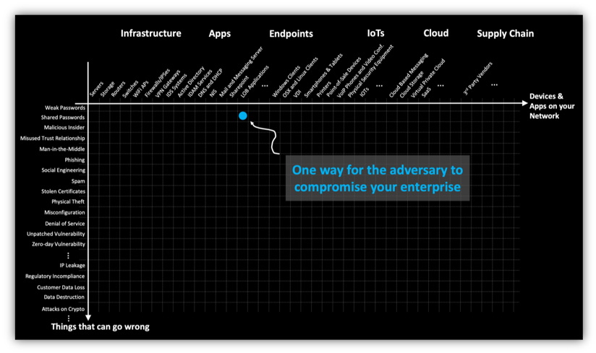
Enterprise attack surface
Cyber Attack vector
The method or way by an adversary can breach or infiltrate an entire network/system. Attack vectors enable hackers to exploit system vulnerabilities, including the human element.
Security breach
Any security incident in which sensitive, protected, or confidential data is accessed or stolen by an unauthorized party, jeopardizing an organization’s brand, customers, and assets. Incidents such as DDoS, Bitcoin mining etc. are also security breaches. Data breaches are the most common, but not all security incidents concern data theft.
So what are some of the most common types of cyber-attack vectors? Read on to find out:
Common types of cyber-attack vectors and how to avoid it
Subscribe to our blog
1. Compromised Credentials
The username and password continue to be the most common type of access credential. Compromised credentials describe a case where user credentials, such as usernames and passwords, are exposed to unauthorized entities. This typically happens when unsuspecting users fall prey to phishing attempts and enter their login credentials on fake websites. When lost, stolen or exposed, compromised credentials can give the intruder an insider’s access. Although monitoring and analysis within the enterprise can identify suspicious activity, these credentials effectively bypass perimeter security and complicate detection. The risk posed by a compromised credential varies with the level of access it provides. Privileged access credentials, which give administrative access to devices and systems, typically pose a higher risk to the enterprise than consumer credentials. And it is not only humans who hold credentials. Servers, network devices and security tools often have passwords that enable integration and communication between devices. In the hands of an intruder, these machine-to-machine credentials can allow movement throughout the enterprise, both vertically and horizontally, giving almost unfettered access.
Do this to avoid this type of cyber-attack:
- Common usernames and weak passwords can lead to compromised credentials, so it’s important that the enterprise has effective password policies that ensure suitable password strength.
- Password sharing across services makes all applications that share credentials vulnerable as a consequence of the breach of one service or application in the cohort. Do not reuse the same password to access multiple apps and systems.
- Using two-factor authentication via a trusted second factor can reduce the number of breaches that occur due to compromised credentials within an organization.
2. Weak and Stolen Credentials
Weak passwords and password reuse make credential exposure a gateway for initial attacker access and propagation. Recent malware attacks such as Mirai highlight this threat not only for managed devices but also IoT connected devices.
Apps and protocols sending login credentials over your network pose a significant security threat. An attacker connected to your network can easily locate and utilize these credentials for lateral movement. For example, in the Target attack, adversaries were able to steal Active Directory credentials and propagate their attack into the enterprise payment network.
Do this to avoid it:
- Track password hygiene and use across your entire enterprise to identify high risk users and their devices.
3. Malicious Insiders
A malicious insider is an employee who exposes private company information and/or exploits company vulnerabilities. Malicious insiders are often unhappy employees. Users with access to sensitive data and networks can inflict extensive damage through privileged misuse and malicious intent.
Do this to avoid it:
- Keep an eye out for disgruntled employees and monitor data and network access for every device and user to expose insider risk.
4. Missing or Poor Encryption
Data encryption translates data into another form that only people with access to a secret key or password can read. Encrypted data is commonly referred to as ciphertext, while unencrypted data is called plaintext. The purpose of data encryption is to protect digital data confidentiality as it is stored on computer systems and transmitted using the internet or other computer networks. Strong encryption must be applied to data at rest, in-motion, and where suitable, in-processing.
Missing / poor encryption leads to sensitive information including credentials being transmitted either in plaintext, or using weak cryptographic ciphers or protocols. This implies that an adversary intercepting data storage, communication, or processing could get access to sensitive data using brute-force approaches to break weak encryption.
Do this to avoid this type of attack vector:
- Don’t rely solely on low-level encryption or assume that following compliance means that the data is securely encrypted.
- Ensure that sensitive data is encrypted at rest, in-transit, and in processing.
5. Misconfiguration
Misconfiguration is when there is an error in system configuration. For example, if setup pages are enabled or a user uses default usernames and passwords, this can lead to breaches. With setup/app server configuration not disabled, the hacker can determine hidden flaws, and this provides them with extra information. Misconfigured devices and apps present an easy entry point for an attacker to exploit.
Do this to avoid this type of cyber-attack:
- Put procedures and systems in place that tighten your configuration process and use automation wherever possible. Monitoring application and device settings and comparing these to recommended best practices reveals the threat for misconfigured devices located across your network.
6. Ransomware
Ransomware is a form of cyber-extortion in which users are unable to access their data until a ransom is paid. Users are shown instructions for how to pay a fee to get the decryption key. The costs can range from a few hundred dollars to thousands, payable to cybercriminals in Bitcoin.
Do this to avoid ransomware attacks:
- Make sure you have systems in place that protect all your devices from ransomware including keeping your operating system patched and up-to-date to ensure you have fewer vulnerabilities to exploit and not installing software or giving it administrative privileges unless you know exactly what it is and what it does.
7. Phishing
Phishing is a cybercrime tactic in which the targets are contacted by email, telephone or text message by someone posing as a legitimate institution to lure individuals into providing sensitive data such as personally identifiable information, banking and credit card details, and passwords. It continues to be one of the most effective social engineering attack vectors. Some phishing schemes are incredibly intricate and can sometimes look completely innocent. The Office of Personnel Management (OPM) hack demonstrates how phishing can defeat almost all layers of traditional security such as email gateways and endpoint controls.
Do this to avoid phishing attacks:
- Measuring web browsing and email click-through behavior for users and devices provides valuable risk insight for your enterprise.
- When in doubt, it’s best to call the organization you received the email from to determine if it is a phishing scam or not.
8. Trust Relationships
Trust relationships refer to a certain level of trust that exists between users and systems. For example, trust relationships can connect two domains, so a user only has to log in once in order to access resources. The two domains in a trust relationship are the trusted domain (the domain that authenticates the user the first time), and the trusting domain (the domain that relies on the trusted domain to authenticate users and gives access to its resources without re-authenticating the user). One common breach scenario example is when credentials are cached on the trusted client, which then gets breached, wreaking havoc.
Do this to avoid this type of cyber attack:
- Managing trust relationships can help you limit or eliminate the impact or damage an attacker can inflict. Google’s BeyondCorp is an example of zero-trust security practice.
Other breach methods
Zero-Day Vulnerabilities
This is a vulnerability that nobody is aware of until the breach happens (hence the name zero day, as there is no time elapsed between when the attack happens, and the vulnerability is made public). If a developer has not released a patch for the zero-day vulnerability before a hacker exploits that vulnerability, then the following attack is known as a zero-day attack. Having the red team write POC exploits is a way to mitigate zero-day vulnerabilities.
Brute Force Attack
This is a relentless attack based on trial and error where the hacker attempts to determine passwords or access encrypted data. Similar to the thief who is attempting to crack a safe, the brute force attack tries numerous different combinations until one finally works. Brute force works across all attack vectors described above; including password attacks, breaking weak encryption etc., so it is not technically an attack vector on its own.
DDoS
Distributed Denial of Service (DDoS) is a cyberattack against a network resource (e.g., server, website) by numerous compromised computer systems. The network resource is flooded with extraneous messages, which causes the target to slow down and/or crash, making it inaccessible to authorized users and systems. A DDoS attack normally occurs due to multiple systems being compromised. A potential mitigation method for this is to use CDNs, reverse proxies, HA proxies, etc. that put layers of defense in between systems serving content and clients requesting content.
Four exposures to keep on your radar screen
- High-risk software components such as Java, Flash, and IE are prone to zero-day attacks due to a large number of inherent vulnerabilities – many of which are not publicly disclosed. Devices containing such high-risk software that are actively exposed to the web are especially prone to attack.
- Misconfigured devices and apps present an easy entry point for an attacker to exploit. Monitoring application and device settings and comparing these to recommended best practices can help you identify misconfigured devices located across your network.
- Unencrypted or weakly encrypted network connections and protocols leave your enterprise susceptible to man-in-the-middle attacks. Additionally, devices and users that connect to insecure networks and apps are at risk and can also be compromised.
- Unpatched vulnerabilities are easily exploited by malware to infect your endpoint or server. Although vulnerability management products provide a list of devices that need to be patched, the real challenge is to identify high-risk devices that can be readily used/hijacked to launch attacks. Vulnerabilities in critical infrastructure or devices with access to sensitive data present a significant risk to your enterprise

KT0203 Penetration testing concepts
Penetration Testing
Penetration Testing or Pen Testing is a type of Security Testing used to cover vulnerabilities, threats and risks that an attacker could exploit in software applications, networks or web applications. The purpose of penetration testing is to identify and test all possible security vulnerabilities that are present in the software application. Penetration testing is also called Pen Test.

Vulnerability is the risk that an attacker can disrupt or gain authorized access to the system or any data contained within it. Vulnerabilities are usually introduced by accident during software development and implementation phase. Common vulnerabilities include design errors, configuration errors, software bugs etc. Penetration Analysis depends upon two mechanisms namely Vulnerability Assessment and Penetration Testing(VAPT).
Why Penetration Testing?
Penetration is essential in an enterprise because –
- Financial sectors like Banks, Investment Banking, Stock Trading Exchanges want their data to be secured, and penetration testing is essential to ensure security
- In case if the software system is already hacked and the organization wants to determine whether any threats are still present in the system to avoid future hacks.
- Proactive Penetration Testing is the best safeguard against hackers
Types of Penetration Testing:
The type of penetration test selected usually depends on the scope and whether the organization wants to simulate an attack by an employee, Network Admin (Internal Sources) or by External Sources. There are three types of Penetration testing and they are
- Black Box Testing
- White Box Penetration testing
- Grey Box Penetration Testing
In black-box penetration testing, a tester has no knowledge about the systems to be tested. He is responsible to collect information about the target network or system.
In a white-box penetration testing, the tester is usually provided with complete information about the network or systems to be tested including the IP address schema, source code, OS details, etc. This can be considered as a simulation of an attack by any Internal sources (Employees of an Organization).
In a grey box penetration testing, a tester is provided with partial knowledge of the system. It can be considered as an attack by an external hacker who had gained illegitimate access to an organization’s network infrastructure documents.
How to do Penetration Testing
Following are activities needs to be performed to execute Penetration Test –
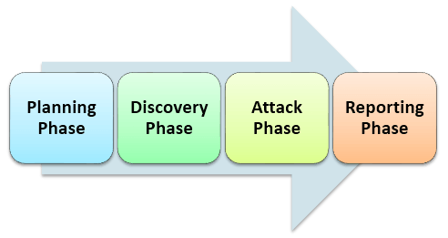
Step 1) Planning phase
- Scope & Strategy of the assignment is determined
- Existing security policies, standards are used for defining the scope
Step 2) Discovery phase
- Collect as much information as possible about the system including data in the system, usernames and even passwords. This is also called as FINGERPRINTING
- Scan and Probe into the ports
- Check for vulnerabilities of the system
Step 3) Attack Phase
- Find exploits for various vulnerabilities You need necessary security Privileges to exploit the system
Step 4) Reporting Phase
- A report must contain detailed findings
- Risks of vulnerabilities found and their Impact on business
- Recommendations and solutions, if any
The prime task in penetration testing is to gather system information. There are two ways to gather information –
- ‘One to one’ or ‘one to many’ model with respect to host: A tester performs techniques in a linear way against either one target host or a logical grouping of target hosts (e.g. a subnet).
- ‘Many to one’ or ‘many to many’ model: The tester utilizes multiple hosts to execute information gathering techniques in a random, rate-limited, and in non-linear.
Examples of Penetration Testing Tools
There is a wide variety of tools that are used in penetration testing and the important Pentest tools are:
1) Intruder
Intruder is a powerful, automated penetration testing tool that discovers security weaknesses across your IT environment. Offering industry-leading security checks, continuous monitoring and an easy-to-use platform, Intruder keeps businesses of all sizes safe from hackers.

Features
- Best-in-class threat coverage with over 10,000 security checks
- Checks for configuration weaknesses, missing patches, application weaknesses (such as SQL injection & cross-site scripting) and more
- Automatic analysis and prioritisation of scan results
- Intuitive interface, quick to set-up and run your first scans
- Proactive security monitoring for the latest vulnerabilities
- AWS, Azure, and Google Cloud connectors
- API integration with your CI/CD pipeline

KT0204 Hacking concepts
What is hacking? And how to prevent it

Hacking definition
Hacking is the act of identifying and then exploiting weaknesses in a computer system or network, usually to gain unauthorized access to personal or organizational data. Hacking is not always a malicious activity, but the term has mostly negative connotations due to its association with cybercrime.
How does hacking work?
So, how do hackers hack? Hackers use a variety of techniques to achieve their aims. Some of the most common methods include:
Social engineering
Social engineering is a manipulation technique designed to exploit human error to gain access to personal information. Using a fake identity and various psychological tricks, hackers can deceive you into disclosing personal or financial information. They may rely on phishing scams, spam emails or instant messages, or even fake websites to achieve this.
Hacking passwords
Hackers use different ways to obtain passwords. The trial and error method is known as a brute force attack, which involves hackers trying to guess every possible combination to gain access. Hackers may also use simple algorithms to generate different combinations for letters, numbers, and symbols to help them identify password combinations. Another technique is known as a dictionary attack, which is a program that inserts common words into password fields to see if one works.
Infecting devices with malware
Hackers may infiltrate a user’s device to install malware. More likely, they will target potential victims via email, instant messages and websites with downloadable content or peer-to-peer networks.
Exploiting insecure wireless networks
Rather than using malicious code to infiltrate someone’s computer, hackers may simply take advantage of open wireless networks. Not everyone secures their router, and this can be exploited by hackers driving around looking for open, unsecured wireless connection. This is an activity known as wardriving. Once hackers are connected to the unsecured network, they only need to bypass basic security to gain access to devices connected to that network.
Gaining backdoor access
Hackers may create programs that search for unprotected pathways into network systems and computers. Hackers may gain backdoor access by infecting a computer or system with a Trojan horse, created by hackers to acquire and steal important data without the victim noticing.
Spying on emails
Hackers can create code which allows them to intercept and read emails. Most email programs today use encryption formulas which mean that even if hackers intercept a message, they can't read it.
Logging keystrokes
Some programs allow hackers to track every keystroke a computer user makes. Once installed on a victim's computer, the programs record each keystroke, giving the hacker everything they need to infiltrate a system or steal someone’s identity.
Creating zombie computers
A zombie computer, or bot, is a computer that a hacker can use to send spam or commit Distributed Denial of Service (DDoS) attacks. After a victim executes a seemingly innocent code, a connection opens between their computer and the hacker's system. The hacker can then secretly control the victim’s computer, using it to commit crimes or spread spam.
What damage can hackers do?
Cybersecurity hacking can cause real havoc. Whatever technique hackers use, once they have gained access to your data or devices, they can:
- Steal your money and open credit card and bank accounts in your name
- Destroy your credit rating
- Request new account Personal Identification Numbers (PINs) or additional credit cards
- Make purchases on your behalf
- Add themselves or an alias that they control as an authorized user so it’s easier to use your credit
- Obtain cash advances
- Use and abuse your Social Security number
- Sell your information to others who will use it for malicious purposes
- Delete or damage important files on your computer
- Obtain sensitive personal information and share it, or threaten to share it, publicly
Why do people hack?
Who are hackers and why do they hack? Motivations for hacking vary. Some of the most common include:
Money
The biggest motivation is often financial gain. Hackers can make money by stealing your passwords, accessing your bank or credit card details, holding your information to ransom, or selling your data to other hackers or on the dark web.
Corporate espionage
Sometimes, hackers are motivated by stealing trade secrets from competitor companies. Corporate espionage is a form of hacking designed to access classified data or intellectual property in order to gain a competitive advantage over corporate rivals.
Political espionage
Nation states can use hackers for political purposes. This might involve stealing classified data, interfering with elections, accessing government or military documents, or attempting to cause political unrest.
Revenge
Sometimes, hackers are motivated by anger – a desire to get revenge on individuals or organizations which they feel have wronged them in some way.
Hacktivism
Hacking can be a form of civil disobedience. Some hackers use their skills to promote a particular political agenda or social movement.
Notoriety
Hackers can be motivated by a sense of achievement, that is, breaking ‘the system’. Hackers can be competitive, challenging each other and gaining recognition from their exploits. Social media gives them a platform to boast about their activities.
Security improvements
Not all hacking is malicious. Some hacking, for example, white hat hacking or penetration testing, is done to test vulnerabilities with the aim of improving security for all users. White hat hacking is therefore considered ethical hacking.

KT0205 Ethical hacking concepts

Ethical hacking has evolved as an effective way for companies to test their network security and determine if they're vulnerable to attacks by malicious hackers. This is accomplished by having a team of hackers attempt to penetrate the company's network and then assessing those attempts and identifying weaknesses in the system.
There are many ethical hacking types, ranging from black box penetration testing, and gray box penetration testing, to white box penetration testing. Each type of hacking in cyber security has its advantages and disadvantages. It is, therefore, essential to understand the differences before deciding which one is right for your needs.
In this article, we will go over each type of hacking in cyber security in detail so you can decide which one is right for your needs.

What Is Ethical Hacking, and Why Do We Need It?
Ethical hacking, also known as the white hat hacking type, tests a computer system or network to assess its security and attack vulnerability. But why do we need ethical hacking? Ethical hacking is essential to uncover your systems' weaknesses, so you can fix them before malicious hackers do.
You might think this sounds common sense, but many companies overlook this crucial step in their security protocols until they've been hacked. It's much easier (and cheaper) to fix bugs in your system before they're exploited than after.
Ethical hacking often involves penetration testing or vulnerability scanning, and it helps organizations to discover security vulnerabilities that hackers can exploit. These tests are usually performed by skilled computer professionals who are not maliciously trying to break into a system but want to help improve its defenses against real-world threats.
What is the Importance and the Key Concepts Of Ethical Hacking?
Ethical hacking is crucial because it helps protect the network from cyber-attacks. Ethical hacking is a special kind of penetration testing conducted for security purposes.
There is three central importance of Ethical Hacking:
- It helps find all the vulnerabilities in your network, so you can fix them immediately before they get exploited by criminals or hackers.
- It helps identify the weak points in your network and improves its security by implementing strong security measures.
- It also helps train employees about cybersecurity issues, so they don't fall for phishing scams or other attacks.
However, to become an ethical hacker, you must first understand the three key concepts of Ethical Hacking. The three main concepts of Ethical Hacking are:
1. Scanning
Scanning identifies the target network, its devices, and their current configurations. This information can be used to identify vulnerabilities and determine what type of ethical hacking attack will work best on those devices.
2. Enumeration
Enumeration is gathering information about the target network, such as usernames and passwords, which can be used in later stages of an attack.
3. Exploitation
Exploitation involves taking advantage of a device's vulnerability to gain access to sensitive data or control over that device.
What are the Different Types of Ethical Hacking?
Ethical hacking is a complex process that involves a combination of skills, techniques, and methods to test the security of an organization's computer systems. There are several types of hacking in cyber security practices:
1. Black-box Testing
In black-box testing, the hacker doesn't have any prior knowledge of the system, and is testing the software from outside the system before entering it via a brute force approach . For example, if you were testing a website, you might not know what kind of server it's running on or what programming languages were used to create it.
This hacking type is often considered one of the most dangerous types of hacking in cyber security and is used to identify security holes in a network or system that an attacker could exploit. They illegally gain access to private information like credit card numbers or bank accounts, which they then sell or use for illegal purposes like identity theft or fraud.
For example, a black box testing can be used to check a user's login, view their account information, change their password and log out. The tester would not need to know how this is achieved within the application's code to design such a test.
2. White-box Testing
In white box testing, the hacker knows everything about the system, how it works, and its weaknesses before he tries to break in the system. White-box testing is often done by developers who want to see how well their systems hold up under pressure before they release them into production environments where attackers may try to crack them open.
They work closely with IT departments and follow company policy, so they can find out what is happening on the inside without breaking any laws. They also ensure that no one hacks into their employer's system.
Some of the common examples of white-box testing are designing reviews, code inspections, data-flow analysis, and statement coverage.
3. Gray-box Testing
This is a mix between white-box and black-box testing; the tester has some knowledge about the system but not all of it, so they need to use deductive reasoning skills and their technical knowledge to find vulnerabilities within the system or network being tested.
Gray hats sometimes use their skills for good and malicious purposes, such as stealing money from banks or other companies through computer viruses they create (which means they could be considered black hats).
The examples of gray-box testing include areas like:
- Usability Tests
- Performance Tests
- Security Tests
This approach helps you in understanding how well your application will perform in real-world environments, which can be critical for ensuring successful development.
4. Web Application Hacking
Web application hacking type is the process of exploiting security vulnerabilities or weaknesses in web-based applications. Web applications are typically written in languages like HTML, CSS, and JavaScript, but they can also be written in other languages like PHP and Ruby on Rails. Because of the nature of these languages and how web browsers interpret them, it is possible to perform specific actions on a website without actually being authorized.
One example of this would be cross-site scripting (XSS), which involves injecting malicious code into a website's HTML. If you can craft an XSS attack properly, you can hijack the browser's session with the server without ever having access to their username or password.
5. Hacking Wireless Networks
Hacking wireless networks is a hacking type that involves accessing a computer network without authorization, typically by exploiting weak points in the system's security.
An excellent example of this is the practice of wardriving, where an attacker drives around with a laptop or other device capable of picking up wireless signals, looking for unprotected or poorly protected networks.
How to Choose an Ethical Hacking Course and Certification?
The Ethical Hacking Courses and Certification are the best way to learn to hack. However, choosing the right course can be a daunting task. To help you make it easier, here are some factors to remember while choosing a course:
1. Duration
One of the most important things to look for in different types of ethical hacking courses is the duration of the course. Most courses last about nine months, but some can go as long as two years.
2. Cost
The longer the course, the more detailed explanation of concepts, and the more expensive it will be. Choose a course that fits your schedule and budget.
3. Availability
Another thing to look for in the ethical hacking course is whether it is available online or offline. Some courses are only available online, while others are available only in person at a physical location. Decide on what kind of learning style you prefer before choosing a course.

KT0206 Information security controls
What are information security controls?
According to NIST (the National Institute of Standards and Technology), security controls are defined as “the safeguards or countermeasures prescribed for an information system or an organization to protect the confidentiality, integrity, and availability of the system and its information.”
That means that any countermeasure used to keep a computer, device, network, or safe from a data breach or another attack is a countermeasure.
That may seem extremely broad, but information security controls are often categorized, both by type and by the goals of the countermeasure. What does that mean? Below is a listing of information security controls by type:
- Physical controls: Locks on doors that keep intruders from devices, the ability to remove a device from a network, and access control to physical equipment are all physical controls.
- Administrative controls:
- information security awareness, and training are administrative controls.
- Technical controls: Items that use technology to combat attacks, like authentication, antivirus software, and firewalls are technical controls.
- Legal and regulatory or compliance controls: Privacy legislation or information security frameworks are legal or regulatory controls.
When controls are classified by a goal, however, the list looks a little different:
- Preventive controls: Intended to prevent an incident from occurring, such as good cyber hygiene, network segmentation, and user authentication.
- Detective controls: Tools used during an incident to respond to a breach, such as anti-malware software, a ransomware response plan, or security ratings.
- Corrective controls: After the event, corrective controls limit the extent of any damage caused by the incident, such as cybersecurity insurance or new response plans.
What security controls does my organization need?
No one organization will implement every single information security control. Some may be redundant and some might not be relevant to your organization or your networks, but every organization needs some of the above.
There are several security standards and frameworks that provide a starting point for organizations when it comes to security best practices and controls.
- NIST, mentioned above, offers a free, voluntary cybersecurity framework consisting of standards, guidelines, and practices to promote the protection of an organization’s critical infrastructure. It lists more than 100 individual controls a company can use to mitigate risk.
- Another standard, the ISO/IEC 27001, is offered by the International Organization for Standardization (ISO) and the International Electrotechnical Commission (IEC). Thai international standard identifies 114 controls in 14 groups, ranging from policies to incident management.
- The SANS CIS Controls are a recommended set of actions for cyber defense that provide specific and actionable ways to stop attacks.
- COBIT5 is a proprietary control set published by ISACA which is based on five principles of security.

Internal Assessment Criteria and Weight
- IAC0201Concepts of information security are defined
- IAC0202Information security controls are listed and discussed

KM-03-KT03: Foot printing and Reconnaissance
Topic elements to be covered include:
- KT0301Footprinting concepts and objectives
- KT0302Footprinting uses
- KT0303Types of foot printing
- KT0304Passive and active foot printing
- KT0305Footprinting methodologies
- KT0306Tools, tricks and techniques for information gathering
- KT0307Footprinting steps
- KT0308Countermeasures and prevention
- KT0309Footprinting Pen Testing

KT0301 Foot printing concepts and objectives
What is Foot printing?
- Foot printing is the process of collecting as much information as possible about a target network, for identifying various ways to intrude into an organization's network system.
- Foot printing is the first step of any attack on information systems; attacker gathers publicly available sensitive information, using which he/she performs social engineering, system and network attacks, etc. that leads to huge financial loss and loss of business reputation.
- Know Security Posture: Foot printing allows attackers to know the external security posture of the target organization.
- Reduce Focus Area: It reduces attacker's focus area to specific range of IP address, networks, domain names, remote access, etc.
- Identify Vulnerabilities: It allows attacker to identify vulnerabilities in the target systems in order to select appropriate exploits.
- Draw Network Map: It allows attackers to draw a map or outline the target organization's network infrastructure to know about the actual environment that they are going to break.
Objectives of Foot printing
- Collect Network Information:
  - Domain name
  - Internal domain names
  - Network blocks
  - IP addresses of the reachable systems
  - Rogue websites/private websites
  - TCP and UDP services running
  - Access control Mechanisms and ACL's
  - Networking protocols
  - VPN Points
  - IDSes running
  - Analog/digital telephone numbers
  - Authentication mechanisms
  - System Enumeration
- Collect System Information:
  - User and group names
  - System banners
  - Routing tables
  - SNMP information
  - System architecture
  - Remote system type
  - System names
  - Passwords
- Collect Organization's Information:
  - Employee details
  - Organization's website
  - Company directory
  - Location details
  - Address and phone numbers
  - Comments in HTML source code
  - Security policies implemented
  - Web server links relevant to the organization
  - Background of the organization
  - News articles
  - Press releases

KT0302 Footprinting uses
What Is Foot printing?
Think about foot printing as looking for every place an organization may leave information about itself. To put it another way, it's searching for in any location where the organization's ''footprint'' can be observed. This is the first and perhaps most critical step in the hacking process.
Foot printing is about collecting all available information about a computer system or network in order to gain access to it. Unethical hackers perform this task before hacking into a system without permission. In addition, through ethical hacking, organizations today are also engaging in this type of reconnaissance to identify security deficiencies in their systems and networks.
There are two types of foot printing: 1) active and 2) passive. Active foot printing might consist of sending a phishing email to an employee in an attempt to collect proprietary information. Passive foot printing could be as simple as reading a company's website or googling them to see what information is available about them.
Information
If you've ever searched for any business or even an individual online, you already know there is a ton of information out there, likely including some things you never expected to find. When undertaking foot printing, there is a wealth of data available for hackers, giving them intelligence about an organization.
Some of those data points include:
- Company IP addresses
- Operating systems on machines
- Network basics
- Employee email addresses
- Web domain names
- Important phone numbers
- Identities of key figures in an organization
- Organizational policies
- Current or future project information or changes
- Legal details or documents
- News coverage or press releases
- A company's patents and trademarks
- Presentations, webinars and articles
Uses
The process of footprinting and gathering the aforementioned information may be useful in the following scenarios:
- Reducing or eliminating attacks. Once security vulnerabilities are addressed, the likelihood of threats can be decreased.
- Finding weaknesses. Knowing where vulnerabilities exist, a company can work to correct them.
- Identifying security posture. A company that engages in footprinting can get a more clear picture of security strengths and weaknesses.
- Laying the foundation for an attack. This is the methodology hackers will employ to find weak points through which they can launch their attack.
Footprinting How-To
Before a hacker would attempt to break into a computer system or network, he or she would want to understand it, right? Think about it in terms of a burglar who cases a home or business before physically breaking in. The burglar looks for things like alarm systems, cameras, dogs on the premises or the schedule of the homeowners before attempting entry.

KT0303 Types of foot printing
Types of Foot printing
There are two main types of foot printing: passive and active.
- Passive foot printing involves collecting data without actively engaging with the target system. Under this approach, information is collected through crawling websites and social media platforms, among other methods. For example, tools like tcpdump and Wireshark can be used to capture packets sent and received by the target system.
- Active foot printing involves interacting with the target system to gather information. This can be done manually or using automated tools like Nmap and Nessus. Active foot printing is more intrusive and can potentially cause harm to the target system if not done carefully, but it can also gather information that can’t be collected through passive foot printing.

KT0304 Passive and active foot printing
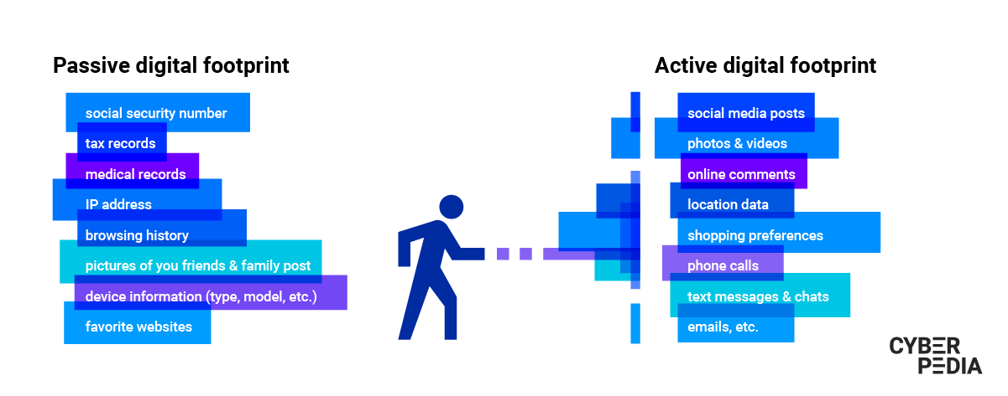
Passive Footprinting
This involves gathering information about the target without direct interaction. It is a type of foot printing gathering that is mainly useful when there is a requirement that the information-gathering activities are not to be detected by the target is not sent to the target organization from a host or from anonymous hosts or services over the Internet. We can just gather the documented and put away data about the target utilizing web crawlers, social networking websites, etc.

Passive foot printing techniques include
- Finding the Top-level Domains (TLDs) and sub-domains of an objective through web services
- Gathering area information on the objective through web services
- Performing individuals search utilizing social networking websites and individuals search services
- Stealing monetary data about the objective through various monetary services
- Get-together framework subtleties of the objective association through places of work
- Checking objective utilizing ready services
- Social occasion data utilizing gatherings, discussions, and online journals
- Deciding the working frameworks being used by the objective association
- Extricating data about the objective utilizing Internet documents
- Performing competitive intelligence
- Discovering data through web crawlers
- Monitoring website traffic of the target
- Tracking the online reputation of the target
- Gathering data through social designing on social networking destinations

Active Foot printing: –
This involves gathering information about the target with direct interaction. In this type of foot printing, the target may recognize the ongoing information gathering process, as we only interact with the target network.

Active Foot printing techniques include
- Querying published name servers of the target
- Extracting metadata of published documents and files
- Stealing a lot of website information using various types of mirroring and web spidering tools
- Gathering information through email tracking
- Performing Whois lookup
- Extracting DNS information
- Performing traceroute analysis
- Performing social engineering
The major goals of foot printing incorporate gathering the organization data, mainframe data, and hierarchical data of the victim. By directing foot printing across various organization levels, we can acquire precious data, for example, network blocks, explicit IP addresses, representative subtleties, etc. Such data can help the network intruders in accessing confidential information or performing different types of hacks on the objective organization.

KT0305 Foot printing methodologies

Various methods used to collect information about the target organization. They are
Foot printing through Search Engines
This is a passive information gathering process where we gather information about the target from social media, search engines, various websites etc. Information gathered includes name, personal details, geographical location detrails, login pages, intranet portals etc. Even some target specific information like Operating system details, IP details, Netblock information, technologies behind web application etc can be gathered by searching through search engines
Eg: collecting information from Google, Bingo etc

Google Hacking:
Google hacking refers to collecting information using google dorks (keywords) by constructing search queries which result in finding sensitive information. Details collected include compromised passwords, default credentials, competitor information, information related to a particular topic etc.

Examining HTML Source and Examining Cookies:
Html source codes of a web application may give us an understanding of the application functionality, hidden fields, comments, variable names etc. Cookies are used to identify a user in his session. these cookies may be stored in the browser or passed in the URL, or in the HTTP header.
The entire website can be mirrored using tools like HTT tracker to gather information at our own phase.

Email Foot printing
email header reveals information about the mail server, original sender’s email id, internal IP addressing scheme, as well as the possible architecture of the target network

Competitive Intelligence
Competitive intelligence gathering is the process of gathering information about the competitors from resources such as the Internet.
Eg: company website, search engine, internet, online databases, press releases, annual reports, trade journals

Google Hacking/Google Dorks
This is a process of creating search queries to extract hidden information by using Google operators to search specific strings of text inside the search results.

Who is Foot printing
Whois databases and the servers are operated by RIR - Regional Internet Registries. These databases contain the personal information of Domain Owners. Whois is a Query response protocol used for querying Whois databases and its protocol is documented in RFC 3912. Whois utility interrogates the Internet domain name administration system and returns the domain ownership, address, location, phone numbers, and other details about a specified domain name.
DNS Foot printing
DNS is a naming system for computers that converts human-readable domain names into computer readable IP-addresses and vice versa.DNS uses UDP port 53 to serve its requests. A zone subsequently stores all information, or resource records, associated with a particular domain into a zone file; Resource records responded by the name servers should have the following fields:
- Domain Name — Identifying the domain name or owner of the records
- Record Types — Specifying the type of data in the resource record
- Record Class — Identifying a class of network or protocol family in use
- Time to Live (TTL) — Specifying the amount of time a record can be stored in cache before discarded.
- Record Data — Providing the type and class dependent data to describe the resources.
A (address)—Maps a hostname to an IP address
SOA (Start of Authority)—Identifies the DNS server responsible for the domain information
CNAME (canonical name)—Provides additional names or aliases for the address record
MX (mail exchange)—Identifies the mail server for the domain
SRV (service)—Identifies services such as directory services
PTR (pointer)—Maps IP addresses to hostnames
NS (name server)—Identifies other name servers for the domain
HINFO = Host Information Records
DNS servers perform zone transfers to keep themselves up to date with the latest information. A zone transfer of a target domain gives a list of all public hosts, their respective IP addresses, and the record type.

Foot printing through Social Engineering:
Social media like twitter, Facebook are searched to collect information like personal details, user credentials, other sensitive information using various social engineering techniques. Some of the techniques include
- Eavesdropping: It is the process of intercepting unauthorized communication to gather information
- Shoulder surfing: Secretly observing the target to gather sensitive information like passwords, personal identification information, account information etc
- Dumpster Diving: This is a process of collecting sensitive information by looking into the trash bin. Many of the documents are not shredded before disposing them into the trash bin . Retrieving these documents from trash bin may reveal sensitive information regarding contact information, financial information, tender information etc.
- Foot printing countermeasures:
  - Creating awareness among the employees and users about the dangers of social engineering
  - Limiting the sensitive information
  - encrypting sensitive information
  - using privacy services on whois lookup database
  - Disable directory listings in the web servers
  - Enforcing security policies

KT0306 Tools, tricks and techniques for information gathering
Tools, Tricks, and Techniques for Information Gathering
Tools
Who is a renowned Internet record listing tool to identify who owns a domain or who registers for that particular domain along with their contact details. The Internet Corporation for Assigned Names and Numbers (ICANN) regulates domain registration and ownership details. Who’s records have proven extraordinarily beneficial and have developed into an essential resource for maintaining the integrity of domain name registration and website ownership process.
- Harvester is also an information-gathering tool that helps you extract a particular target's email address and subdomains. Harvester is coded using a simple python script that searches information from giant search engines like Google, Yahoo, Bing, and much more.
- Metagoofil is another information gathering or foot printing tool used for extracting information or data publicly available on the internet belonging to the company.
- Netifera is a potent tool that gives a complete platform to gather information regarding the targeted website you want to attack. It is a free tool that comes inbuilt with Backtrack Linux OS. This software will give information such as IP address, the Programming language used for website development, the number of websites hosted, and DNS.
Techniques
- OS Identification: involves sending illegal TCP (Transmission Control Protocol) or ICMP (Internet Control Message Protocol) packets to the victim's system to identify the OS (Operating system) used by the victim on his server or computer.
- A ping sweep establishes a range of IP addresses that map hackers to live hosts. Fping, Nmap, Zenmap, ICMPEnum, and SuperScan are some of the tools used to ping a large number of IP addresses at a time; to generate lists of hosts for large subnets.
Tricks
We can gather information from other sources, such as social networking sites (Facebook, Twitter, LinkedIn, etc.), where general users share their personal data and additional related information. Even search engines play a significant role in gathering information.
Hackers can also gather information from various financial services about a target company, such as the market value of a company's shares, company profile, competitor details, etc.
Hackers can also collect information from the email header, which includes:
- Address from which message was sent.
- Sender's email server.
- Sender's IP address.
- Date and time received by the originator's email server.
- The sender's mail server uses the authentication system.
- Sender's full name.
Objectives of Foot printing
- Collect Network Information: such as Domain name, Internal domain names, IP addresses of the reachable systems, rogue websites/private websites within the domain, Access Control Mechanisms, protocols used, existing VPNs, analogy and digital telephone numbers, authentication mechanisms, and system enumeration.
- Collect System Information: such as users and group names, system banners, routing tables, and the routing protocols it is using, SNMP information, system architecture, operating system used, remote system type, username, and passwords.
- Collect Organizations' Information: such as Employee details, organization's website, company directory, local details, address and phone numbers, comments in HTML Source code within an organization's website, security policies implemented, web server links relevant to the organization, news articles and press release.
Countermeasures
- Classify the type of information which is needed to be kept public.
- Don't put unnecessary information into any profile, social networking account, or website.
- Don't keep a personal contact number in any company or organization's phone book to prevent war-dialing.

KT0307 Footprinting steps
Several steps need to be followed during foot printing to collect all relevant information.
1. Identifying Targets
The first step is to identify which systems or organizations to footprint by scanning networks for open ports or performing reconnaissance using Google searches and tools like Shodan.
2. Gathering Information
After the target has been identified, the next step is to gather as much information about it as possible using tools like Nmap, Netcat, and Who’s to identify open ports and services, usernames and passwords, web server information, and more.
3. Analysing Results
After all relevant data has been collected, it needs to be analysed to determine the most vulnerable points. This is done by identifying common weaknesses across multiple systems or comparing results against known exploits.
4. Planning Attacks
The final step is to use the information gathered during foot printing to plan a successful attack against the target’s systems, networks, and devices. This may involve developing custom exploits or choosing a suitable attack vector based on the data collected.

KT0308 Countermeasures and prevention
- Creating awareness among the employees and users about the dangers of social engineering.
- Limiting the sensitive information.
- encrypting sensitive information.
- using privacy services on whois lookup database.
- Disable directory listings in the web servers.
- Enforcing security policies.

KT0309 Footprinting Pen Testing
The goal of foot printing is simple: Gather as much information about the target as possible. An attacker will try to exploit any discovered vulnerabilities to collect information about the target. Successful penetration tests can enable organizations to fix vulnerabilities before an attack can occur.
Penetration testing, often known as pen testing, involves making an authorized attack on a computer system or network in order to find security weaknesses. Penetration testing is frequently used in the web application security context, for example, to complement web application firewalls and other security measures.
Penetration testers may use many methods to perform an actual penetration test (Gupta, 2022), but foot printing should always be the first step. Understanding the foot printing process and how to interpret collected information sets penetration testers up for success in the later stages of an assessment. Many sources of information are available on foot printing, including online courses, books, and YouTube videos. However, the best way to improve is by practicing and applying what you’ve learned to real-world scenarios.

How to Improve Your Penetration Testing Skills
As a penetration tester, it’s important to conduct foot printing—and fully utilize the information you collect in your planning process—before you simulate an attack scenario. If you’re looking to start or advance your career in cybersecurity, gaining an understanding of the steps involved in foot printing and other aspects of penetration testing is an excellent place to start. One of the best ways to learn penetration testing skills is through a training program like EC-Council’s C|PENT certification course. In the C|PENT program, you’ll learn how to perform effective penetration tests in real-world network environments, including the latest tips and techniques for foot printing and reconnaissance. If you’re interested in learning more, contact EC-Council about starting the C|PENT program today.

Internal Assessment Criteria and Weight
- IAC0301Risks and mitigation related to foot ringing and reconnaissance are interrogated.

KM-03-KT04: Scanning Networks
Topic elements to be covered include:
- KT0401Network scanning concepts and objectives
- KT0402Types of scanning
- KT0403Scanning methodologies, tools and techniques
- KT0404Draw network diagrams
- KT0405Scanning pen testing
- KT0406Vulnerability scanning
- KT0407Countermeasures against scanning

KT0401 Network scanning concepts and objectives
What is Network Scanning?
Wondering how to see all devices on the network? As the term is typically used, “network scanning” is the process allowing you to determine all active devices on your network. Active scanning is when the tool sends a ping to each device on the network and awaits a response. The scanner then looks at the responses it gets to see if there are inconsistencies or vulnerabilities.
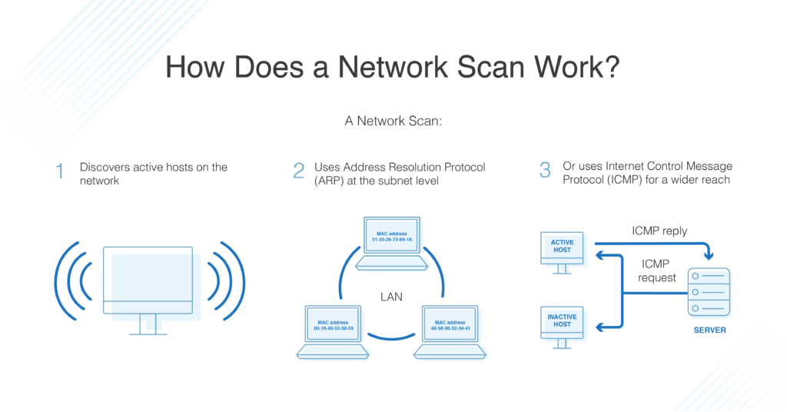
For IP networks, this is often done by sending a ping to each possible IP address and getting a response to determine its status. It’s possible to manually ping your subnet to using an Address Resolution Protocol (ARP) scan. But to view all devices on the network across all subnets, your best bet is to use a tool that can automatically run scans and discover devices. Using the necessary Internet Control Message Protocol (ICMP) scan is more complicated, but it can be done—you’ll need to use echo, timestamp, or subnet mask requests. This method is often used to map network topology.
The purpose of network scanning is to manage, maintain, and secure the system using data found by the scanner. Network scanning is used to recognize available network services, discover and recognize any filtering systems in place, look at what operating systems are in use, and to protect the network from attacks. It can also be used to determine the overall health of the network.
What is Passive Scanning?
Network scanning can also refer to packet sniffing, or passive scanning, which captures and tracks the traffic moving over the network in the form of data packets. If you’d like to track the packet-level traffic on your network, you’ll need to implement sensors on managed devices and applications and deploy a tool for you to easily translate packet data into intelligible and relevant information.
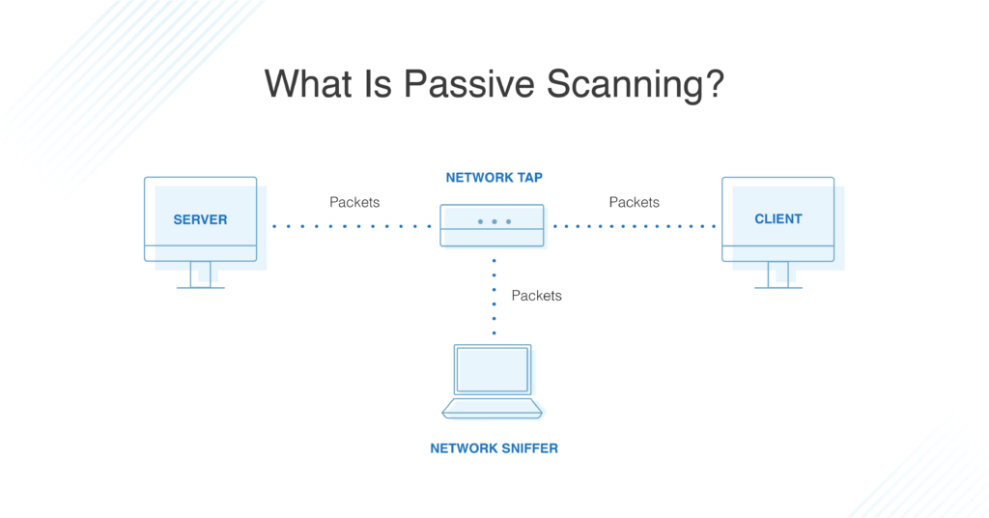
This approach looks at network information as soon as a device or system appears and starts sending messages to the network. In reality, networks release a lot of information in their normal communications, enough that passive scanners can simply look at this traffic flow, rather than pinging the devices themselves. This can help reveal traffic types, protocols, and bottlenecks within the network. It can also reveal potential security risks by catching anomalies.
Passive scanning has some limitations, as it cannot detect devices or applications that never communicate (such as unused apps and devices) and can be vulnerable to problems caused by infected systems intentionally distributing misinformation. However, it’s an important form of network scanning and should be part of your toolkit.
How to Use Network Scanning Tools
Using a network scanning tool is essential if you have more than a few devices on your network, or if your network is large enough to include multiple subnets. Trying to manually manage a large network is difficult and can expose your business to major security risks. There are several different scanning tools on the market, each with a slightly different approach to the task.
I suggest using SolarWinds® Network Performance Monitor (NPM) with its network scanning solution to automatically scan your network. This tool primarily uses passive scanning to reveal a wide range of critical network information. It functions as a network discovery and performance management tool, allowing you to determine what devices and applications are on your network and create instant network topologies. You can scan the network information to determine whether devices are performing correctly, whether they are available, or if there are any faults in the network.
NPM can examine and monitor multi-vendor networks, as well as providing you with visually pleasing network insights. I like the intelligent visualizations such as heat maps and comparative graphs, as it can help you understand your network from a node-by-node perspective. This helps troubleshoot and pinpoint problems or discover weak points that might be vulnerable to attacks. NPM can also scale to much larger environments and enterprises. I also find it to be intuitive for beginner users—figuring out how to use NPM isn’t difficult.

In particular, it looks at issues such as weak passwords, misconfigured systems, old software, and exposed services and functions. It also allows you to scan your entire network over different local environments and create a map of your network. You can then prioritize, organize, or remedy vulnerabilities.
Similarly, if you’re looking for effective packet sniffing, Swascan Network Scan tool is also useful. First, the interface is engaging, clean, and very simple to use. With high-quality data analysis and graphs, Network Scan tool provides complex information about vulnerabilities in your network. The reports and accompanying managers can then assist you with fixing these errors through their detailed action plan.
Network Scanning Today
If you’re wondering how to scan your network, first take the time to understand which type of scanning you need. Managing IP addresses and devices? You might be able to get away with manual IP scanning, but there are many easy-to-use IP manager tools out there. Performing packet sniffing is more complicated but is a critical task to ensure you have network oversight. This means implementing the right sensors and a tool that translates packet data into easily readable information.

KT0402 Types of scanning
Types of Network Scanning
Scanning has three types:
- Port scanning - used to list open ports and services
- Network scanning - used to list IP addresses
- Vulnerability scanning - used to discover the presence of known vulnerabilities

KT0403 Scanning methodologies, tools and techniques
Scanning Techniques
Port scanning techniques are extremely useful when it comes to identifying open ports. Scanning techniques represent different categories which are used based on protocol types. They are categorized into three categories:
- Scanning ICMP network services
- Scanning TCP network services
- Scanning UDP network services
Scanning ICMP network services
ICMP Scanning
ICMP scanning is used for identifying active devices and determining whether ICMP can pass through a firewall.
Ping Sweep
Ping sweep is used to determine the range of IP addresses that is mapped to active devices. It allows hackers to calculate subnet masks and identify the number of present hosts in the subnet. This in turn enables them to create an inventory of active devices in the subnet.
ICMP Echo Scanning
ICMP Echo Scanning is used to determine which hosts are active in a target network by pinging all the machines in the network.
Scanning TCP Network Services
TCP Connect
TCP connect scan used for detecting open ports upon the completion of the three-way handshake. It works by establishing a full connection and then dropping it by sending a RST packet.
Stealth Scan
Stealth scan is used for bypassing firewall and logging mechanisms. It works by resetting the TCP connection before the three-way handshake is completed, which in turn makes the connection half open.
Inverse TCP Flag Scanning
Inverse TCP flag scanning works by sending TCP probe packets with or without TCP flags. Based on the response, it is possible to determine whether the port is open or closed. If there is no response, then the port is open. If the response is RST, then the port is closed.
Xmas Scan
Xmas scan works by sending a TCP frame with FIN, URG, and PUSH flags set to the target device. Based on the response, it is possible to determine whether the port is open or closed. If there is no response, then the port is open. If the response is RST, then the port is closed. It is important to note that this scan works only for UNIX hosts.
ACK Flag Probe Scanning
ACK flag probe scanning works by sending TCP probe packets with ACK flag set in order to determine whether the port is open or closed. This is done by analyzing the TTL and WINDOW field of the received RST packet’s header. The port is open if the TTL value is less than 64.
Similarly, the port is also considered to be open if the WINDOW value is not 0 (zero). Otherwise, the port is considered to be closed.
ACK flag probe is also used to determine the filtering rules of the target network. If there is no response, then that means that a stateful firewall is present. If the response is RST, then the port is not filtered.
Scanning UDP Network Services
IDLE/IPID Header Scan
IDLE/IPID header scan works by sending a spoofed source address to the target to determine which services are available. In this scan, hackers use IP address of a zombie machine for sending out the packets. Based on the IPID of the packer (fragment identification number), it is possible to determine whether the port is open or closed.
UDP Scanning
UDP scanning uses UDP protocol to test whether the port is open or closed. In this scan there is no flag manipulation. Instead, ICMP is used to determine if the port is open or not. So, if a packet is sent to a port and the ICMP port unreachable packet is returned, then that means that the port is closed. If, however, there is no response, then the port is open.
SSDP and List Scanning
SSDP, or Simple Service Discovery Protocol, service responds to queries sent over IPv4 and IPv6 broadcast addresses. Attackers use this scan to exploit UPnP vulnerabilities and carry out buffer overflow or DoS attacks. List scanning indirectly discovers hosts. This scan works by listing out IP addresses and names without pinging the hosts and with performing a reverse DNS resolution to identify the names of the hosts.

KT0404 Draw network diagrams
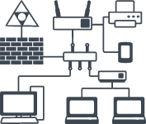
- How to create a network diagram
- Select a network diagram template.
- Name the network diagram.
- Remove existing elements that you don't need on your diagram.
- Add network components to the diagram.
- Name the items in your network diagram.
- Draw connections between components.
- Add a title and share your network diagram.

KT0405 Scanning pen testing

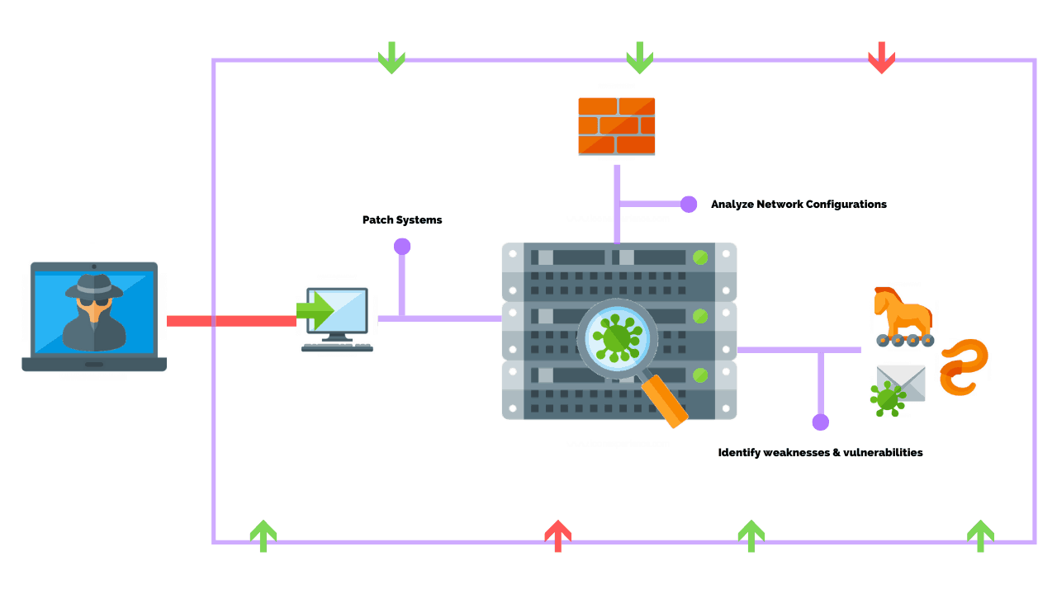
What is Network Penetration Testing?
Network penetration testing is the process of simulating a hacker-style attack on your network assets to detect and exploit security misconfiguration, network vulnerabilities, and threats like open ports, vulnerable devices, or outdated software running on the network.
For easier reference, imagine it to be a mock drill against known cyber threats. The goal of a network pen test is to detect security vulnerabilities in a network and help the target organization strengthen its defenses against cyber threats.
What is the importance of network penetration testing?
To understand more about how to secure networks and prevent data breaches, we’ve put some insights into the importance of network penetration testing through this article.
Sometimes, companies who have put their systems through vulnerability scanning doubt the relevance of pen tests since both processes have the same goal. However, an internal or external network pen test is to follow vulnerability assessments.
While vulnerability assessment uses automated website scanners to conduct security checks, internal penetration testing puts forward stimulated cyber-attacks. With external penetration testing, you can test the site from an outsider’s perspective. If both point out the issues in the firewall and other security measures, network pen tests bring in more concerted efforts to recognize the problem and solve it.
Using high-quality versions of both VA and PT allows you to cyclically go through a website vulnerability scanner, attain risk reports and the varying levels of danger, then use this information to conduct a pen test before preparing the final assessment and applying fixes.
What is the Purpose of Network Pentest?
1. Protect your data
Single-handedly the most important reason, every organization must guard itself against data breaches. Pen testing networks often function like ethical hacks and simulate cyber-attacks as best as possible. A small weakness has the potential to let out sensitive information, affecting your customers’ trust and the more serious violation of various rules and regulations. Here, a helpful way to determine the level of possible intrusion is to identify the different levels of risk that you are exposed to.
2. Ensuring overall security
Be it the structure of your business as a whole, sensitive data, or newly released applications, ensure that no overlooked flaw can compromise your integrity through network pentests. Security assessments and website security scans should be a part and parcel of any new initiatives, especially if there is the management of important data. Some examples of such flaws include SQL injections, weakly configured firewalls, outdated software, and traditional virus or malware.
3. Compliance requirements
Certain regulations insist on penetration testing services, no matter the industry. For example, data security for the payment card industry ensures such tests for the protection of customers’ sensitive information (PCI DSS).
4. Continued maintenance
Network pen tests require multiple runs through a continuous time period to ensure long-term security. Professionals hired for this purpose will also look over the security controls used for the business network such as firewall, layered security, encryption processes, etc. Proper penetration tests, keeping in mind the needs of the system, client, and overall security.

KT0406 Vulnerability scanning
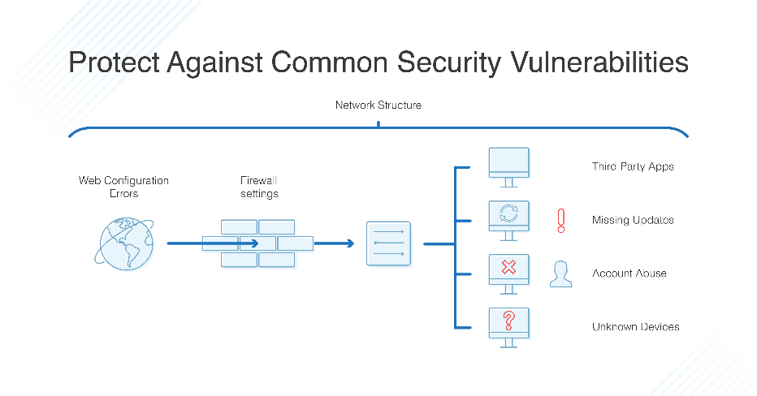
What is the importance of Network Vulnerability Scanning?
Network vulnerability scanning is an essential part of any IT department’s security infrastructure. Although it’s an essential part of any IT department’s security infrastructure, there is still some confusion as to what network vulnerability scanning really is, as well as what it does, and why you might use it.
Network vulnerability scanning is an integral part of the security assessment process of any network or system. It is a complex process, given the number of systems that need to be scanned, so it is best to approach this in an organized and systematic way.
Network vulnerability scanning is a great way to gauge the security of your network. It helps you identify the weak points in your system that you need to patch up. This blog will take you through a complete guide to understanding these scans and how you can use them.
Understanding Top 3 Network Vulnerabilities
Most of the security breaches that we hear about in the news are network breaches. If a network is vulnerable to attack, the network is vulnerable to network vulnerabilities. It is at the network level that many attacks begin, including traditional breaches and sophisticated malware attacks.
It is a good idea to understand network vulnerabilities so that you can take steps to prevent them. There are three main network vulnerabilities that you will want to understand:
1. Misconfigured devices
Misconfigured devices are easily accessible to attackers through which they can access other devices in the network. In a majority of cases, attackers use misconfigured devices in order to expand their presence within a target network. This is also a good way to collect privileged information. All it takes is a single misconfigured device to compromise the entire network.
2. Unpatched systems
Organizations often neglect updating their systems and this makes them vulnerable to attacks. This security hole can be easily exploited by attackers. The unpatched systems are open to vulnerabilities and cybercriminals can easily send in viruses, Trojans and Ransomware.
This increases the risk to the organizations and the customers as well. At Astra, we have come across many organizations that have not updated their systems for the last several years. This has led to the creation of a vast number of vulnerabilities that can be exploited by attackers.
3. Human error
Humans are the weakest link in the security chain. It’s quite easy for an attacker to trick employees to gain access to the network. For example, social engineering is one of the most common methods used by attackers to gain access to the network.
Best Practices to avoid Network Security Risks
Network security risks are a serious threat to any business. It is important to take preventive measures to avoid these risks and ensure that your business functions smoothly without any interruptions. The following are four best practices that you can implement to ensure a secure network.
1. Segmentation of network
Segmentation of network means that you separate the network into different segments. This way you can provide security to your network. You need to ensure that the internal network is not connected to the external network. The machines present in the internal network are not accessible from the external network.
2. Network Vulnerability Scanning
There is no way to avoid security threats, but you can minimize these threats by performing network vulnerability scanning on a regular basis. The scanning helps in detecting the vulnerabilities in the network and removing them.
3. Backup
Back up your data on a regular basis so that you can recover it if you face any data loss due to any security breach.
4. Install an IPS/IDS
Make sure to have an IPS or an IDA installed on your network. This software provides the necessary protection against malicious attacks on the network

KT0407 Countermeasures against scanning
Here is a checklist of countermeasures to use when considering technical modifications to networks and filtering devices to reduce the effectiveness of network scanning and probing undertaken by attackers:
- Filter inbound ICMP message types at border routers and firewalls. This forces attackers to use full-blown TCP port scans against all of your IP addresses to map your network correctly.
- Filter all outbound ICMP type 3 unreachable messages at border routers and firewalls to prevent UDP port scanning and firewalking from being effective.
- Consider configuring Internet firewalls so that they can identify port scans and throttle the connections accordingly. You can configure commercial firewall appliances (such as those from Check Point, NetScreen, and WatchGuard) to prevent fast port scans and SYN floods being launched against your networks. On the open-source side, there are many tools such as portsentry that can identify port scans and drop all packets from the source IP address for a given period of time.
- Assess the way that your network firewall and IDS devices handle fragmented IP packets by using fragtest and fragroute when performing scanning and probing exercises. Some devices crash or fail under conditions in which high volumes of fragmented packets are being processed.
- Ensure that you’re routing and filtering mechanisms (both firewalls and routers) can't be bypassed using specific source ports or source-routing techniques.
- If you house publicly accessible FTP services, ensure that your firewalls aren't vulnerable to stateful circumvention attacks relating to malformed PORT and PASV commands.
- If a commercial firewall is in use, ensure the following:
  - The latest service pack is installed.
  - Ant spoofing rules have been correctly defined, so that the device doesn't accept packets with private spoofed source addresses on its external interfaces.
  - Fast mode services aren't used in Check Point Firewall-1 environments.
- Investigate using inbound proxy servers in your environment if you require a high level of security. A proxy server will not forward fragmented or malformed packets, so it isn't possible to launch FIN scanning or other stealth methods.
- Be aware of your own network configuration and its publicly accessible ports by launching TCP and UDP port scans along with ICMP probes against your own IP address space. It is surprising how many large companies still don't properly undertake even simple port-scanning exercises.

Internal Assessment Criteria and Weight
- IAC0401Risks and mitigation of scanning networks are interrogated

KM-03-KT05: Enumeration
Topic elements to be covered include:
- KT0501Enumeration concepts and objectives
- KT0502Types of enumeration
- KT0503Enumeration countermeasures
- KT0504Enumeration methodologies, techniques and tools
- KT0505Enumeration pen testing

KT0501 Enumeration concepts and objectives

Enumeration is defined as a process which establishes an active connection to the target hosts to discover potential attack vectors in the system, and the same can be used for further exploitation of the system.
Enumeration is used to gather the following:
- Usernames, group names
- Hostnames
- Network shares and services
- IP tables and routing tables
- Service settings and audit configurations
- Application and banners
- SNMP and DNS details

KT0502 Types of enumeration
the various types of Enumerations.
1. NetBIOS(Network Basic Input Output System) Enumeration:
- NetBIOS name is an exceptional 16 ASCII character string used to distinguish the organization gadgets over TCP/IP, 15 characters are utilized for the gadget name and the sixteenth character is saved for the administration or name record type.
- Programmers utilize the NetBIOS enumeration to get a rundown of PCs that have a place with a specific domain, a rundown of offers on the individual hosts in the organization, and strategies and passwords.
- NetBIOS name goal isn’t supported by Microsoft for Internet Protocol Version 6.
- The initial phase in specifying a Windows framework is to exploit the NetBIOS API. It was initially an Application Programming Interface (API) for custom programming to get to LAN assets. Windows utilizes NetBIOS for document and printer sharing.
- A hacker who finds a Windows OS with port 139 open, can verify what assets can be gotten to or seen on the far-off framework. In any case, to count the NetBIOS names, the distant framework probably empowered document and printer sharing. This sort of enumeration may empower the programmer to peruse or keep in touch with the distant PC framework, contingent upon the accessibility of offers, or dispatch a DoS.
- NetBIOS name list:
Name | NetBIOS Code | Type
<host name> | <00> | UNIQUE
<domain> | <00> | GROUP
<host name> | <03> | UNIQUE
<username> | <03> | UNIQUE
<host name> | <20> | UNIQUE
<domain> | <1D> | GROUP
<domain> | <1B> | UNIQUE
- Nbtstat Utility: In Windows, it shows NetBIOS over TCP/IP (NetBT) convention insights, NetBIOS name tables for both the neighborhood and distant PCs, and the NetBIOS name reserve. This utility allows a resuscitate of the NetBIOS name cache and the names selected with Windows Internet Name Service. The sentence structure for Nbtstat:
nbtstat [-a RemoteName] [-A IPAddress] [-c] [-n] [-r] [-R] [-RR] [-s] [-S] [Interval]
The table appeared beneath shows different Nbtstat boundaries:
Parameters
-a RemoteName
-A IPAddress
-c
-n
-r
-RR
-s
-S
Interval
2. SNMP(Simple Network Management Protocol) Enumeration:
- SNMP enumeration is a cycle of specifying client records and gadgets on an objective framework utilizing SNMP. SNMP comprises a manager and a specialist; specialists are inserted on each organization gadget, and the trough is introduced on a different PC.
- SNMP holds two passwords to get to and design the SNMP specialist from the administration station. Read Community String is public of course; permits review of gadget/framework setup. Read/Write people group string is private of course; permits far off altering of arrangement.
- Hackers utilize these default network strings to remove data about a gadget. Hackers list SNMP to remove data about organization assets, for example, has, switches, gadgets, shares, and so on, and network data, for example, ARP tables, directing tables, traffic, and so forth.
- SNMP utilizes dispersed engineering containing SNMP agents, managers, and a few related parts. Orders related with SNMP include: Get Request, Get Next Request, Get Response, Set Request, Trap.
Given below is the communication between the SNMP agent and manager:
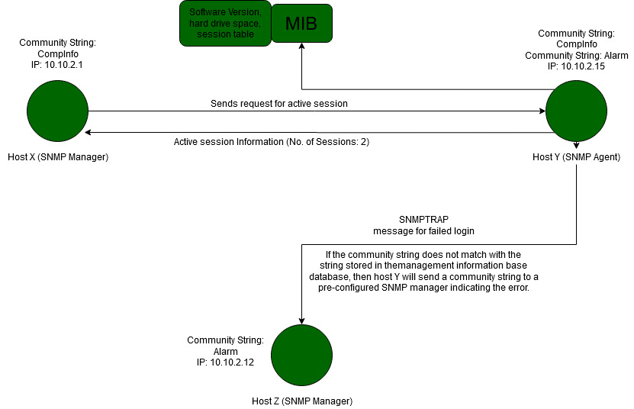
- SNMP Enumeration tools are utilized to examine a solitary IP address or a scope of IP addresses of SNMP empowered organization gadgets to screen, analyse, and investigate security dangers. Instances of this sort of instruments incorporate Net Scan Tolls Pro, Soft Perfect Network Scanner, SNMP Informant, and so forth
3. LDAP Enumeration:
- Lightweight Directory Access Protocol is an Internet Protocol for getting to dispersed registry administrations.
- Registry administrations may give any coordinated arrangement of records, regularly in a hierarchical and sensible structure, for example, a corporate email index.
- A customer starts an LDAP meeting by associating with a Directory System Agent on TCP port 389 and afterward sends an activity solicitation to the DSA.
- Data is sent between the customer and the worker utilizing Basic Encoding Rules.
- Programmer inquiries LDAP administration to assemble information such as substantial usernames, addresses, division subtleties, and so on that can be additionally used to perform assaults.
- There are numerous LDAP enumeration apparatuses that entrance the registry postings inside Active Directory or other catalogue administrations. Utilizing these devices, assailants can identify data, for example, substantial usernames, addresses, division subtleties, and so forth from various LDAP workers.
- Examples of these kinds of tools include LDAP Admin Tool, Active Directory Explorer, LDAP Admin, etc.
4. NTP Enumeration:
- Network Time Protocol is intended to synchronize clocks of arranged PCs.
- It utilizes UDP port 123 as its essential method for correspondence.
- NTP can check time to inside 10 milliseconds (1/100 seconds) over the public web.
- It can accomplish correctness of 200 microseconds or better in a neighbourhood under ideal conditions.
- Executives regularly disregard the NTP worker regarding security. Be that as it may, whenever questioned appropriately, it can give important organization data to the programmers.
- Hackers’ inquiries NTP workers to assemble significant data, for example, a list of hosts associated with NTP workers, Clients’ IP addresses in an organization, their framework names and Oss, and Internal IPs can likewise be gotten if NTP worker is in the demilitarized zone.
- NTP enumeration tools are utilized to screen the working of SNTP and NTP workers present in the organization and furthermore help in the configuration and confirmation of availability from the time customer to the NTP workers.
5. SMTP Enumeration:
- Mail frameworks ordinarily use SMTP with POP3 and IMAP that empowers clients to spare the messages in the worker letter drop and download them once in a while from the mainframe.
- SMTP utilizes Mail Exchange (MX) workers to coordinate the mail through DNS. It runs on TCP port 25.
- SMTP provides 3 built-in commands: VRFY, EXPN, RCPT TO.
- These servers respond differently to the commands for valid and invalid users from which we can determine valid users on SMTP servers.
- Hackers can legitimately associate with SMTP through telnet brief and gather a rundown of substantial clients on the mainframe.
- Hackers can perform SMTP enumeration using command-line utilities such as telnet, netcat, etc., or by using tools such as Metasploit, Nmap, Net Scan Tools Pro, etc.
6. DNS Enumeration using Zone Transfer:
- It is a cycle for finding the DNS worker and the records of an objective organization.
- A hacker can accumulate significant organization data, for example, DNS worker names, hostname, machine names, usernames, IPs, and so forth of the objectives.
- In DNS Zone Transfer enumeration, a hacker tries to retrieve a copy of the entire zone file for a domain from the DNS server.
- In order to execute a zone transfer, the hacker sends a zone transfer request to the DNS server pretending to be a client; the DNS then sends a portion of its database as a zone to you. This zone may contain a ton of data about the DNS zone organization.
7. IPsec Enumeration:
- IPsec utilizes ESP (Encapsulation Security Payload), AH (Authentication Header), and IKE (Internet Key Exchange) to make sure about the correspondence between virtual private organization (VPN) end focuses.
- Most IPsec-based VPNs use the Internet Security Association and Key Management Protocol, a piece of IKE, to establish, arrange, alter, and erase Security Associations and cryptographic keys in a VPN climate.
- A straightforward checking for ISAKMP at the UDP port 500 can demonstrate the presence of a VPN passage.
- Hackers can research further utilizing an apparatus, for example, IKE-output to identify the delicate information including encryption and hashing calculation, authentication type, key conveyance calculation, and so forth.

KT0503 Enumeration countermeasures
Enumeration Countermeasures
- SNMP:
  - Remove the SNMP agent or turn off the SNMP service
  - If shutting off SNMP is not an option, then change the default community string name
  - Upgrade to SNMP3, which encrypts passwords and messages
  - Implement the Group Policy security option called "Additional restrictions for anonymous connections"
  - Ensure that the access to null session pipes, null session shares, and IPSec filtering is restricted.
- DNS:
  - Disable the DNS zone transfers to the untrusted hosts
  - Make sure that the private hosts and their IP addresses are not published into DNS zone files of public DNS server
  - Use premium DNS registration services that hide sensitive information such as HINFO from public
  - Use standard network admin contacts for DNS registrations in order to avoid social engineering attacks
- SMTP: Configure SMTP servers to:
  - Ignore email messages to unknown recipients
  - Not include sensitive mail server and local host information in mail responses
  - Disable open relay feature
- LDAP:
  - By default, LDAP traffic is transmitted unsecured; use SSL technology to encrypt the traffic
  - Select a user name different from your email address and enable account lockout
- SMB:
  - Disable SMB protocol on Web and DNS Servers
  - Disable SMB protocol on Internet facing servers
  - Disable ports TCP 139 and TCP 445 used by the SMB protocol
  - Restrict anonymous access through RestrictNullSessAccess parameter from the Windows Registry

KT0504 Enumeration methodologies, techniques and tools
Techniques for Enumeration
- Extracting user names using email ID's
- Extract information using the default password
- Brute Force Active Directory
- Extract user names using SNMP
- Extract user groups from Windows
- Extract information using DNS Zone transfer

Services and Port to Enumerate
- TCP 53: DNS Zone transfer
- TCP 135: Microsoft RPC Endpoint Mapper
- TCP 137: NetBIOS Name Service
- TCP 139: NetBIOS session Service (SMB over NetBIOS)
- TCP 445: SMB over TCP (Direct Host)
- UDP 161: SNMP
- TCP/UDP 389: LDAP
- TCP/UDP 3368: Global Catalog Service
- TCP 25: Simple Mail Transfer Protocol (SMTP)

KT0505 Enumeration pen testing
What is penetration testing?
Penetration testing or Ethical hacking is a simulation of cyber-attacks to a computer system or application or infrastructure to detect vulnerabilities, if any. Penetration testing provides great insights on the list of vulnerabilities which we can categorize and rank as high, medium and low. We fix these vulnerabilities depending on the business requirement and timelines.
Let us understand the various phases of penetration testing
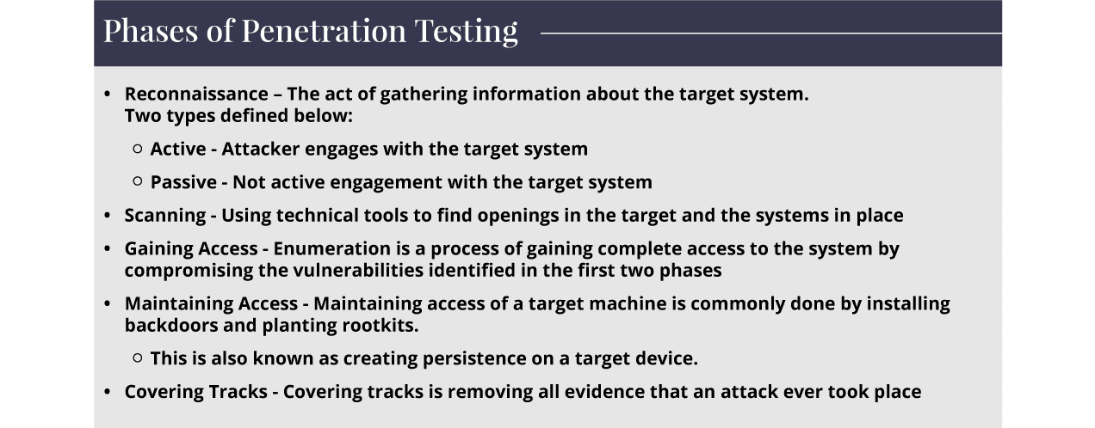
Description of Enumeration
Enumeration is the phase 3 of the Penetration Testing or Ethical Hacking. It is a process of gaining complete access to the system by compromising the vulnerabilities identified in the first two phases. The Scanning stage only helps to identify the vulnerabilities to a certain extent, but Enumeration helps us learn the complete details such as users, groups and even system level details – routing tables. This phase of the Ethical hacking is to gain end-to-end knowledge of what will be tested in the target environment. Tools are deployed to gain complete control over the system.
Significance of Enumeration
Enumeration is the most critical aspect of Ethical hacking. The metrics, outcomes, results are used directly in testing the system in the next steps of penetration testing. Enumeration helps us to decipher the detailed information – Hostnames, IP tables, SNMP and DNS, Application, Banners, Audit configurations and service settings. The significance of Enumeration is that it systematically collects details. This allows pentesters to completely examine the systems. The pentesters collect information about the weak links during the enumeration phase of ethical hacking.
Enumeration helps in finding the attack Vectors and threats.
Enumeration Classification
We can perform enumeration on the following:
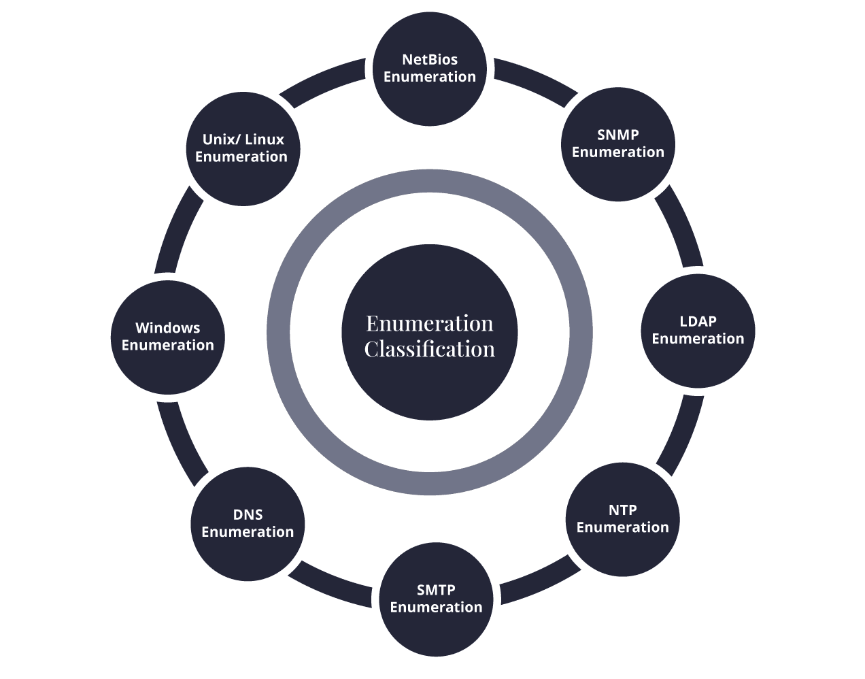

Enumeration and its types – Tool box
Enumeration as a process extracts the user names, machine names, network resources, shares and services from the ecosystem. There is a robust toolbox that helps the enumeration process become scalable. This is a mix of software and hardware systems. There are free and commercial software tools for the enumeration. The hardware tools are mainly the key loggers and special wireless hardware. The pentesters find the right and optimum way to reach the various components of the systems.
Techniques for Enumeration
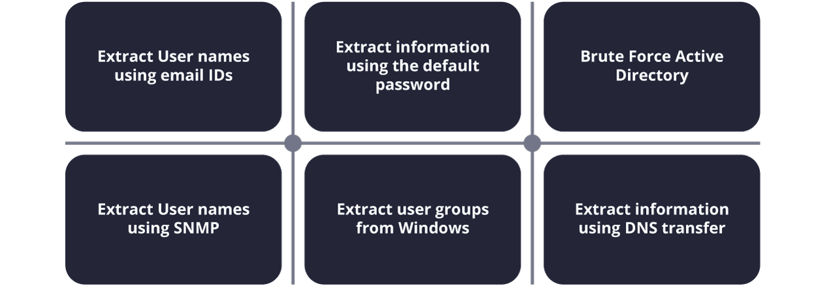

Types of information enumerated by intruders:
The types of the information enumerated by intruders are the following:
- Network source
- Users and groups
- Routing tables
- Audit settings
- Service configuration settings
- The various machine names
- Applications
- Banners
- SNMP details
- DNS details

Internal Assessment Criteria and Weight
- IAC0501Risks and mitigation of Enumeration are interrogated

KM-03-KT06: Vulnerability Analysis
Topic elements to be covered include:
- KT0601Vulnerability analysis concepts and objectives
- KT0602Vulnerability assessment solutions
- KT0603Vulnerability scoring systems
- KT0604Vulnerability assessment tools
- KT0605Vulnerability assessment reports

KT0601 Vulnerability analysis concepts and objectives

What is Vulnerability Analysis, and How Does It Work?
Did you know that 60% of all data breaches were made possible by unpatched vulnerabilities (Willis, V. 2019)? That staggering figure shows why a vulnerability assessment is critical to any cybersecurity strategy.
There is no denying that every system has vulnerabilities. Detecting them quickly is key to properly identifying, prioritizing, and mitigating them. However, as organizational architecture grows more complex, it’s difficult to fully understand it without utilizing a systematic vulnerability analysis.
Read on to learn why vulnerability analysis is important and how it can be utilized to help your organization overcome its cybersecurity risks.
What Is Vulnerability Assessment?
The purpose of vulnerability analysis, or vulnerability assessment, is to create a structured process for discovering vulnerabilities in a system, prioritizing them, and creating a mitigation strategy. Cybersecurity professionals often use vulnerability analysis alongside other detection methods, such as penetration testing, to better understand an organization’s system and its most significant risks.
Since there are multiple uses of vulnerability analysis, there are many different types of assessments to choose from ;
- Application assessments to determine vulnerabilities within the web applications your organization uses.
- Network assessments that require a review of your procedures and policies to protect you against unauthorized access.
- Database assessments to discover configuration issues, unprotected data, and other vulnerabilities within your infrastructure.
- Host assessments to reveal vulnerabilities of your critical servers that could impact operations and security if not properly tested and protected.
Most organizations need to run a combination of these assessments regularly. As with most cybersecurity practices, you need to invest time into vulnerability assessments on a routine basis and adjust practices and policies accordingly as an organization’s architecture and cyberthreats evolve.
Vulnerability Assessment Checklist
Even if you’ve conducted vulnerability assessments in the past, staying up to date on the best practices of vulnerability assessment methodology helps you get the most out of the process. As such, here’s a checklist to follow that ensures an assessment is thorough, efficient, and productive (New York State Department of Health, 2022):
- Define desirable business outcomes in advance: Some organizations make certain processes, such as pen tests and vulnerability assessments, mandatory and routine. That is okay, but desirable outcomes need to be defined before every assessment, or it may not be as productive or impactful as a team hopes. Prioritizing risks, achieving compliance, preventing data breaches, or reducing recovery time are all reasonable goals.
- Prioritize before you assess: While a vulnerability assessment can help you prioritize risks, you must also prioritize your assets before moving forward. Conducting a thorough assessment can be an exhaustive process, especially for the first time, so you must first assess the most important components. This also means understanding the different types of assessments you can conduct and how to best structure them before you dive in.
- Prepare for your assessment: Rarely is a vulnerability assessment run with the click of a button. Technical preparation involves conducting meetings, constructing a threat model, interviewing your system developers, and verifying the details of your test environment. Both passive and active vulnerability testing is valuable but knowing when and where to use each VA testing method is essential for success. In addition to knowing your testing options, you need to understand the environment you’re working in and the biggest risks you must prioritize, explore, and mitigate.
- Review as you go: During the test, you must manually check your results to filter out false positives and prioritize true positives. It would help if you also recorded the steps taken and collected evidence to ensure that the process for getting a given result is fully understood and repeatable, as you’ll need to explore it more closely later.
- Create detailed reports after each assessment: A vulnerability assessment is only as valuable as the knowledge it provides, so creating a comprehensive account alongside each assessment is critical to ensuring information is remembered, shared, and used to take action. A complete description of all vulnerabilities, associated risk levels, mitigation steps, and remedies should be compiled.
- Invest in continued education and training: Aside from continuing your education through certification programs, retaining the results and reports of each vulnerability assessment you conduct proves valuable for teaching yourself and others how to better prevent and respond to incidents that may occur in the future. Detailed reports are also helpful in communicating issues to non-technical stakeholders, such as those in the C-suite who need to be aware of significant risks and strategies for dealing with them.
If you stick to these best practices the next time you plan a vulnerability assessment, you’re sure to get a lot more out of the process. Of course, getting to the point where you’re confident enough to conduct a vulnerability assessment takes knowledge and hands-on practice, which is why pursuing further education can help prepare you.

KT0602 Vulnerability assessment solutions
What Is Vulnerability Assessment?

Vulnerability assessment—also called vulnerability analysis—is a process that identifies, quantifies and analyses security weaknesses in IT infrastructure. The VA’s primary goal is to unearth any vulnerabilities that can compromise the organization’s overall security and operations. As such, the VA can help you minimize the probability of threats.
Many security professionals use the terms “vulnerability assessment” and “penetration testing” interchangeably, even though they don’t mean the same thing. While VA finds and measures the severity of a system’s weaknesses, penetration testing is a goal-oriented exercise. In other words, penetration testing focuses more on simulating real-life attacks by mapping out paths that a real attacker can take to breach defenses.
The Importance of Vulnerability Assessment
Vulnerability assessment is no longer just a nice-to-have resource in an organization. Depending on the organization’s type, you can be obliged to undertake regular VAs to remain compliant. Over the years, various compliance regulations have emerged to address ever-evolving security challenges.
Compliance with General Data Protection Regulations (GDPRs), the Payment Card Industry Data Security Standard (PCI DSS) and the Health Insurance Portability and Accountability Act (HIPAA) are such examples. These standards require organizations to undertake VAs regularly to ensure they are safeguarding customers’ sensitive data. A vulnerability assessment is a holistic security process that includes different tasks, such as:
- Conducting security control checks.
- Analysing routers and Wi-Fi networks for password hacks.
- Reviewing network strength against attacks such as network intrusions, distributed denial of service (DDoS) and man-in-the-middle (MITM) attacks.
- Scanning network ports for known and potential vulnerabilities and threats.
A vulnerability assessment outcome is a VA report, which serves as an organization’s security policy and other security products. To undertake a VA, you need to use a combination of tools such as vulnerability scanning tools and technical judgment. Once completed, the VA recommends actions that can help mitigate the identified risks.
The Types of Vulnerability Scans
You can classify vulnerability scans based on the:
- Type of assets they can scan.
- Origin of the scan.
- Security posture of the network.
Let’s look at these classifications in detail.
Type of Assets Vulnerability Assessments can scan
The five categories of vulnerability scans are based on the kind of digital assets they can scan. They are network-based scanners, host-based scanners, application scanners, wireless network scanners, and database scanners.
- Network-based scanners. You can use network-based scanners to discover unauthorized devices or unknown users on the network. These scanners allow network administrators to determine whether obscure perimeter loopholes such as unauthorized remote access exist on the network. Network-based scanners do not have direct access to the file system. As such, they cannot undertake low-level security checks.
- Host-based scanners. As the name suggests, a host-based scanner resides on every host on the monitored network. It locates and identifies vulnerabilities on workstations, servers or other network hosts, providing greater visibility in your assets’ configuration settings.
- Application scanners. Application scanners find vulnerabilities in websites. Their operation mode is similar to those of search engines—they “crawl” through websites by sending a range of probes to each web page on a website to look out for weaknesses.
- Wireless network scanners. Wireless network scanners—also called wireless protocol analysers—are tools that you can use to discover open wireless networks in your environment. Organizations that prohibit wireless networks can use these wireless network scanners to detect any unauthorized Wi-Fi networks.
- Database scanners. You can use database scanners to identify the vulnerabilities in your database. Database scanners can help you thwart malicious hacks like SQL injection attacks.
The Origin of the scan
There are two types of vulnerability scans under this category: external and internal scanners.
- External vulnerability scanners. With external scanners, you conduct vulnerability scanning from outside of the company’s network. External scanners usually target the IT infrastructure exposed to the internet, including open ports in the network firewall and web application firewalls.
- Internal vulnerability scanners. Unlike external scanners, internal scanners conduct vulnerability scanning from inside of the enterprise network. These scans allow you to protect and harden critical applications by detecting internal threats, such as malware, that have penetrated the network.
The Security Posture of the Network
Authenticated and non-authenticated vulnerability scanning are the main types of vulnerability scans under this category.
- Authenticated vulnerability scanning. Authenticated scanning—also called credentialed scanning—allows the network administrator to log in as a user and identify the network’s weaknesses from a trusted user viewpoint. Since you have logged in the system, you can dig deeper into the network to unearth numerous threats.
- Unauthenticated vulnerability scanning. With unauthenticated scanning, you don’t need to log in to a network to perform scanning. While you can gain an outsider’s view of the network, you will likely miss out on most vulnerabilities when you use unauthenticated scanning.

KT0603 Vulnerability scoring systems
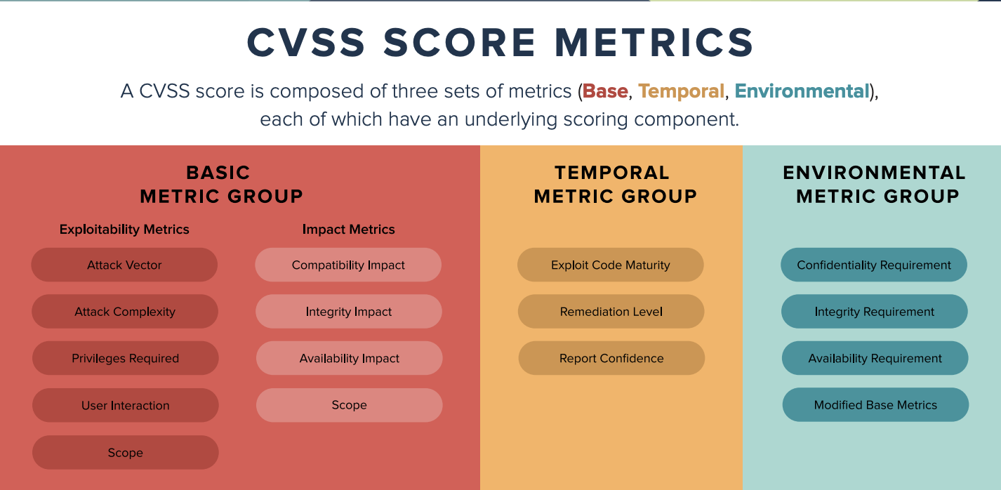
The Common Vulnerability Scoring System (CVSS) is used to rate the severity and risk of computer system security.
CVSS is an open framework that consists of the following metric groups:
- Base
- Temporal
- Environmental
Base
The base score severity range is 0 - 10 and represents the inherent characteristics of the vulnerability. The base score has the largest bearing on the final CVSS score, and can be further divided into the following sub scores:
- Impact
The impact sub score represents metrics for confidentiality impact, integrity impact, and the availability impact of a successfully exploited vulnerability.
- Exploitability
In CVSS v2, the exploitability sub score represents metrics for Access Vector, Access Complexity, and Authentication. The sub score measures how the vulnerability is accessed, the complexity of the attack, and the number of times an attacker must authenticate to successfully exploit a vulnerability.
In CVSS v3, the exploitability sub score represents metrics for Attack Vector, Attack Complexity, Privileges Required, User Interaction, and Scope. The sub score measures how the vulnerability is accessed, the complexity of the attack, any required privileges, the interaction needed between the attacker and another user, and the impact on resources beyond the vulnerable component.
Temporal
The temporal score represents the characteristics of a vulnerability threat that change over time, and consists of the following metrics:
- Exploitability (CVSS v2) or Exploit Code Maturity (CVSS v3)
The availability of techniques or code that can be used to exploit the vulnerability, which changes over time.
- Remediation Level
The level of remediation that is available for a vulnerability.
- Report Confidence
The level of confidence in the existence of the vulnerability and the credibility of its technical details.
Environmental
The environmental score represents characteristics of the vulnerability that are impacted by the user's environment. Configure the following environmental metrics to highlight the vulnerabilities of important or critical assets by applying higher environmental metrics. Apply the highest scores to the most important assets because losses that are associated with these assets have greater consequences for the organization.
- Collateral Damage Potential (CDP) (CVSS v2 only)
The potential for loss of life or physical assets through the damage or theft of this asset, or the economic loss of productivity or revenue.
- Target Distribution (TD) (CVSS v2 only)
The proportion of vulnerable systems in your user's environment.
- Confidentiality Requirement (CR)
The level of impact to the loss of confidentiality when a vulnerability is exploited on this asset.
- Integrity Requirement (IR)
This metric indicates the level of impact to the loss of integrity when a vulnerability is successfully exploited on this asset.
- Availability Requirement (AR)
The level of impact to the asset's availability when a vulnerability is successfully exploited on this asset.

KT0604 Vulnerability assessment tools
Conducting a vulnerability analysis is rarely fully automated, but it’s not completely manual. In most cases, while there will be some hands-on input from a security professional, you’ll also be leveraging various tools to discover vulnerabilities and learn more about them (University of North Dakota, 2022).
Some of the most common vulnerability analysis tools include:
- OpenVAS for All Systems: OpenVAS is one of the most far-reaching scanning tools as it covers not only web apps and web servers but also your network, operating systems, virtual machines, and databases. When vulnerabilities are discovered, the risk assessments and recommendations will help you decide what to do next.
- SolarWinds for Network Errors: SolarWinds offers a network configuration manager that allows vulnerability testing in areas many other tools don’t cover. By revealing misconfigured equipment on your network, SolarWinds can help you discover missing information about your system and the risks it is exposed to.
- Intruder for Cloud Storage: While Intruder is not free, it is a powerful tool for scanning cloud-based storage systems, and the best part is that it monitors constantly and scans automatically, ensuring vulnerabilities are detected as quickly as possible. It also offers recommendations and quality reports to guide your strategy.
- Nikto2 for Web Apps: If you’re looking for an open-source tool to help you scan web applications, Nikto2 is capable software that can alert you to web server vulnerabilities. The downside is that it does not offer any risk assessment features or recommendations, so you’ll have to decide what to do with the vulnerabilities that are found.
- Nexpose for New Vulnerabilities: Nexpose is another open-source tool that’s completely free to use to scan your web apps, devices, and networks. Plus, since it’s updated with the newest vulnerabilities every day via its active community, you can trust Nexpose to provide a reliable scanning solution. The tool also categorizes vulnerabilities based on risk, allowing you to focus on the most pressing issues.
In your work as a cybersecurity professional, you’ll likely come across all of these tools already being used by an organization or your colleagues. Of course, the list doesn’t stop here—there are dozens of other tools in the market like those listed above and finding the right one for your use case means spending some time familiarizing yourself with them.

KT0605 Vulnerability assessment reports

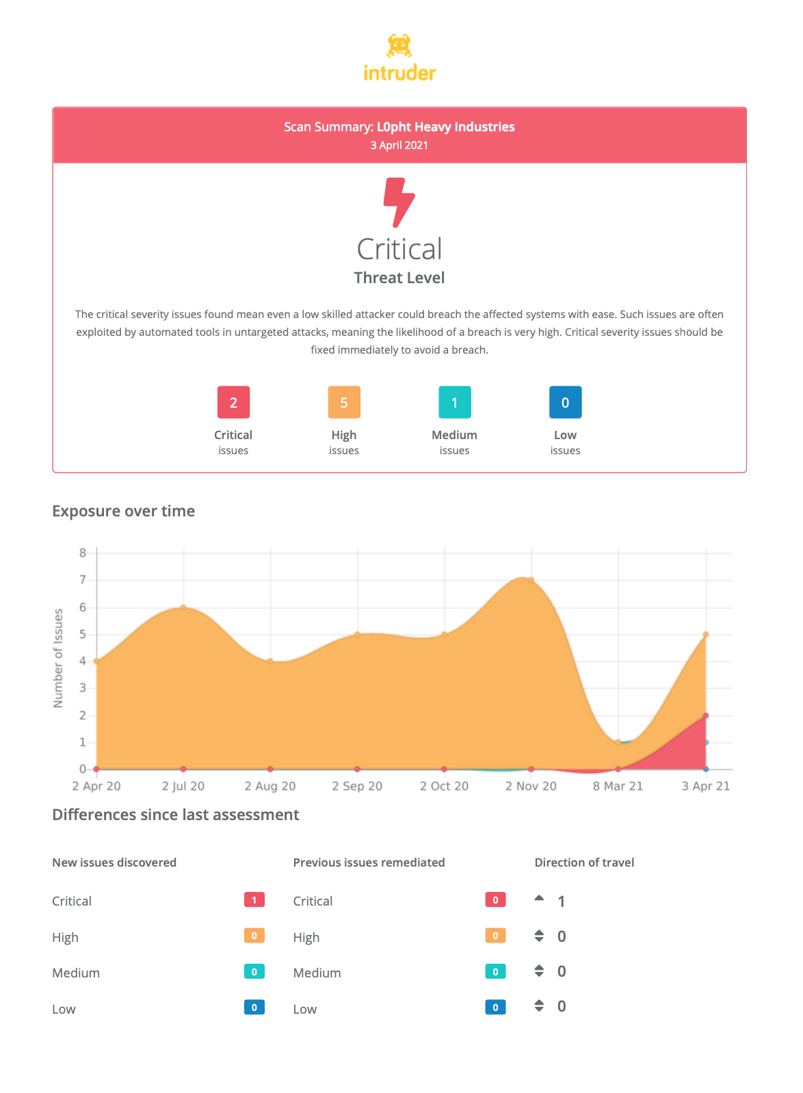

Reporting is the most important part of the vulnerability assessment process. A vulnerability assessment aims to help the customer understand what potential vulnerabilities potentially exist within their environment and how to address these issues. Even the best vulnerability assessment is of little or no use if the customer can’t understand the results and use them to correct the identity’s weaknesses.
Despite its importance, reporting is often the least-liked part of the vulnerability assessment process. However, to provide high-quality vulnerability assessment services and get repeat business from customers, you need to know how to write a good vulnerability report.

What should a vulnerability report include?
A vulnerability report has several potential audiences that all have different needs and levels of technical knowledge. A good vulnerability report should address all of these needs and should contain several key sections, including:
- Executive summary: the executive summary provides a high-level overview of the assessment for non-technical executives. The goal of this summary should be to help executives gauge their current security posture and highlight any critical issues that might impact corporate cybersecurity or regulatory compliance.
- Overview: the overview section should be geared towards a more technical audience but still provide a high-level assessment summary. For example, it can contain information about the systems scanned, tools used, and the number and severity of discovered vulnerabilities.
- Details: This report section should provide in-depth technical detail about how the vulnerability assessment was performed. This section should build on the overview by describing the exact steps performed at each assessment stage and their results. A reader should be able to replicate the assessment findings from this section.
- Findings: this section of the report provides more details about the assessment findings. Vulnerabilities may be ranked by severity to draw attention to the biggest issues within an organization’s environment. For each potential vulnerability checked, this section should describe the result, affected system(s), severity level, and provide a link to additional information such as a CVE.
- Recommended mitigations: the goal of a vulnerability assessment is to help an organization move towards a better security posture, so providing recommended mitigations can be helpful. In many cases, this can be as simple as recommending an update to the software, a stronger password on a system, or a change to an insecure security setting.
A vulnerability report should contain this key information, including other sections or organizing it differently. Some organizations, such as PurpleSec and PivotPoint Security, have published sample vulnerability reports that show how the results from their assessments are structured within a report.

Internal Assessment Criteria and Weight
- IAC0601Risks and mitigation of vulnerability analysis concepts and objectives are interrogated

KM-03-KT07: System Hacking
Topic elements to be covered include:
- KT0701System hacking concepts
- KT0702Passwords, privileges, applications
- KT0703Covering tracks
- KT0704Penetration testing
- KT0705Human precautions against hacking

KT0701 System hacking concepts
System hacking is the process of exploiting vulnerabilities in electronic systems for the purpose of gaining unauthorized access to those systems. Hackers use a variety of techniques and methods to access electronic systems, including phishing, social engineering, and password guessing.
Purpose of System Hacking:
Generally, the motive of the hackers behind System Hacking is gaining access to the personal data of an individual or sensitive information belonging to an organization in order to misuse the information and leak it which may cause a negative image of the organization in the minds of people, Privilege Escalation, executing malicious applications to constantly monitor the system.
How this is carried out?
This type of hacking is generally done by a Hacker who has a lot of information regarding the System security, network, software, and how the system communicates with others in the network, often called Foot printing and Reconnaissance. Then these hackers try numerous ways to carry out the attack but the common ways are:
- By deploying Viruses, Worms, Malware, Trojans
- Using phishing techniques
- Social Engineering
- Identifying and exploiting Vulnerability
Steps:
1. Reconnaissance: The first step in this type of Hacking is collecting information regarding the System’s infrastructure, working, system’s network. This step is very important as after this step the Hacker knows what attack to perform and how to gain access without leaving a trace.
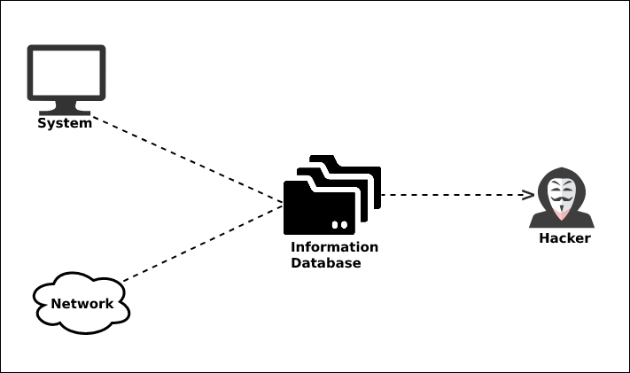

2. Scanning: This step involves scanning the target System, which includes:
- Vulnerability Scanning: Checking vulnerabilities in the targeted system that can be exploited to gain access.
- Mapping of Network: Finding the working of the network, firewalls, routers, and systems connected to it.
- Port Scanning: Scanning the open ports, and services running over the System/Server.
3. Gaining Access: This is the phase in which the hacker breaks into the system and gains unauthorized access to the System/Network and then elevates his privileges to that of Administrator or Super User so he can play with the System files that a normal/Guest user is unable to access.
4. Maintaining the Access: After the Hacker enters the System he tries to maintain the connection with it in the background until he accomplishes the goal with which he entered it.
Prevention from Hacking:
- Using Firewall.
- Installing Anti-Virus and Anti-Spyware packages.
- Keeping the system up-to-date as security patches updates comes regularly.
- Be Aware of various phishing techniques.

KT0702 Passwords, privileges, applications
Executing Applications
Intruder executes malicious applications after gaining administrative privileges so they can run malicious programs remotely, to capture all sensitive data, crack passwords, capture screenshots or to install a backdoor.
Tool: Remote Exec, PDQ Deploy, Dame Ware NT Utilities
Keylogger
keystroke loggers are programs or hardware devices that monitor each keystroke a user types on a keyboard, logs onto a file, or transmits them to a remote location.
keyloggers are placed between the keyboard hardware and the OS
A key logger can
- Record each keystroke
- capture screenshots at regular intervals of time showing user activity such as when he or she types a character or click a mouse button
- Track the activities of users by logging window titles, names of launched applications and other information
- monitor online activity of users by recording addresses of the websites that they are have visited and with the keywords entered by them
- record all the login names, bank and credit card numbers and passwords including hidden passwords or data that are in asterisk or blank spaces
- record online chat conversion
Types of Keylogger
- Hardware Keylogger
- Software Keylogger
Spyware
Spyware is stealthy computer monitoring software that allows you to secretly record all activities of a computer user.

Privilege escalation is the process by which a user with limited access to IT systems can increase the scope and scale of their access permissions. For trusted users, privilege escalation allows expanded access for a limited time to complete specific tasks. For example, users may need access to troubleshoot a technical problem, run a quarterly financial report, or install a program.
Privilege escalation is also one of the most common techniques attackers use to discover and exfiltrate sensitive valuable data. From a hacker’s perspective, privilege escalation is the art of increasing privileges from initial access, which is typically that of a standard user or application account, all the way up to administrator, root, or even full system access. With NT Authority\System access, attackers have full access to one system. With Domain Administrator access, they own the entire network.
An attacker may employ a variety of strategies to escalate privileges
Let’s say an attacker successfully steals a User’s password and gains access to their account. That password may enable certain privileges, for example, it may only unlock data stored locally on a laptop. But an attacker is hungry for more. They’re looking for more sensitive data they can resell on the Dark Web. They’re looking for access to business-critical systems so they can deploy ransomware, threaten shutdown, and demand financial payment.
To achieve those goals, an attacker employs a variety of strategies to escalate privileges:
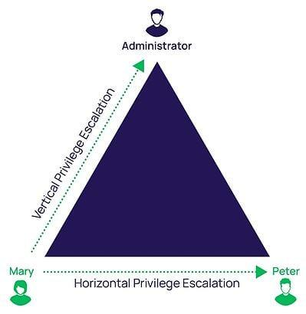
- Vertical privilege escalation, sometimes referred to as privilege elevation, is when an attacker compromises a user account that has limited permissions on a system. They then look for ways to increase their privileges using the same account. For example, they might add the compromised account to the local administrator group.
- Horizontal privilege escalation, the more common method, is when an attacker gains access to another credential on the network with higher privileges than the initial one used to gain their foothold. With higher-level privileges, an attacker can move freely around the network without detection.
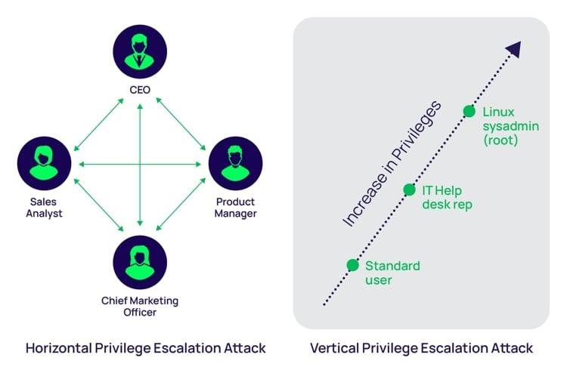
Examples illustrating the difference between vertical and horizontal privilege escalation
In this blog, you’ll learn how an attacker escalates privileges on Windows systems using a step-by-step process. By viewing privilege escalation through the lens of a hacker you’ll see how attackers exploit security vulnerabilities to achieve their goals. And, you’ll identify opportunities to increase Windows privilege management to reduce your risk of a cyberattack.

KT0703 Covering tracks
Covering Tracks
- Once intruders have successfully gained administrator access on a system, they will try to cover the tracks to avoid their detection.
- Attacker uses following techniques to cover tracks on the target system:
  - Disable auditing
  - Clearing logs
  - Manipulating logs
Disabling Auditing: Auditpol
- Intruders will disable auditing immediately after gaining administrator privileges.
- At the end of their stay, the intruders will just turn on auditing again using auditpol.exe.
Clearing Logs
- Attacker uses clearlogs.exe utility to clear the security, system, and application logs.
- If the system is exploited with Metasploit, attacker uses meterpreter shell to wipe out all the logs from a Windows system.
Manually Clearing Event Logs
- Windows:
  - Navigate to Start > Control Panel > System and Security > Administrative Tools > double click Event Viewer.
  - Delete the all the log entries logged while compromising of the system.
- Linux:
  - Navigates to /var/log directory on the Linux system.
  - Open plain text file containing log messages with text editor /var/log/messages
  - Delete the all the log entries logged while compromising of the system.
Ways to Clear Online Tracks
- Remove Most Recently Used (MRU), delete cookies, clear cache, turn off AutoComplete, clear Toolbar data from the browsers.
- Privacy Settings in Windows 8.1:
  - Click on the Start button, choose Control Panel > Appearance and Personalization > Taskbar and Start Menu.
  - Click the Start Menu tab, and then, under Privacy, clear the Store and display recently opened items in the Start menu and the taskbar check box.
- From the Registry in Windows 8.1:
  - HKCU\Software\Microsoft\Windows\CurrentVersion\Explorer and then remove the key for "Recent Docs"
  - Delete all the values except "(Default)"
Covering Tracks Tools
- Cleaner:
  - Cleaner is system optimization and cleaning tool.
  - It cleans traces of temporary files, log files, registry files, memory dumps, and also your online activities such as your Internet history.
- MRU-Blaster:
  - MRU-Blaster is an application for Windows that allows you to clean the most recently used lists stored on your computer.
  - It allows you to clean out your temporary Internet files and cookies.

KT0704 Penetration testing
“Covering Tracks” is the final stage of a penetration test as a process – all the rest is paperwork. In a nutshell, its goal is to erase the digital signs left out by the pen tester during the earlier stages of the test. These digital signs, in essence, prove the pen tester’s presence in the targeted computer system.
Whereas in the phases previous to this one the pen tester successfully managed to avoid detection by firewalls and intrusion detection systems, the purpose of this phase is to cover up all the little clues that would give away the nature of his deeds. “Covering Tracks” consists of measures for the prevention of real-time detection (Anti-Incident Response), and measures for the prevention of digital evidence collection during a possible post factum inquiry (Anti-Forensics).
Diagram: “The Last 3 Phases of Penetration Testing with Focus on Covering Tracks.”
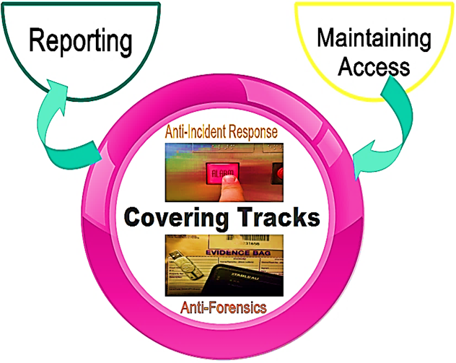
Anti-Incident Response
Its purpose is to confuse, out-manoeuvre and disrupt the incident response team at the targeted company. Moreover, anti-incident response activities ensure a pen tester would have the opportunity to gain a long-term foothold on the attacked network even if he has already been detected.
Some important components of a workable anti-incident response are:
- Secretly deploy backdoors
- Set up an agile lateral movement infrastructure
- The number of infected hosts should not be too large, and they should constantly be updated
- The more varied the malware on the network, the better
- Pick up the pace to prevent responders or investigators from keeping up with what is going on
- Busy servers offer the perfect cover for internal hop-points
- Busy file servers may be ideal for data staging areas
- Establishing a VPN for C2 communication may facilitate bypassing some network monitoring measures
- Camouflage the source of malware transmission
When it comes to how the anti-incident response usually works, the emphasis is placed on actions taken to prevent an immediate discovery of an ongoing, and mostly continuous, cyber-attack. On the other hand, due to steps taken by criminals or pen testers to damage the evidence and cause a digital investigation to die out in its infancy, anti-forensics hamper the ability of investigators (or their inability) to find enough digital evidence presentable before a court of law at a later stage. Therefore, anti-incident response activities have a sense of urgency because most of the action takes place on a live, running system in real time. Presumably, the counter-actions that incident responders are bound to take are much more time-constrained than those by investigators in a potential digital investigation later on.

KT0705 Human precautions against hacking
Where was the last public place you visited that had Wi-Fi? These days, nearly every coffee shop, library, airport and hotel offer a way to access the internet from your cell phone or other mobile device. That means the information you have on your phone could be available to hackers in the area – unless you’ve taken steps to protect your data.
Don’t access personal or financial data with public Wi-Fi.
This may seem like a no-brainer, but you’d be surprised how many people check their bank accounts or make purchases with a credit card while using public Wi-Fi. It’s best to do those things on a secure connection.

Turn off anything you don’t need.
Hackers can use certain features on your phone to get at your information, location or connection. So, instead of keeping your GPS, wireless connection and geo-tracking on all the time, just turn them on when you need them.

Choose your apps wisely.
Only download apps from trustworthy sources that have established a good reputation. Make sure you update your software and apps regularly and get rid of old apps you don’t use.

Use a password, lock code, or encryption.
Make sure your passwords are at least eight characters long, with a mix of upper and lower case, and include numbers or other characters, and never use the auto-complete feature for passwords. You can use the storage encryption feature on your phone to protect your private

Be sceptical about links and attachments.
If you’re not sure about the source, don’t use the link or open the attachment.

Trace or erase.
Make sure your data is secure if your mobile device is stolen or lost. You can set up your device to lock itself after a pre-set number of failed log-in attempts.

Internal Assessment Criteria and Weight
- IAC0701Risks and mitigation of system hacking are interrogated

KM-03-KT08: Malware Threats
Topic elements to be covered include:
- KT0801Malware concepts and objectives
- KT0802Malware types
- KT0803Malware analysis
- KT0804Countermeasures and anti-malware software
- KT0805Malware penetration testing

KT0801 Malware concepts and objectives
What is malware?
Malware, or malicious software, is any program or file that is intentionally harmful to a computer, network or server.
Types of malwares include computer viruses, worms, Trojan horses, ransomware and spyware. These malicious programs steal, encrypt and delete sensitive data; alter or hijack core computing functions and monitor end users' computer activity.
What does malware do?
Malware can infect networks and devices and is designed to harm those devices, networks and/or their users in some way.
Depending on the type of malware and its goal, this harm may present itself differently to the user or endpoint. In some cases, the effect malware has is relatively mild and benign, and in others, it can be disastrous.
No matter the method, all types of malwares are designed to exploit devices at the expense of the user and to the benefit of the hacker -- the person who has designed and/or deployed the malware.
How do malware infections happen?
Malware authors use a variety of physical and virtual means to spread malware that infects devices and networks. For example, malicious programs can be delivered to a system with a USB drive, through popular collaboration tools and by drive-by downloads, which automatically download malicious programs to systems without the user's approval or knowledge.
Phishing attacks are another common type of malware delivery where emails disguised as legitimate messages contain malicious links or attachments that deliver the malware executable file to unsuspecting users. Sophisticated malware attacks often feature the use of a command-and-control server that enables threat actors to communicate with the infected systems, exfiltrate sensitive data and even remotely control the compromised device or server.
Emerging strains of malware include new evasion and obfuscation techniques designed to not only fool users, but also security administrators and antimalware products. Some of these evasion techniques rely on simple tactics, such as using web proxies to hide malicious traffic or source IP addresses. More sophisticated threats include polymorphic malware that can repeatedly change its underlying code to avoid detection from signature-based detection tools; anti-sandbox techniques that enable malware to detect when it is being analysed and to delay execution until after it leaves the sandbox; and fileless malware that resides only in the system's RAM to avoid being discovered.

KT0802 Malware types

Types of Malwares:
Malware is an inclusive term for all types of malicious software. Malware examples, malware attack definitions and methods for spreading malware include:
Adware – While some forms of adware may be considered legitimate, others make unauthorized access to computer systems and greatly disrupt users.
Botnets – Short for “robot network,” these are networks of infected computers under the control of single attacking parties using command-and-control servers. Botnets are highly versatile and adaptable, able to maintain resilience through redundant servers and by using infected computers to relay traffic. Botnets are often the armies behind today's distributed denial-of-service (DDoS) attacks.
Crypto jacking – is malicious crypto mining (the process of using computing power to verify transactions on a blockchain network and earning cryptocurrency for providing that service) that happens when cybercriminals hack into both business and personal computers, laptops, and mobile devices to install software.
Malvertising – Malvertising is a portmanteau of “malware + advertising” describing the practice of online advertising to spread malware. It typically involves injecting malicious code or malware-laden advertisements into legitimate online advertising networks and webpages.
Polymorphic malware – Any of the above types of malwares with the capacity to “morph” regularly, altering the appearance of the code while retaining the algorithm within. The alteration of the surface appearance of the software subverts detection via traditional virus signatures.
Ransomware – Is a criminal business model that uses malicious software to hold valuable files, data or information for ransom. Victims of a ransomware attack may have their operations severely degraded or shut down entirely.
Remote Administration Tools (RATs) – Software that allows a remote operator to control a system. These tools were originally built for legitimate use, but are now used by threat actors. RATs enable administrative control, allowing an attacker to do almost anything on an infected computer. They are difficult to detect, as they don’t typically show up in lists of running programs or tasks, and their actions are often mistaken for the actions of legitimate programs.
Rootkits – Programs that provide privileged (root-level) access to a computer. Rootkits vary and hide themselves in the operating system.
Spyware – Malware that collects information about the usage of the infected computer and communicates it back to the attacker. The term includes botnets, adware, backdoor behaviour, keyloggers, data theft and net-worms.
Trojans Malware – Malware disguised in what appears to be legitimate software. Once activated, malware Trojans will conduct whatever action they have been programmed to carry out. Unlike viruses and worms, Trojans do not replicate or reproduce through infection. “Trojan” alludes to the mythological story of Greek soldiers hidden inside a wooden horse that was given to the enemy city of Troy.
Virus Malware – Programs that copy themselves throughout a computer or network. Malware viruses piggyback on existing programs and can only be activated when a user opens the program. At their worst, viruses can corrupt or delete data, use the user’s email to spread, or erase everything on a hard disk.
Worm Malware – Self-replicating viruses that exploit security vulnerabilities to automatically spread themselves across computers and networks. Unlike many viruses, malware worms do not attach to existing programs or alter files. They typically go unnoticed until replication reaches a scale that consumes significant system resources or network bandwidth.

KT0803 Malware analysis
What is Malware Analysis?
Malware Analysis is the practice of determining and analysing suspicious files on endpoints and within networks using dynamic analysis, static analysis, or full reverse engineering.
What are the benefits of Malware Analysis?
A strong Malware Analysis practice aids in the analysis, detection, and mitigation of potential threats. Malware Analysis can help organizations identify malicious objects used in advanced, targeted, and zero-day attacks

Why is Malware Analysis Important?
Malware Analysis is important because it helps security operations teams rapidly detect and prevent malicious objects from gaining persistence and causing destruction within the organization.

Types of Malware Analysis
There are three main types of Malware Analysis:
Static Analysis examines the files for signs of malicious intent without executing the program. This form can also call for manual review by an IT professional after the initial examination to conduct further analysis as to how the malware interacts with the system. Static document analysis looks for abnormalities in the file itself, not in how it executes.
It seeks to answer questions such as the following:
- Are there structural anomalies such as embedded shellcode, abnormal macros, or other executable program that would not normally be present in a document of this type?
- Does the document have any missing or added segments?
- Are there any embedded files?
- Are there any encryption, fingerprinting, or other suspicious capabilities?
- Is there anything about the document that just looks odd?
Dynamic Analysis relies on a closed system (known as a sandbox), to launch the malicious program in a secure environment and simply watch to see what it does. The inspection environment simulates an entire host (including the CPU, system memory, and all devices) to continuously observe all the actions malicious objects can take. This automated system enables professionals to watch the malware in action without letting it infect their system. Dynamic analysis interacts with the malware to elicit every malicious behaviour supports automation, fast and accurate findings, and can support identifying and analysing the obscurities within an organization’s infrastructure
Reverse Engineering malware involves disassembling (and sometimes decompiling) a software program. Through this process, binary instructions are converted to code mnemonics (or higher-level constructs) so that engineers can look at what the program does and what systems it impacts. Only by knowing its details are engineers then able to create solutions that can mitigate the program’s intended malicious effects. A reverse engineer (aka “reverser”) will use a range of tools to find out how a program is propagating through a system and what it is engineered to do. And in doing so, the reverser would then know which vulnerabilities the program was intending to exploit

KT0804 Countermeasures and anti-malware software
Implementing Malicious Code Countermeasures
Because malware is so prevalent, it’s important to protect systems. The primary method of protection is antivirus software and an aggressive defense-in-depth strategy. As an overview, the following methods can be implemented as countermeasures against malware:
• Install antivirus software on all systems.
• Install antivirus and antispam software on e-mail servers.
• Install antivirus and content filter software on firewalls.
• Keep all antivirus software up to date.
• Keep all systems up to date.
• Educate users.

KT0805 Malware penetration testing

What Is Penetration Testing?
We can figure out the vulnerabilities of a computer system, a web application or a network through penetration testing.
A penetration test will tell whether the existing defensive measures employed on the system are strong enough to prevent any security breaches. Penetration test reports also suggest countermeasures which can be taken to reduce the risk of the system being hacked.
Causes of Vulnerability
- Design and Development Errors: There can be flaws in the design of hardware and software. These bugs can put your business-critical data at risk of exposure.
- Poor System Configuration: This is another cause of vulnerability. If the system is poorly configured, then it can introduce loopholes through which attackers can enter into the system & steal the information.
- Human errors: Human factors like improper disposal of documents, leaving the documents unattended, coding errors, insider threats, sharing passwords over phishing sites, etc. can lead to security breaches.
- Connectivity: If the system is connected to an unsecured network (open connections) then it comes within the reach of hackers.
- Complexity: The security vulnerability rises in proportion to the complexity of a system. The more features a system has, the more are the chances of the system being attacked.
- Password: Passwords are used to prevent unauthorized access. They should be strong enough that no one can guess your password. Passwords should not be shared with anyone at any cost and passwords should be changed periodically. In spite of these instructions, at times people reveal their passwords to others, write them down somewhere and keep easy passwords that can be guessed.
- User Input: You must have heard of SQL injection, buffer overflows, etc. The data received electronically through these methods can be used to attack the receiving system.
- Management: Security is hard & expensive to manage. Sometimes organizations lack behind in proper risk management and hence vulnerability gets induced in the system.
- Lack of training to staff: This leads to human errors and other vulnerabilities.
- Communication: Channels like mobile networks, internet, telephone opens up security theft scope.

Penetration Testing Tools and Companies
Automated tools can be used to identify some standard vulnerabilities present in an application. Pentest tools scan code to check if there is a malicious code present which can lead to a potential security breach.
Pentest tools can verify security loopholes present in the system by examining data encryption techniques and figuring out hard-coded values like usernames and passwords.
Criteria for selecting the best penetration tool:
- It should be easy to deploy, configure and use.
- It should scan your system easily.
- It should categorize vulnerabilities based on severity that need an immediate fix.
- It should be able to automate the verification of vulnerabilities.
- It should re-verify the exploits found previously.
- It should generate detailed vulnerability reports and logs.
Once you know what tests you need to perform you can either train your internal test resources or hire expert consultants to do the penetration task for you.

Internal Assessment Criteria and Weight
- IAC0801Risks and mitigation of malware are interrogated

KM-03-KT09: Sniffing
Topic elements to be covered include:
- KT0901Sniffing concepts and objectives
- KT0902Sniffing attacks
- KT0903Sniffing techniques
- KT0904Sniffing tools
- KT0905Countermeasures
- KT0906Detection techniques
- KT0907Sniffing pen testing

KT0901 Sniffing concepts and objectives
Sniffing is the process of monitoring and capturing all the packets passing through a given network using sniffing tools. It is a form of “tapping phone wires” and get to know about the conversation. It is also called wiretapping applied to the computer networks.
There is so much possibility that if a set of enterprise switch ports is open, then one of their employees can sniff the whole traffic of the network. Anyone in the same physical location can plug into the network using Ethernet cable or connect wirelessly to that network and sniff the total traffic.
In other words, Sniffing allows you to see all sorts of traffic, both protected and unprotected. In the right conditions and with the right protocols in place, an attacking party may be able to gather information that can be used for further attacks or to cause other issues for the network or system owner.
What can be sniffed?
One can sniff the following sensitive information from a network −
- Email traffic
- FTP passwords
- Web traffics
- Telnet passwords
- Router configuration
- Chat sessions
- DNS traffic
How it works
A sniffer normally turns the NIC of the system to the promiscuous mode so that it listens to all the data transmitted on its segment.
Promiscuous mode refers to the unique way of Ethernet hardware, in particular, network interface cards (NICs), that allows an NIC to receive all traffic on the network, even if it is not addressed to this NIC. By default, a NIC ignores all traffic that is not addressed to it, which is done by comparing the destination address of the Ethernet packet with the hardware address (a.k.a. MAC) of the device. While this makes perfect sense for networking, non-promiscuous mode makes it difficult to use network monitoring and analysis software for diagnosing connectivity issues or traffic accounting.
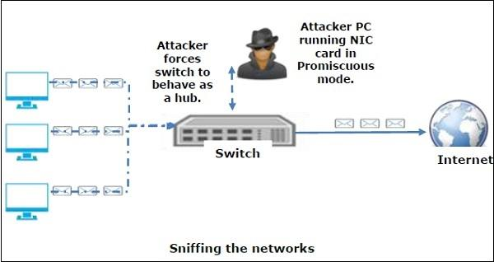
A sniffer can continuously monitor all the traffic to a computer through the NIC by decoding the information encapsulated in the data packets.

KT0902 Sniffing attacks
What Are Sniffing Attacks?
A sniffing attack occurs when an attacker uses a packet sniffer to intercept and read sensitive data passing through a network (Biasco, 2021). Common targets for these attacks include unencrypted email messages, login credentials, and financial information.
In some cases, attackers may also use sniffing attack tools and packet sniffers to inject malicious code into otherwise innocuous data packets in an attempt to hijack a target’s computer or other devices.
How Do Hackers Intercept Packets?
There are several ways an attacker can capture packets passing through a network. One popular method is to set up a packet sniffer on a computer connected to the network in question. This computer acts as a proxy between the targeted devices and the rest of the world, allowing the attacker to capture all traffic passing through.
Another common technique is ARP poisoning, in which the attacker tricks devices on the network into thinking they are communicating with another device when they are not (Grimmick, 2021). This allows the attacker to intercept and read all traffic passing between the two “devices.”
Types of Sniffing Attacks
There are two primary sniffing attack types: passive and active.
Passive Sniffing
In a passive sniffing attack, the hacker monitors traffic passing through a network without interfering in any way. This type of attack can be beneficial for gathering information about targets on a network and the types of data (e.g., login credentials, email messages) they are transmitting. Because it does not involve any interference with the target systems, it is also less likely to raise suspicion than other types of attacks.
Active Sniffing
Active sniffing is a type of attack that involves sending crafted packets to one or more targets on a network to extract sensitive data. By using specially crafted packets, attackers can often bypass security measures that would otherwise protect data from being intercepted. Active sniffing can also involve injecting malicious code into target systems that allows attackers to take control of them or steal sensitive information.

KT0903 Sniffing techniques

What is sniffing software used for?
When first created, sniffers were (and can still be) very helpful tools for engineers to manage their networks. Because they allow administrators to view all the traffic on a network, they can be used to diagnose issues and assess performance.
How do network admins use sniffing software? First, it’s important to understand how internet traffic generally works over a network. In most situations, your computer will only investigate packets that have been specifically addressed to it. Reaching back to the “cars driving on a road” metaphor, we can imagine your computer as a house along that road. You wouldn’t inspect every car that drives by your house, but if someone parks in your driveway, you’d likely open the door to see who it is. This is how your computer treats most packets of data: It ignores the ones going along the network to other destinations while inspecting the packets that are sent to it.
Sniffing software adjusts a computer’s network settings so that it “sniffs” every packet — instead of just those sent to it — and copies them all for later investigation. Rather than answering the door only when someone comes to visit, the sniffer is glued to the window, watching all the cars as they drive by.
Our window sniffer might obsessively monitor every car, or they might choose to investigate only trucks, or red cars, or cars with at least three occupants, or maybe just motorcycles. In other words, a person using a sniffer in unfiltered mode can harvest all the network’s traffic, or they can configure the sniffer to filter packets containing a specified type of data.
Legitimate uses for sniffing software
Skilled technicians place sniffers inside a network to tap into its traffic and track what’s being sent. You’ve probably seen at least one movie in which a crafty detective puts a tap on a suspect’s phone line, then listens in as they discuss all sorts of nasty business. Sniffers are essentially the same thing, but for the internet.
Here’s a short list of a people who might make use of a network sniffer:
- Network engineers: By analysing the type and level of traffic on a network, engineers can use the data to optimize their network’s structure for efficiency and speed.
- System admins: Network sniffers are amazing troubleshooting tools. Sysadmins can dive into bottlenecks or other slowdowns as they’re happening to examine the issue.
- Employers: IT technicians at a corporate office may use sniffers to monitor their employees while at work. Employers can learn about the websites their workers are visiting, how much time they spend there, and whether they’re viewing or downloading anything they shouldn’t be.
- Security professionals: Unusual traffic amounts or types can indicate that everything is not as it seems. Security teams can identify atypical internet usage patterns that may indicate the presence of a hacker or malware. Speaking of which.

Criminal uses for sniffing software
Network sniffers aren’t used only by the good guys. Cybercriminals can tap into a network and help themselves to all the traffic sent through it. By monitoring internet use, including emails and instant messages, a hacker may be able to access login credentials, insider information, and financial details. That’s why sniffers can be so dangerous in the wrong hands. And there are plenty of free sniffers available online — music to a cybercriminal’s ears.
Cybercriminals will use social engineering tricks or phishing scams to fool their victims into downloading their sniffers. They may steer targets to infected websites that automatically download the sniffer when visited, or send emails with attachments that can install the malicious software.
Alternatively, hackers can sniff unsecured public Wi-Fi networks, ensnaring the traffic of anyone who uses them. Wireless sniffers are especially popular in spoofing attacks, as the cybercriminal can use the data captured by the sniffer to “spoof” a device on the wireless network.
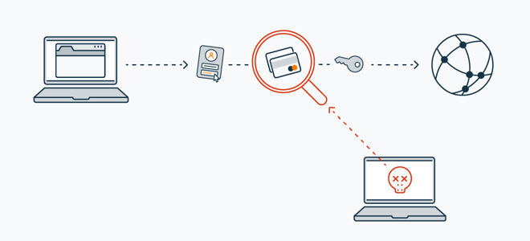
How does a sniffer work?
We’ve covered what sniffers can do, but how does a sniffer work? There are two main types of sniffing techniques: passive and active sniffing. The type of sniffing technique used depends on the structure of the network one is trying to sniff. Passive sniffing works with hubs, but if switches are involved, active sniffing is required.
What is passive sniffing?
Hubs are simple networking devices that connect several devices together into a single network. There aren’t any regulatory mechanisms that steer traffic to its intended recipient; rather, all devices receive all the traffic, and then determine whether or not that traffic is relevant.
Because all devices in a hub receive all the network’s traffic, a sniffer can easily — and passively — soak up everything that’s being sent. There’s nothing to actually do other than sit back and sniff. This makes passive sniffing very difficult to detect. Not impossible, but difficult.
How about active sniffing?
As you connect additional devices to a hub, the higher levels of traffic can get overwhelming. Network switches are the solution to this issue. Switches regulate traffic within a network by sending data specifically to the device that is meant to receive it. A passive sniffer on a network hub will be able to see only the data going to and from its host machine.
This is where active sniffing comes into play. In order to access all the traffic passing through the network, an active sniffer needs to get around or overcome the way switches direct everything. There are a few different ways to accomplish this, but all of them involve injecting additional traffic into the network. This is what makes it an active process, and what differentiates active sniffing from the passive variety.
The upside for potential victims is that an active sniffer is easier to detect, because it gives its own presence away.

KT0904 Sniffing tools
List Of Top Network Sniffing Tools

- Auvik
- SolarWinds Network Packet Sniffer
- Wireshark
- Paessler PRTG
- ManageEngine NetFlow Analyzer
- Tcpdump
- WinDump
- NetworkMiner
- Colasoft Capsa
- Telerik Fiddler
- Kismet

KT0905 Countermeasures
Precautionary measures against Sniffing attacks
- Connect to trusted networks: Do you trust a free Wi-Fi offered by the coffee shop next door? Connecting to any public network will have a risk that the traffic might be sniffed. Attackers choose these public places exploiting the user’s lack of knowledge. Public networks are setup and then may or may not be monitored for any intrusions or bugs. Attackers can either sniff that network or create a new network of their own with similar names so that the users get tricked into joining that network. An attacker sitting at an airport can create a Wi-Fi with the name of “Free Airport Wi-Fi” and the nearby users may connect to it sending all the data through the attackers’ sniffer node. The word of caution here is that you should only connect to the network you trust – home network, office network etc.
- Encrypt! Encrypt! Encrypt! : Encrypt all the traffic that leaves your system. This will ensure that even if the traffic is being sniffed, the attacker will not be able to make sense of it. One thing here to be noted is that security work on defense in depth principle. Encrypting he data does not mean that now everything is safe. The attacker might be able to capture a lot of data and run crypto attacks to get something out of it. Use of secured protocols ensures that the traffic is encrypted and renders security for the traffic. Websites using https protocol are more secure than the ones that use HTTP – how is that achieved? Encryption.
- Network scanning and monitoring: Networks must be scanned for any kind of intrusion attempt or rogue devices that may be setup in span mode to capture traffic. Network admins must monitor the network as well so as to ensure the device hygiene. IT team can use various techniques to determine the presence of sniffers in the network. Bandwidth monitoring is one, an audit of devices which are set to promiscuous mode etc.

KT0906 Detection techniques
How do you identify a Sniffer?
Identifying the type of sniffer can depend on how sophisticated the attack is. It is possible that the sniffer may go undetected for a large amount of time hiding in the network. There is some anti-sniffer software available in the market to catch the intruders but it may be possible that the sniffers get away with it creating a false sense of security. A sniffer can be software installed onto your system, a hardware device plugged in, sniffer at a DNS level or other network nodes etc. Practical networks are complex and so it becomes difficult to identify sniffers. Since identification is tough, we will be discussing ways to render the sniffed information useless to the attacker.
Protocols vulnerable to sniffing attacks
As we are aware that the network follows a layered approach, each layer has a dedicated task that the next layer adds up to it. Till now we have not discussed that on what layer sniffing attacks happen. Sniffing attacks work on various layers depending on the motive of the attack. Sniffers can capture the PDU’s from various layers but layer 3 (Network) and 7 (Application) are of key importance. Out of all the protocols, some are susceptible to sniffing attacks. Secured version of protocols are also available but if some systems are still using the unsecured versions then the risk of information leakage becomes considerable. Let’s discuss some of the protocols that are vulnerable to sniffing attacks.
1) HTTP:
Hypertext transfer protocol is used at layer 7 of the OSI model. This is an application layer protocol that transmits the information in plain text. This was fine, when there were static websites or websites that did not required any input from the user. Anyone can set up a MITM proxy in between and listen to all the traffic or modify that traffic for personal gains. Now when we have entered into the web 2.O world, we need to ensure that the user’s interaction is secured. This is ensured by using the secured version of HTTP i.e. HTTPS. Using https, the traffic is encrypted as soon as it leaves layer 7.
2) TELNET:
Telnet is a client-server protocol that provides communication facility through virtual terminal. Telnet does not encrypt the traffic by default. Anyone having access to a switch or hub that connects the client and the server can sniff the telnet traffic for username and password. SSH is used as an alternate to the unsecured telnet. SSH uses cryptography to encrypt the traffic and provides confidentiality and integrity to the traffic.
3) FTP:
FTP is used to transfer files between client and server. For authentication FTP used plain text username and password mechanism. Like telnet, an attacker can sniff the traffic to gain credentials and access all the files on the server. FTP can be secured by sung SSL/TLS or can be replaced by a more secured version called SFTP (SSH file transfer protocol).
4) POP:
It stands for Post office protocol and is used by email clients to download the emails form the mail server. It also used plain text mechanism for communication hence it is also vulnerable to sniffing attacks. POP is followed by POP2 and POP3 which are little bit more secure than the original version.
5) SNMP:
Simple network management protocol is used for communication with managed network devices on the network. SNMP uses various messages for communication and community strings for performing client authentication. Community strings in effect are just like password that is transmitted in clear text. SNMP has been superseded by SNMPV2 and V3, v3 being the latest and most secure.

KT0907 Sniffing pen testing
Sniffing Pen Testing
- Sniffing pen test is used to check if the data transmission from an organization is secure from sniffing and interception attacks.
- Sniffing pen test helps administrators to:
  - Audit the network traffic for malicious content.
  - Implement security mechanism such as SSL and VPN to secure the network traffic.
  - Identify rogue sniffing application in the network.
  - Discover rogue DHCP and DNS servers in the network.
  - Discover the presence of unauthorized networking devices.
- Step 1: Perform MAC flooding attack
  - Perform MAC flooding attack using tools such as Yersinia and macof.
- Step 2: Perform DHCP Starvation Attack
  - Perform DHCP starvation attack using tools such as Dhcpstarv and Yersinia.
- Step 3: Perform Rogue Server Attack
  - Perform rogue server attack by running rogue DHCP server in the network and responding to DHCP requests with bogus IP addresses.
- Step 4: Perform ARP Poisoning
  - Perform ARP poisoning using tools, such as Cain & Abel, WinArpAttacker, Ufasoft Snif, etc.
- Step 5: Perform MAC Spoofing
  - Perform MAC spoofing using tools such as SMAC.
- Step 6: Perform IRDP Spoofing
  - Perform IRDP spoofing by sending spoofed IRDP router advertisement messages.
- Step 7: Perform DNS Spoofing
  - Perform DNS spoofing using techniques such as arpspoof/dnsspoof.
- Step 8: Perform Cache Poisoning
  - Perform cache poisoning by sending Trojan to the victim's machine that changes proxy server settings in IE to that of attackers, thus redirecting to fake website.
- Step 9: Perform Proxy Server DNS Poisoning
  - Perform proxy server DNS poisoning by running rogue DNS.
- Step 10: Document all the Findings

Internal Assessment Criteria and Weight
- IAC0901Risks and mitigation of sniffing are interrogated

KM-03-KT10: Social Engineering
Topic elements to be covered include:
- KT1001Social engineering concepts and objectives
- KT1002Social engineering techniques
- KT1003Types of social engineering attacks
- KT1004Countermeasures
- KT1005Social engineering penetration testing

KT1001 Social engineering concepts and objectives
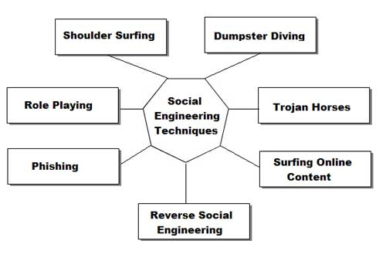
What is Social Engineering?
Social engineering is a term that describes a non-technical kind of intrusion that relies heavily on human interaction and often involves tricking other people to break normal security procedures.
Social engineering, in the context of information security, is understood to mean the art of manipulating people into performing actions or divulging confidential information. This is a type of confidence trick for the purpose of information gathering, fraud, or gaining computer system access. It differs from traditional cons in that often the attack is a mere step in a more complex fraud scheme.
“Social engineering” as an act of psychological manipulation had previously been associated with the social sciences, but its usage has caught on among computer and information security professionals.
Well known attacks
All social engineering techniques are based on specific attributes of human decision-making known as cognitive biases. These biases, sometimes called “bugs in the human hardware,” are exploited in various combinations to create attack techniques.
Pretexting
Pretexting (adj. pretextual), also known in the UK as blagging or bohoing, is the act of creating and using an invented scenario (the pretext) to engage a targeted victim in a manner that increases the chance the victim will divulge information or perform actions that would be unlikely in ordinary circumstances. An elaborate lie, it most often involves some prior research or setup and the use of this information for impersonation (e.g., date of birth, Social Security number, last bill amount) to establish legitimacy in the mind of the target.
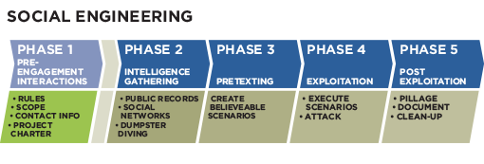
This technique can be used to fool a business into disclosing customer information as well as by private investigators to obtain telephone records, utility records, banking records and other information directly from company service representatives. The information can then be used to establish even greater legitimacy under tougher questioning with a manager, e.g., to make account changes, get specific balances, etc.
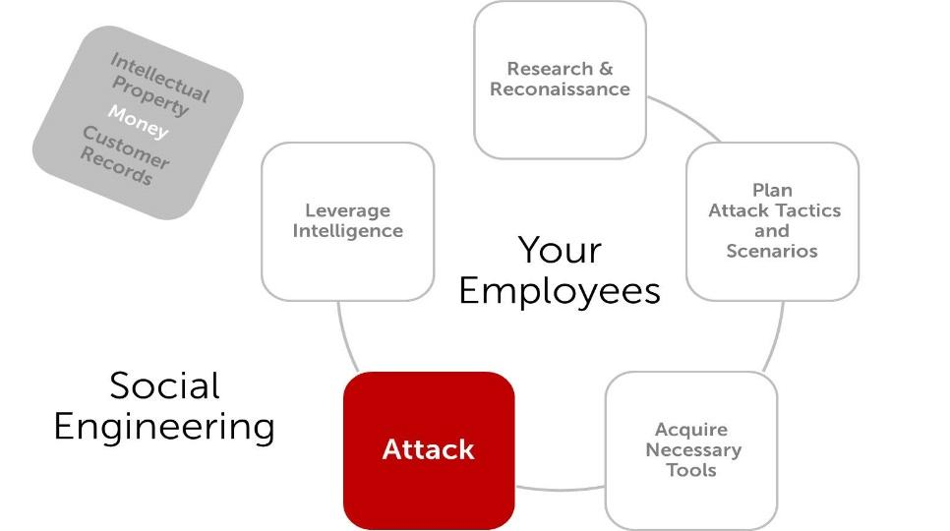
Pretexting can also be used to impersonate co-workers, police, bank, tax authorities, clergy, insurance investigators — or any other individual who could have perceived authority or right-to-know in the mind of the targeted victim. The pretexter must simply prepare answers to questions that might be asked by the victim. All that is needed is a voice that sounds authoritative, an earnest tone, and an ability to think on one’s feet to create a pretextual scenario. There are also other techniques to get from people what attacker wants. One way is to be likable. People are used to do a favour for people they like, so all is needed is use charm, give a few compliments and ask to do what is needed. Other way is better described better in part called Quid pro quo.
Diversion theft
Diversion theft, also known as the “Corner Game” or “Round the Corner Game”, originated in the East End of London.
In summary, diversion theft is a “con” exercised by professional thieves, normally against a transport or courier company. The objective is to persuade the persons responsible for a legitimate delivery that the consignment is requested elsewhere — hence, “round the corner”.
Phishing
Phishing is a technique of fraudulently obtaining private information. Typically, the phisher sends an e-mail that appears to come from a legitimate business—a bank, or credit card company—requesting “verification” of information and warning of some dire consequence if it is not provided. The e-mail usually contains a link to a fraudulent web page that seems legitimate—with company logos and content—and has a form requesting everything from a home address to an ATM card’s PIN.
For example, 2003 saw the proliferation of a phishing scam in which users received e-mails supposedly from eBay claiming that the user’s account was about to be suspended unless a link provided was clicked to update a credit card (information that the genuine eBay already had). Because it is relatively simple to make a Web site resemble a legitimate organization’s site by mimicking the HTML code, the scam counted on people being tricked into thinking they were being contacted by eBay and subsequently, were going to eBay’s site to update their account information. By spamming large groups of people, the “phisher” counted on the e-mail being read by a percentage of people who already had listed credit card numbers with eBay legitimately, who might respond.
Smishing is term used for phishing in mobile communication. Actually, this is phishing over the SMS messages.
IVR or phone phishing
Phone phishing (or “vishing”) uses a rogue interactive voice response (IVR) system to recreate a legitimate-sounding copy of a bank or other institution’s IVR system. The victim is prompted (typically via a phishing e-mail) to call in to the “bank” via a (ideally toll free) number provided in order to “verify” information. A typical system will reject log-ins continually, ensuring the victim enters PINs or passwords multiple times, often disclosing several different passwords. More advanced systems transfer the victim to the attacker posing as a customer service agent for further questioning.
Baiting
Baiting is like the real-world Trojan Horse that uses physical media and relies on the curiosity or greed of the victim.
In this attack, the attacker leaves a malware infected floppy disk, CD-ROM, or USB flash drive in a location sure to be found (bathroom, elevator, sidewalk, parking lot), gives it a legitimate looking and curiosity-piquing label, and simply waits for the victim to use the device.
In either case, as a consequence of merely inserting the disk into a computer to see the contents, the user would unknowingly install malware on it, likely giving an attacker unfettered access to the victim’s PC and, perhaps, the targeted company’s internal computer network.
Unless computer controls block the infection, PCs set to “auto-run” inserted media may be compromised as soon as a rogue disk is inserted.
Hostile devices, more attractive than simple memory, can also be used. For instance, a “lucky winner” is sent a free digital audio player that actually compromises any computer it is plugged to.
Dumpster diving
Dumpster diving is the practice of sifting through commercial or residential waste to find items that have been discarded by their owners, but that may prove useful to the dumpster diver. Dumpster diving is also viewed as an effective urban foraging technique Dumpster divers will forage dumpsters for items such as clothing, furniture, food, and similar items in good working condition. Companies usually dump staff that can be used by attacker, like some documents that are expired or not used, lists of employees, with some personal information, lists of former employees. All these things can be then of great use for creating pretexting scenarios and information gathering.

KT1002 Social engineering techniques
All social engineering techniques are based on specific attributes of human decision-making known as cognitive biases. These biases, sometimes called "bugs in the human hardware,” are exploited in various combinations to create attack techniques, some of which are listed below. The attacks used in social engineering can be used to steal employees' confidential information. The most common type of social engineering happens over the phone. Other examples of social engineering attacks are criminals posing as exterminators, fire marshals and technicians to go unnoticed as they steal company secrets.
One example of social engineering is an individual who walks into a building and posts an official-looking announcement to the company bulletin that says the number for the help desk has changed. So, when employees call for help the individual asks them for their passwords and IDs thereby gaining the ability to access the company's private information. Another example of social engineering would be that the hacker contacts the target on a social networking site and starts a conversation with the target. Gradually the hacker gains the trust of the target and then uses that trust to get access to sensitive information like password or bank account details.
Principles
Authority
In social engineering, the attacker may pose as authority to increase the likelihood of adherence from the victim.
Intimidation
Attacker (potentially disguised) informs or implies that there will be negative consequences if certain actions are not performed. Consequences could include subtle intimidation phrases such as "I'll tell your manager" to much worse.
Consensus/Social proof
People will do things that they see other people are doing. For example, in one experiment, one or more confederates would look up into the sky; bystanders would then look up into the sky to see what they were missing. At one point this experiment was aborted, as so many people were looking up that they stopped traffic. See conformity, and the Asch conformity experiments.
Scarcity
Perceived scarcity will generate demand. The common advertising phrase "while supplies last" capitalizes on a sense of scarcity.
Urgency
Linked to scarcity, attackers use urgency as a time-based psychological principle of social engineering. For example, saying offers are available for a "limited time only" encourages sales through a sense of urgency.
Familiarity / Liking
People are easily persuaded by other people whom they like. Cialdini cites the marketing of Tupperware in what might now be called viral marketing. People were more likely to buy if they liked the person selling it to them. Some of the many biases favoring more attractive people are discussed. See physical attractiveness stereotype.

KT1003 Types of social engineering attacks
Social engineering is a general term that refers to a broad range of manipulation tactics used by hackers to acquire information.
- Baiting: Baiting is a social engineering attack where the attacker entices the user with a free item to lure them into clicking on a link. This may come in the form of a free music or movie download lined up with the user’s interests. When the unsuspecting user clicks the link, they become infected with malware.
- Phishing: Phishing is a type of social engineering attack that uses email, phone or text to entice a user to click on a malicious link. The communication appears to be from a legitimate source connected to the user. When the user selects the ill-intentioned link, the user’s device or system becomes infected with malware and data is often compromised.
- Pretexting: This tactic is one more commonly associated with the term social engineering. With pretexting, an individual impersonates a representative from a trusted organization with the goal of acquiring sensitive information. This social engineering technique relies heavily on gathering research before initiating contact with the target.
- Quid Pro Quo: The quid pro quo attack is a variation of baiting. Often known as the “something for something” social engineering technique, the quid pro quo attack involves promising a service or benefit for complying with the request of an attacker. For example, a social engineer may promise a free software upgrade to entice a user to download what is actually malware to their system.
- Reverse Social Engineering: In this kind of social engineering scheme, the attacker convinces a target that they have a problem or issue and then positions themselves with a solution. The target then initiates contact with the social engineer believing that they are able to solve their problem.
- Tailgating: This social engineering tactic is a physical attack. With tailgating, a hacker gains access to restricted areas of a building by following an approved employee into the building and piggybacking on their credentials. In these cases, the social engineer often pretends to be an employee or even a delivery person.
- Whaling and Spear Phishing: These attacks are a variation of phishing and, because they target a specific individual, they require a significant amount of research. In whaling attacks, these individuals are high-profile people, often executives or the C-suite.

KT1004 Countermeasures
Social engineering attacks uses peoples’ vulnerability and peoples’ lack of information. Establishing security procedures and training employees can quite well reduce company risk of being victim of social engineering attack. Some of the best practeses are:
- Establishing frameworks of trust on an employee/personnel level (i.e., specify and train personnel when/where/why/how sensitive information should be handled)
- Identifying which information is sensitive and evaluating its exposure to social engineering and breakdowns in security systems (building, computer system, etc.)
- Establishing security protocols, policies, and procedures for handling sensitive information.
- Performing unannounced, periodic tests of the security framework
- Reviewing the above steps regularly: no solutions to information integrity are perfect
- Using a waste management service that has dumpsters with locks on them, with keys to them limited only to the waste management company and the cleaning staff.

KT1005 Social engineering penetration testing
Social engineering penetration testing is the practice of attempting typical social engineering scams on a company’s employees to ascertain the organization's level of vulnerability to that type of exploit.
Social engineering pen testing is designed to test employees' adherence to the security policies and practices defined by management. Testing should provide a company with information about how easily an intruder could convince employees to break security rules or divulge or provide access to sensitive information. The company should also get a better understanding of how successful their security training is and how the organization stacks up, security-wise, in comparison to their peers.
Social engineering testing may be conducted as part of more comprehensive penetration tests (pen tests). Like ethical hacking methods, the tests themselves generally replicate the types of efforts that real-world intruders use.
Physical testing, for example, might involve a tester trying to enter a secured building at a time when many employees are entering, perhaps talking on a phone and carrying multiple items to see if someone just holds the door open rather than adhering to the approved procedure of letting the door close after them so any person following must use an employee card or badge for entry.
Phishing exploits, a common social engineering method, are often used to test employee vulnerability. Testers might send an email purportedly from someone in management asking the employee to open an unexpected attachment, provide sensitive information or visit an unapproved website.
A tester might call employees pretending to be someone in IT, providing them with new passwords and telling them to change their current passwords to the new ones.

Internal Assessment Criteria and Weight
- IAC1001Risks and mitigation of social engineering are interrogated

KM-03-KT11: Denial-of-Service
Topic elements to be covered include:
- KT1101DoS/DDoS concepts and objectives
- KT1102DoS/DDoS attack techniques and tools
- KT1103Countermeasures and protection tools
- KT1104DoS/DDoS attack penetration testing

KT1101 DoS/DDoS concepts and objectives
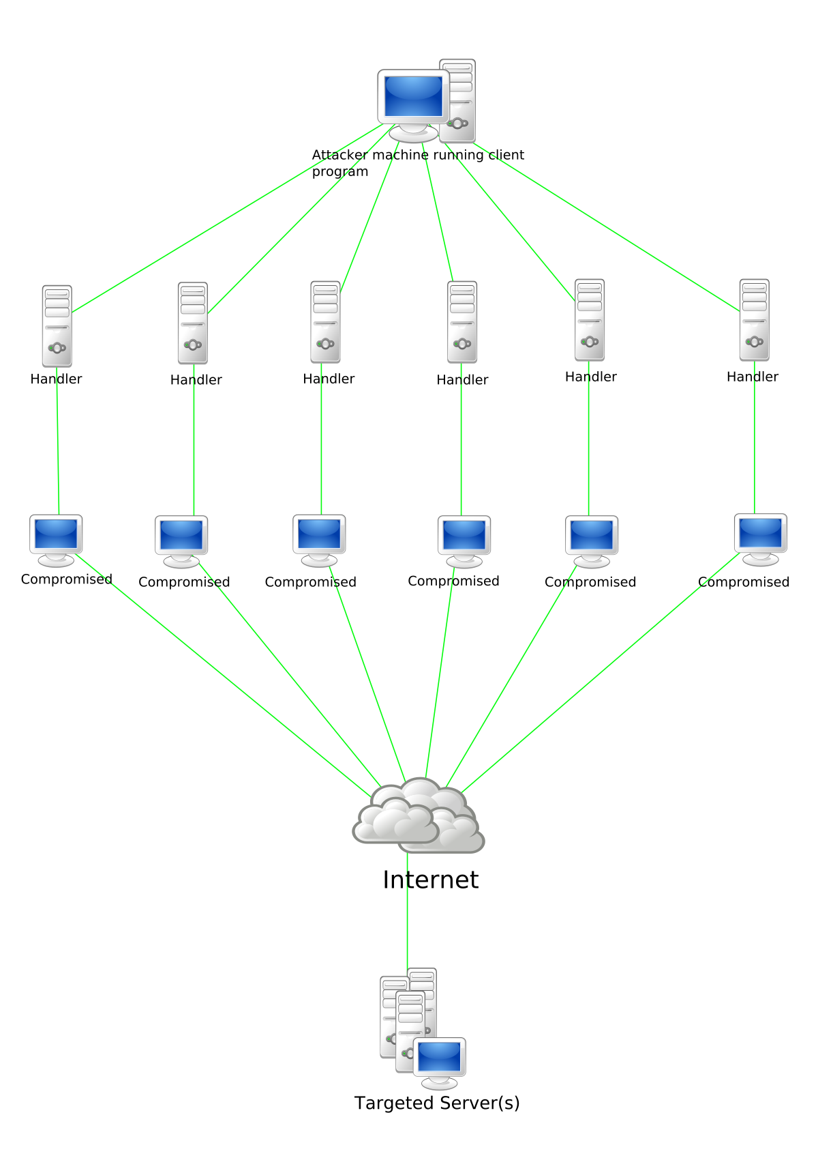
What is a denial of service attack (DoS) ?
A Denial-of-Service (DoS) attack is an attack meant to shut down a machine or network, making it inaccessible to its intended users. DoS attacks accomplish this by flooding the target with traffic, or sending it information that triggers a crash. In both instances, the DoS attack deprives legitimate users (i.e. employees, members, or account holders) of the service or resource they expected.
Victims of DoS attacks often target web servers of high-profile organizations such as banking, commerce, and media companies, or government and trade organizations. Though DoS attacks do not typically result in the theft or loss of significant information or other assets, they can cost the victim a great deal of time and money to handle.
There are two general methods of DoS attacks: flooding services or crashing services. Flood attacks occur when the system receives too much traffic for the server to buffer, causing them to slow down and eventually stop. Popular flood attacks include:
- Buffer overflow attacks – the most common DoS attack. The concept is to send more traffic to a network address than the programmers have built the system to handle. It includes the attacks listed below, in addition to others that are designed to exploit bugs specific to certain applications or networks
- ICMP flood – leverages misconfigured network devices by sending spoofed packets that ping every computer on the targeted network, instead of just one specific machine. The network is then triggered to amplify the traffic. This attack is also known as the smurf attack or ping of death.
- SYN flood – sends a request to connect to a server, but never completes the handshake. Continues until all open ports are saturated with requests and none are available for legitimate users to connect to.
Other DoS attacks simply exploit vulnerabilities that cause the target system or service to crash. In these attacks, input is sent that takes advantage of bugs in the target that subsequently crash or severely destabilize the system, so that it can’t be accessed or used.
An additional type of DoS attack is the Distributed Denial of Service (DDoS) attack. A DDoS attack occurs when multiple systems orchestrate a synchronized DoS attack to a single target. The essential difference is that instead of being attacked from one location, the target is attacked from many locations at once. The distribution of hosts that defines a DDoS provide the attacker multiple advantages:
- He can leverage the greater volume of machine to execute a seriously disruptive attack
- The location of the attack is difficult to detect due to the random distribution of attacking systems (often worldwide)
- It is more difficult to shut down multiple machines than one
- The true attacking party is very difficult to identify, as they are disguised behind many (mostly compromised) systems
Modern security technologies have developed mechanisms to defend against most forms of DoS attacks, but due to the unique characteristics of DDoS, it is still regarded as an elevated threat and is of higher concern to organizations that fear being targeted by such an attack.

KT1102 DoS/DDoS attack techniques and tools
DDoS Attack Tools Categorization
Now that you have a better grasp of DDoS attacks, you may be wondering: What are DDoS attack tools and their categorizations?
Let’s find out!
A number of DDoS attack tools are available on the black market and otherwise. Some of them are called stressors. They’re genuine tools for security researchers and network engineers to examine and test against organizations’ networks. Although used for vulnerability assessment practices, bad actors utilize them for evil purposes too.
Here are common categories of tools for DDoS attacks:
Low and Slow Attack Tools
DDoS attack tools under this category use a low volume of data and run sluggishly as they’re made to send small packets of data across several network connections. This keeps ports on a specific server open for a longer time to consume a server’s resources. The process goes on until the server fails to handle any more requests.
Application Layer-7 Attack Tools
To understand this, you must know what the OSI model is. Open Systems Interconnection or OSI models are the seven layers computer systems use to communicate over a network. All major computer and telecommunication companies accepted and synchronized with the OSI model in the 1980s.
So, as the name says, application layer-7 attack tools target the seventh layer of the OSI model where HTTP requests are generated. Bad actors overwhelm servers with traffic that looks like legitimate requests made by users.
Protocol and Transport Layer Attack Tools
This category of DDoS attack tools uses UDP and heavy-volume traffic to overburden a server and render it dysfunctional. The UDP or User Datagram Protocol is used for time-sensitive transmissions like videos and DNS lookups. Its job is to speed up communications without a formal connection before data transmission.

9 Famous DDoS Attack Tools
Below are the nine most famous DDoS attack tools. Their usage depends on what industries the attackers target and their intentions.
LOIC
LOIC or Low Orbit Ion Cannon is a beginner-friendly, free, and famous DDoS attack tool used for sending UDP, TCP, and HTTPS requests to a targeted server. It uses a significant volume of traffic to its advantage by focusing on a computer’s network connection and sending unnecessary packets to shut down a website.
HULK
HULK is short for HTTP Unbearable Load King, a tool designed for research purposes. It’s a choice of many attackers since it overloads the server with legitimate requests that don’t leave a trace or create suspicion.
As the server is driven on HTTP, it bypasses the cache engine and generates obscure traffic.
Tor’s Hammer
Tor’s Hammer is categorized under low and slow tools for DDoS attacks and was initially meant for testing purposes only. It can attempt attacks inside the Tor network that operate in the 7th layer of the OSI model. It works by activating dead connections, thus confusing the web to show results.
Tor’s Hammer successfully bypasses firewalls and other security systems for DDoS or DoS attacks. It can generate and spoof IP traffic, sending small and continuous legitimate-looking HTTP packets to the victim server However, it’s a relatively ineffective tool since the network it uses is slow.
RUDY
RUDY is short for R U Dead Yet? Instead of using HTTP headers, it works by exploiting long-form field HTTP POST submissions that swamp a network with coordinated streams of denial attacks.
Malicious actors begin by scouting servers with web forms, followed by sending HTTP requests. The aim to outperform competitors is typically what motivates DDoS attacks using the RUDY tool. It’s a popular method as the small HTTP packets look legitimate and go unnoticed until the attack.
DDoSISM
DDoSISM is another DDos attack tool used to execute application layer-seven attacks written on Linux and C++. It works by creating multiple non-existent hosts with random IP addresses to simulate a DDos attack against targeted servers.
The strength of the server security framework is analysed upon the response to this attack. DDoSISM is quite diversified in nature, allowing security experts to try various techniques.
Slowloris
SLOWLORIS is defined as one of the most-used DDoS attack tools. It sends legitimate HTTP requests to overwhelm a server even with little bandwidth. This tool sends HTTP headers in small chunks as slowly as possible, maintaining the connection with a victim’s server for a long time to gain maximum advantage.
This way, the server is tricked into waiting for the HTTP headers to arrive, thereby leaving no space for genuine users. The technique works well because the requests are authentic and not spoofed.
Golden Eye
The Golden Eye tool for DDoS attacks was originally created for simulations to put the server in various DoS situations. Experts then examine the security protocols and server response to patch any loopholes.

KT1103 Countermeasures and protection tools
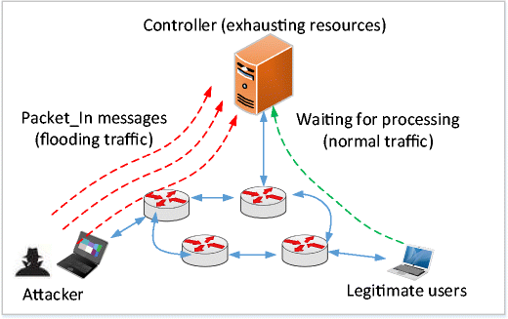

Detection Techniques
- Detection techniques are based on identifying and discriminating the illegitimate traffic increase and flash events from legitimate packet traffic.
- All detection techniques define an attack as an abnormal and noticeable deviation from a threshold of normal network traffic statistics.
- Activity Profiling
- Wavelet-based Signal Analysis
- Changepoint Detection
Activity Profiling
- An attack is indicated by:
  - An increase in activity levels among the network flow clusters.
  - An increase in the overall number of distinct clusters (DDoS attack)
- Activity profile is done based on the average packet rate for a network flow, which consists of consecutive packets with similar packet fields.
- Activity profile is obtained by monitoring the network packet's header information.
Activity Profiling monitors a network packet's header information, calculates the average packet rate for a network flow.
Wavelet-based Signal Analysis
- Wavelet analysis describes an input signal in terms of spectral components.
- Wavelets provide for concurrent time and frequency description.
- Analysing each spectral window's energy determines the presence of anomalies.
- Signal analysis determines the time at which certain frequency components are present.
Sequential Change-Point Detection
- Isolate Traffic: Change-point detection algorithms isolate changes in network traffic statistics caused by attacks.
- Filter Traffic: The algorithms filter the target traffic data by address, port, or protocol and store the resultant flow as a time series.
- Identify Attack: Sequential change-point detection technique uses Cumulative Sum (Cusum) algorithm to identify and locate the DoS attacks; the algorithm calculates deviations in the actual versus expected local average in the traffic time series.
- Identify Scan Activity: This technique can also be used to identify the typical scanning activities of the network worms.
DoS/DDoS Countermeasure Strategies
- Absorbing the Attack:
  - Use additional capacity to absorb attack; it requires preplanning.
  - It requires additional resources.
- Degrading Services:
  - Identify critical services and stop non critical services.
- Shutting Down the Services:
  - Shut down all the services until the attack has subsided.
DDoS Attack Countermeasures
- Protect Secondary Victims
- Neutralize Handlers
- Prevent Potential Attacks
- Deflect Attacks
- Mitigate Attacks
- Post-attack Forensics
DoS/DDoS Attack Countermeasures: Protect Secondary Victims
- Install anti-virus and anti-Trojan software and keep these up-to-date.
- Increase awareness of security issues and prevention techniques in all Internet users.
- Disable unnecessary services, uninstall unused applications, and scan all the files received from external sources.
- Properly configure and regularly update the built-in defensive mechanisms in the core hardware and software of the system.
DoS/DDoS Attack Countermeasures: Detect and Neutralize Handlers
- Network Traffic Analysis: Analyse communication protocols and traffic patterns between handlers and clients or handlers and agent in order to identify the network nodes that might be infected by the handlers.
- Neutralize Botnet Handlers: There are usually few DDoS handlers deployed as compared to the number of agents. Neutralizing a few handlers can possibly render multiple agents useless, thus thwarting DDoS attacks.
- Spoofed Source Address: There is a decent probability that the spoofed source address of DDoS attack packets will not represent a valid source address of the definite sub-network.
DoS/DDoS Countermeasures: Detect Potential Attacks
- Egress Filtering:
  - Scanning the packet headers of IP packets leaving a network.
  - Egress filtering ensures that unauthorized or malicious traffic never leaves the internal network.
- Ingress Filtering:
  - Protects from flooding attacks which originate from the valid prefixes (IP address)
  - It enables the originator to be traced to its true source.
- TCP Intercept:
  - Configuring TCP Intercept prevents DoS attacks by intercepting and validating the TCP connection requests.

KT1104 DoS/DDoS attack penetration testing
WHAT IS A DDOS AND DOS ATTACK?
DoS stands for denial of service, while DDOS stands for distributed denial of service. During a DOS attack, only one device is used to send a large number of packets to the server. On the other hand, DDOS attacks are carried out by using multiple systems or devices to attack the server. Essentially, DDOS attacks are a subset of DOS attacks. DDOS attacks are generally more dangerous than DOS. The goal of both attacks is to make a system, network, server, or application unavailable to legitimate users due to its overload with packets.

ARE THERE DDOS PENETRATION TESTS?
Yes, it is possible to check how well a server, network, or application can resist a DDOS attack by conducting DOS or DDOS testing as part of a pentest. Generally, hackers can use two strategies when carrying out these attacks: they can try to blindly overload the equipment or target a specific vulnerability in the network or system to bring it offline.
Cyber security companies can conduct both DOS and DDOS penetration tests, however, there’s not much you can gain from DDOS testing. Attackers with enough resources will always be able to overload your equipment and render it unavailable. On the other hand, DOS pen-testing can reveal valuable information about vulnerabilities in applications and device configurations, which can then be remedied to prevent attacks from threat actors.
ARE THERE RISKS INVOLVED WITH DOS PENTESTING?
As with any penetration test, there are some risks involved. For instance, your systems might experience a decrease in performance or your server could crash, but the latter is a worst-case-scenario situation. It is important to remember that conducting a DOS or DDOS penetration test actually helps to reduce the risks of a real attack, so the dangers associated with conducting the tests are a small price to pay for real-life security.

WHAT TOOLS ARE USED FOR DOS AND DDOS TESTS?
HPING3
This is an open-source tool for crafting packets. The program allows you to set packet type and the rate at which the packets will be sent to the server. Overall, this is a terrific program for simulating DOS attacks, testing firewalls, conducting OS fingerprinting, network testing, port scanning, uptime guessing, etc.
GOLDENEYE
GoldenEye is another piece of open-source DDOS attack testing software. The application is based on HULK but it differs from its predecessor significantly, as it doesn’t just send packets to the server, it also simulates the users staying connected to the server. This program is perfect for carrying out stress tests on networks and applications.
HULK
HULK or Http Unbearable Load King is a program created by cybersecurity expert Barry Shteiman. This tool effectively finds its way around caching and attacks the server directly with unique packets. Unlike many other DDOS testing tools that utilize a predictable pattern when sending the packets, making the attack easier to detect and stop, HULK makes each request unique. This tool also allows you to carry out the simulated attack safely with the ability to control and stop it at any time.

Internal Assessment Criteria and Weight
- IAC1101Risks and mitigation of DoS/DDoS are interrogated

KM-03-KT12: Session Hijacking
Topic elements to be covered include:
- KT1201Session hijacking concepts
- KT1202Types of level session hijacking
- KT1203Session hijacking tools
- KT1204Countermeasures
- KT1205Penetration testing

KT1201 Session hijacking concepts
Session hijacking is defined as taking over an active TCP/IP communication session without the user’s permission. When implemented successfully, attackers assume the identity of the compromised user, enjoying the same access to resources as the compromised user. Identity theft, Information theft, stealing sensitive data are some of the common impacts of session hijacking.
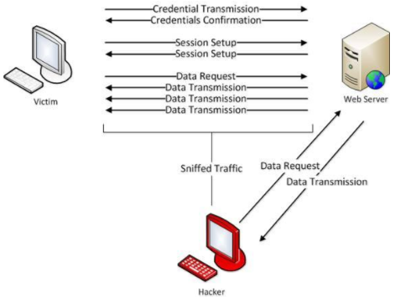
Types of session hijacking attacks:
There are two types of session hijacking depending on how they are done. If the attacker directly gets involved with the target, it is called active hijacking, and if an attacker just passively monitors the traffic, it is passive hijacking.
Active:
The attacker will silence one of the machines, usually the client computer, and take over the clients’ position in the communication exchange between the workstation and the server. The active attack also allows the attacker to issue commands on the network making it possible to create new user accounts on the network, which can later be used to gain access to the network without having to perform the session hijack attack.
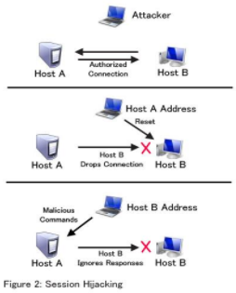
Passive:
In Passive session hijacking attack, the attacker monitors the traffic between the workstation and server. The primary motivation for the passive attack is to monitor network traffic and potentially discover valuable data or passwords.
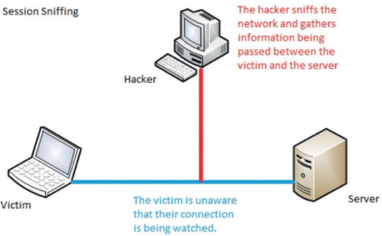

KT1202 Types of level session hijacking
Session Hijacking can be done at two levels:
- Network Level
- Application Level
Network Level hijacking includes TCP and UDP sessions.
Application-Level hijacking occurs with HTTP Sessions.

Application-Level Hijacking:
Here the valid session token is stolen or predicted to take over the session. Various attacks involved here are-
Man in the middle attack:
By using automated tools/spoofing methods the attacker splits the connection between the targets into two. One connection between the client and attacker and another one between attacker and server. Since the attacker becomes the man in the middle, all the traffic goes through him, hence he can capture the session Id.
Cross-site scripting:
Client-side vulnerabilities like XSS attacks allow an attacker to craft a malicious script to get the session Id from the application.
Using Proxy:
By setting up a proxy and causing the traffic to flow through the proxy, one can capture the session Id details.
Man-in the–Browser:
By installing a Trojan in the victim’s browser will notify the attacker the session Id.
Session Replay:
Capturing the authentication packets by sniffing the traffic; replaying those packets after a time interval may cause the attacker to successfully login to the session of the authorized user.

KT1203 Session hijacking tools
Session hijacking tools
You can find a lot of advantages when using a session hijacking tool to test your web application, as nowadays, manual testing can be quite expensive for businesses. Some of the benefits you could find are:
- Automated detection of common session hijacking attack vectors
- Automated protection against XSS-based session hijacking attacks
- Automated detection and mitigation of known security flaws in your application code
- Automated testing of the most popular web applications

KT1204 Countermeasures
There’s a lot you can do to help protect yourself online. Take these steps to help prevent session hijacking and increase your online security:
- Avoid public Wi-Fi. Never use public Wi-Fi, especially for important transactions like banking, online shopping, or logging into your email or social media accounts. There may be a cybercriminal at the next table who is using packet sniffing to try to pick up session cookies and other information.
- Use a VPN. If you do need to use public Wi-Fi, get a virtual private network (VPN) to help stay safe and keep session hijackers out of your sessions. A VPN masks your IP address and keeps your online activities private by creating a “private tunnel” through which all your online activity travels. A VPN encrypts the data you send and receive.
- Add security software. Install reputable security software on your devices and make sure to update it regularly. (You can also set automatic updates.) Security software can detect viruses and protect you from malware, including the malware attackers use to perform session hijacking.
- Watch out for scams. Avoid clicking on any link in an email unless you’ve verified it’s from a legitimate sender. Session hijackers may send you an email with a link to click. The link may install malware on your device or take you to a login page that will log you into a site using a session ID prepared by the attacker.
- Be aware of site security. Reputable banks, email providers, online merchants, and social media sites have safeguards in place to avoid session hijacking. Smart site owners will install HTTPS on the entire site, not just their homepage. They’ll also find and close security loopholes promptly. Using iffy online shops or other providers that may not have the best security can leave you vulnerable to a session hijacking attack.
The possibility of falling victim to a session hijacking attack can be scary. But just taking these steps will go a long way toward protecting you from these attackers who want to steal your sessions.

KT1205 Penetration testing
Hackers orchestrate a session hijacking attack to gain unauthorized access to a user’s session and then assume and leverage the victim’s identity for deeper exploitation. As various services of an application create sessions to serve as a reference for a user’s initial authentication, an attack vector exploits such services to stay connected to the server for the duration of the current session. To achieve this, attackers steal a user’s session ID and then apply it to their browser, tricking the application servers into authenticating users.

Risk and impacts of hijacking attacks
Session hijacking is a form of man-in-the-middle attack that, if successful, grants the hacker full access to a legitimate user’s account and browser session. The technique has been around for decades and involves attackers stealing a valid session token from an active user and then accessing the user’s account.
In most cases, session hijacking attacks are avoidable. As such, the risks within an application stack that account for a wider proportion of such attacks include:
- Vulnerable components – Failure to build and maintain adequate security controls in source code and third-party integrations makes applications more susceptible to phishing attempts and man-in-the-middle attacks.
- Predictable session token – Some application session tokens and attribute in session cookies typically contain sensitive data that associates the server with the user’s credentials. Hackers usually use automated tools to guess these session tokens, thereby leveraging such vulnerabilities as one of the most common methods of successful session hijacking.
- Insufficient encryption – Without network traffic encryption beyond initial authentication, hackers exploit the TLS layer to sniff session packets and intercept cookies transmitted between clients and servers.
- Malware – Attackers target web applications with vulnerable servers to install malware that executes on a user’s device to hijack the session. The malware may perform session sniffing, grab the temporary session cookie, and send it to the hacker for further exploitation.
The threat of a session hijacking attack can be severe, depending on the criticality of the application being accessed and the sensitivity of the data compromised. Some potential impacts of a successful attack include:
- Financial fraud – Once attackers take hold of financial systems, they can perform transactions while impersonating a legitimate user. For example, they may make purchases using active session information, transfer funds on behalf of the victim, or even access an intellectual property.
- Identity theft – A standard attack pattern involves gaining access to a client’s login credentials, which allows them to access multiple accounts illegally, escalate privileges and orchestrate a full-blown attack.
- Data breach – Attackers use compromised sessions and logins to gain unauthorized access to sensitive data of a vulnerable server. Once done, attackers leverage this data to exploit the organization or victims through ransomware attacks and the threat of exposing personally identifying data.
- Exploiting Single Sign-On Systems (SSO) – In systems that use an SSO authentication, attackers can also use an active session to log in to other services that authenticate using the SSO. As SSO systems typically leave session security responsibilities on the onus of users, it is harder to protect applications with less predictable cookies and weak authentication mechanisms.

Internal Assessment Criteria and Weight
- IAC1201Risks and mitigation of Session hijacking are interrogated

KM-03-KT13: Evading IDS, Firewalls, and Honeypots
Topic elements to be covered include:
- KT1301IDS, Firewall, and Honeypot Concepts
- KT1302IDS, Firewall, and Honeypot Solutions
- KT1303Evading IDS and Firewalls
- KT1304IDS/Firewall Evading Tools
- KT1305Detecting Honeypots
- KT1306IDS/Firewall Evasion Countermeasures
- KT1307Penetration Testing

KT1301 IDS, Firewall, and Honeypot Concepts
Firewall Classes
Understanding Firewalls
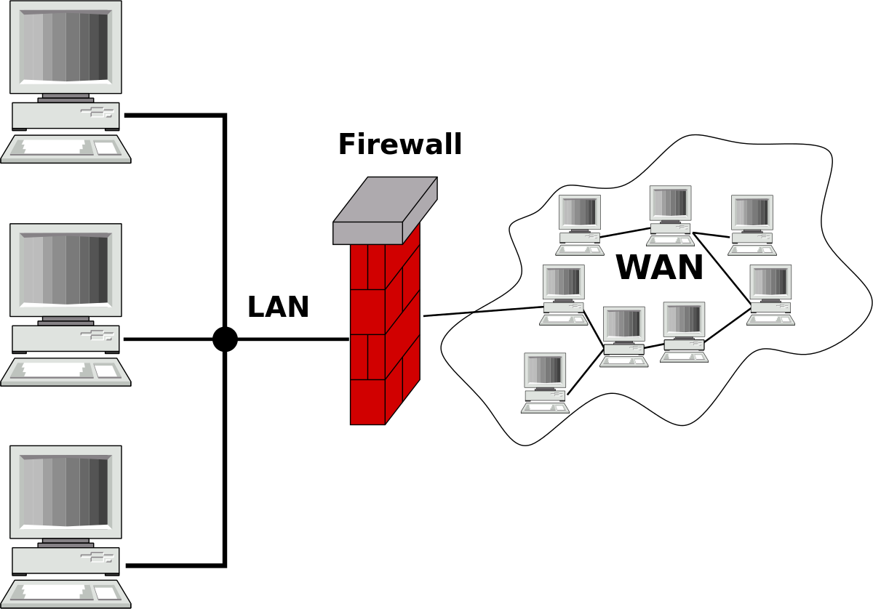
Firewalls can be either software based or hardware devices that are used in the enforcement of security policies. Both can filter traffic based on a set of rules as traffic passes through them.
Routers are not firewalls and should never be considered as such. Network based firewalls will route traffic but this is only if the policy allows. Single hosts can be protected from both incoming and outgoing traffic by use of a host-based firewall. Regardless of whether the firewall is software or hardware, all can create a troubleshooting nightmare should they not be configured carefully or correctly. This is the keystone to a business objective driven policy when it comes to firewall configuration.
Improvised configurations do not work well with firewalls. The configurations must be carefully thought through and any impact caused by the configuration must be considered. This should be done before the implementation of any firewall policies.
Physical or social engineering attacks cannot be protected against by any firewall. The most common weaknesses in any firewall are either leaving them in their default configurations or by careless implementation. Attackers are looking hard for these weaknesses and the best defensive measure it to prevent them from finding them by changing the default settings or by careful firewall configurations. Of equal importance is to understand both the benefits and the limitations of firewalls and prevent being lulled into the false sense of security by thinking their mere presence is equal to network security and protection.
Firewall Classes
Different types of firewalls exist each having their own niche in the market. Some products are multi-functional providing features such as routing and Demilitarized Zones (DMZ). These are the four common firewall classes:
- Packet Filters
- Circuit Level Gateways
- Application-Level Firewalls
- Stateful Multilayer Inspection Firewalls
Packet Filters - Packet filters search for protocol information in the delivery and transport layers. The idea behind this is to filter out the obvious items first. Since every packet is a discreet single logical unit, packet filters only look at one delivery at a time. This method is computationally cheap very efficient.
Circuit Level Gateways - Circuit Level Gateways are a unique set of firewalls that protect the integrity of each end of the session, all without invading the confidentially of the data that is being exchanged. It is a socket level proxy as it creates entirely new connections that are based on the synchronizing of IP addresses and ports.
This method works by including a new translation of the sequence numbers that are tracked by TCP to help the receiving host reassemble all of the segments of data. It also prevents session hijacking and also helps obscure the true endpoints of any observed conversation.
Application-Level Firewalls - Application-Level Firewalls work on the Layer 7 level by looking at the content of each network packet. This includes all client server requests and information content that is delivered on the network.
Application-Level Firewalls are computationally expensive as many factors ride far beyond simple a string pattern that must be matched and incorporated. Factors also include context and policies such as user profiles and time of day constraints. Once a policy violation is detected, there is a consideration as to whether or not log the evidence in a forensically sound manner, to redirect the user to another source or to log the alert allowing manual intervention in the determination as to what action should be taken.
Stateful Multilayer Inspection Firewalls - This class of firewall is a combination of all of the other three types of firewalls. They act by filtering packets at the network layer ridding the easiest data first and then send the remaining packets to the deep packet inspection engine. Deep packet inspection is a form of network packet filtering that examines the data of a packet searching for protocol non-compliance, viruses, spam, intrusions or defined criteria to decide whether the packet may pass or if it needs to be routed to a different destination.
Intrusion Detection Systems (IDS) Classes
IDS Classes
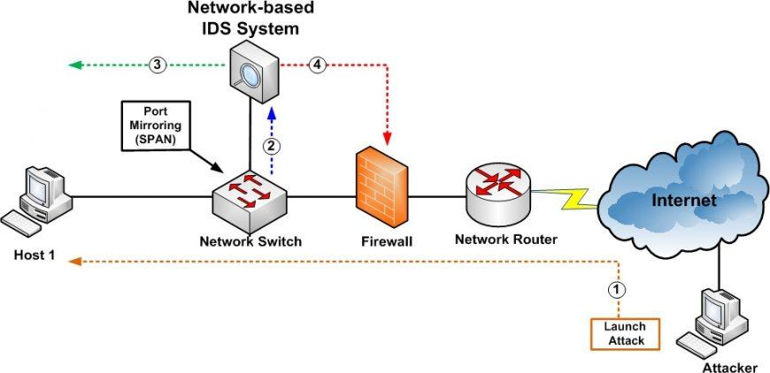Acting as a passive technique, intrusion detection is a critical part of network monitoring. It will only inform when an event has occurred but does not prevent or correct the situation by default. On the other hand, intrusion prevention systems perform on an active level. Sometimes using false positives turning these systems against the owners, this configuration and testing actively seeks out anything considered abnormal.
If trying to decide between the two, keep in mind that there is no "right choice." The decision has to be made by the consideration of its purpose and the best fit. While passive IDSs are prone to false positives and relay on administrative overhead in the form of analysis, it can look for a broad range of suspicious activity whereas active IDSs can create DoS situations if false positives are present and therefore must be tuned finely thus seeking out a much narrower scope of events.
Placement of these detection agents also play a role in the type of system that is chosen. The DMZ should always have an agent present and one should also be in place to the inside of the firewall that will screen all internal networks.
There are several approaches to intrusion detection. Here are seven of the most common:
- Signature Recognition
- Anomaly Detection
- Statistical Detection
- Network-Based Intrusion Detection
- Host-Based Intrusion Detection
- Log File Monitoring
- File Integrity Checking
Signature Recognition - Signatures are primarily recognizable characters of a packet such as a particular series of bytes or characters. The position, or offset of particular bytes can be of significance as well as specified fields values or protocol flag combinations.
Signal detection occurs in real time. After a suspect packet is detected, alerts can be placed in a log file almost immediately. If in place, an Incident Response Plan is activated and notifications can be sent. All of this is most often the greatest weakness of an IDS implementation. This weakness is because by the time the attack is noticed, the objective may have already been met and the attacker might be gone or at least changed the nature of their presence.
Should the IDS be running in "in-line" mode, it could interact with firewall software to implement new policy rules to block the attack. This is the function of an Intrusion Prevention System (IPS).
There is a drawback to signature detection and this is in the complexity and of the amount of the rule set that must be used. With it having to be constantly updated, it will not detect zero-day exploits, which are exploits that there are no signature rules yet available.
Anomaly Detection - Unusual events are what this type of IDS looks for. This means that it is critical to have a knowledge of what traffic is considered "normal." A baseline metric is needed and normal, expected traffic is given to the IDS. The IDS then will provide an alert if events other than what the baseline predicts take place.
This type of monitoring has an advantage as to where certain types of attacks that would normally evade signature analysis would be detected. Some of these attacks would be ARP poisoning or heavily fragmented packets that would cause unusual traffic. The disadvantage is that this IDS is only as good as it's baseline.
Statistical Detection - This IDS notices attacks that occur over time. Should an attacker try and scan very slowly, alerts are still triggered. Analysis, however, takes time and the attack may not be discovered until they have been completed, however at least the target will know the event has happened.
Network-Based Intrusion Detection - Considered "passive", this IDS just listens on the wire. Any form of analysis can be used.
Host-Based Intrusion Detection - This IDS is considered active since it can be invasive in order to monitor the behaviour or actions of a host. As an example, if multiple emails are sent without a subject or content, the HIDS will block all email activity, notify the user and have the user confirm whether the actions were intended or not.
Log File Monitoring - Since log files have thousands of formats and each one is unique to the service that is being monitored, they present a challenge to analyse. Commercial tools are available that know of many popular formats and thus make reporting much easier, and they can provide real-time reporting as well.
File Integrity Checking - The class of IDS that keeps a database of hashes computed from critical files or directories on the system is the System Integrity Verifier (SIV). It recalculates these hashes either periodically or whenever the file is accessed. It then presents an alert when changes have been detected.
SIVs discover files that have been replaced, altered or corrupted. Unfortunately, files that change often are much more difficult to monitor. Fortunately, OS system files and program libraries are not subject to frequent changes and a new hash database must be computed after accepting patches or other security updates.
Interpreting Alerts
It is up to human intervention and analysis to determine if a response action is necessary or appropriate, and if so, to determine what the response should be should an alert to an alarm be triggered. If there is an immediate overreaction to the alert resulting in wasted time in a response to non-issues, not only is it a waste of time but can also create new problems.
The following are categories that are used for IDS alerts.
- True Positive: An event triggering an alert for a real and present threat.
- False Positive: An event triggering an alert showing a real threat when in fact it was not.
- True Negative: An event not triggering an alert and in reality, not a threat at all.
- False Negative: An event not triggering an alert when in fact it was a real threat.
Events to Look for During An Analysis
Redundancy and different methods of detection are included in most of the best monitoring programs. Each threat possesses it's own risk factors to the organization. With this variance, each asset should be monitored differently.
Putting this into an example, consider a public web server and a database server. The web server will most likely be accessed by many people. Certain types of access is expected, however certain access types, such as directory traversals indicate one of the visitors is searching for documents or detect other flaws. Again, this could only be a search engine spider. Regardless, if we know from testing, there is nothing to find and most activities such as this is expected and should be ignored.
Honeypots
The Nature of Honeypots

Honeypots are designed to attract attackers with the idea that monitoring systems will allow the attacker to be observed. Honeypots come in different scales with a honeypot being a host, a honeynet is a network and a honeytoken is a piece of monitored data.
Honeypot Types
There are four different honeypot varieties that exist, all a matter of choice and a balance of risk, accuracy and administrative distraction from the production hosts. These levels are:
- Physical Honeypots
- Virtual Honeypots
- Low Interaction
- High Interaction
Physical Honeypots - These types are considered physical tests, fully functional and heavily monitored. They can be as simple as an unlocked bicycle leaning against a wall. Though it is there and unsecured, this does not mean the owner has given any permissions for anyone to take it.
Virtual Honeypots - Thus type is a sacrificial host setup on a network having real services running on a real OS but only containing fictional information, if any at all. Though this honeypot comes with great risk, it is the most convincing form of honeypot.
This type of honeypot will appear as a rogue infrastructure and cause internal time wasting should it not be formalized in configuration, release and without change management processes in place.
This IDS may have been told to pass all traffic coming from the honeypot and this can be a big mistake should the honeypot be compromised while remaining undetected. In this state, it could be used as a weapon against the network.
Low Interaction - This form appears to an attacker as an access point. It only logs probing activity, however, and since this host is of no production value, all access attempts are considered suspicious.
High Interaction - This form can be of great risk. Being able to be fully compromised, it must be separated from any network segment that has production value. The monitoring capabilities of this type of honeypot facilitates the gathering of information that would not be noticed by NIDS. By diligently monitoring the honeypot, detection of the larger plan of the attacker is possible and if the attacker manages to evade the network-based intrusion detection, hopefully the diversion will be discovered and attacked.
Testing and Evasion Techniques
Scanning for Firewalls, IDS and Honeypots
Knowing where the filters are is critical to the attacker. This is also a primary difference between the white hat penetration test and the true attack as the filters are moved for simple assessments.
Playing a major role in the scanning phase of the attack, the attacker wants to know where their barriers are located. By knowing this, the attack can either be graceful and never discovered or one that will cause alarms to be triggers and thus prompting a rapid escape and retreat.
There are five basic ways to fingerprint firewalls. These are:
- Traceroute
- Banner Grabbing
- Look for any accessible open port
- Port Scanning
- Firewalking
Traceroute - It is important to know the path to a target host when interpreting the results of all other scans. By using traceroute, the attacker can make sure that they don't inadvertently attack a host that don't belong to the target organization. It also aids in distinguishing hosts and gateways which will determine the different scanning techniques used.
Should two or more hops with the same IP address show, this suggests that a load balancer or cluster is in place. Though this may not influence the attack, this information is still good to know.
Banner Grabbing - Using a tool like telnet, an attacker can try to connect to any access point that has been discovered and attempt to gather information. The proper instructions must be sent relative to the expected service to achieve full interaction, but even those that return only errors often divulge important information.
Look for any accessible open port - The two major issues with a routing firewall is the firewall itself and the hosts.
An attacker can gain clues about the nature of the possible routing firewall by determining which ports are showing as being open. IP protocol ID 47 shows support for Generic Router Encapsulation (GRE) and is often accompanied by TCP ports 1723 or 1701 that could reveal a potential VPN gateway.
The most common way to find a series of routers is by using the traceroute command. It is equally important to be able to use a variety of scanning techniques including the ICMP type 8 and other ACK scans. If it is shown that two hosts with the same IP source address exists, this can be an indication of a Network Address Translation (NAT) server or a load balancer.
Port Scanning - Port scanning can be conducted against both the routing firewalls and the hosts that are possibly running software firewalls themselves. The attacker is interested about what they can access.
Firewalking - The fire walk scan requires three hosts: the scanner, the gateway and the destination.
Traffic is sent to the destination by the scanner and informs the firewall tool what the gateway is. Firewall sets the Time to Live (TTL) value of each packet it sends to one hop past the gateway of the destination. If this traffic is passed by the gateway, the destination will respond with an ICMP type 11, which is the Time Exceeded, and the attacker knows the port is open. If not, the packet is dropped from the gateway.
Simple Evasion Techniques
Signature-based analysers and other real time IDS systems can be fooled if they are not set up correctly or are not installed on hardware that is designed to handle the load on their segment. in this case, simple command line tools can play havoc in these circumstances.
- Fragmented Traffic
- Encryption
- Decoy Traffic
- Denial of Service
Fragmented Traffic - Available for Linux, frag router is a command line tool that allows the attacker to ensure that all packets sent to a particular host will be fragmented to the size the attacker specifies. The IDS must then reassemble the fragments before full analysis can take place and therefore keeps the IDS busy. During this period other packets might be able to pass through during the time of high network load.
It is important not to confuse frag router with the tool frag route. Frag route is capable of being an inline packet modification tool otherwise known as a packet sharper.
Encryption - Whether encryption is mandated or forbidden is dictated by security policies. This is the only way any traffic can be flagged as suspicious even when a determination cannot be made as to what the attack is exactly.
Encryption countermeasures can sometimes be used to create covert channels for attackers. If the host end points that have established tunnels are compromised, the attacker might not need to even care about encryption, in fact it is sometimes even a benefit to them. Unless given the ability to decode the packets, IDS tools cannot analyse encrypted traffic. This action will expose the keys to more risk or further complicates key issuance and management.
Decoy Traffic - There are tools such as map that includes options for generating packets that have random IP addresses and port numbers that are used to mix with the attack packets. This could cause the IDS to log many false positives so the analyst has to figure out what is real and what is not.
Denial of Service - The IDS might be Denial of Service based on the underlying operating system or on a flaw in the IDS code itself. If attention is paid, this problem will be fixed quickly. Usually this issue can be fixed by a member of the Security Operations Center (SOC), however it might be just enough time for the attacker that is conducting the access step to plant the maintaining access code.
Packet Crafting
Packet crafting is a technique that allows network administrators to probe firewall rule-sets and find entry points into a targeted system or network. This is done by manually generating packets to test network devices and behaviour instead of using existing network traffic. Testing may target a firewall, IDS, TCP/IP stack, router or any other component of the network.
There are many ways to craft packets such as languages like PERL or Python created by programmers to automate crafting traffic and have complete control over the system. Comprised of a series of bits, a packet can be captured, manipulated, parsed, adjusted, created and sent in any way attackers might need as long as they know what is required for a given attack.
One of the easiest command line tools is Hping that comes with Backtrack Linux. It can be used to test firewalls and IDS.
Signature Changing
A quicker approach than Packet Crafting is to change the signature. Signatures that are based on a sequence of bytes in the data layer can be circumvented if the bytes under analysis are changed.
Adding bytes into the data is known as an Injection Attack. Should the signature bee too strict, the attacker might be able to change some values that have nothing to do with the signature but would cause the analysis rule to decide on a false negative. Some of these tools are:
- Sidestep: Is a tool that generates Metasploit payloads encrypted using the CryptoPP library and uses several other techniques to evade the Anti-Virus.
- ADMutate: Will attempt to encode the shell code with a simple mechanism so the shell code will be unique to any NIDS sensor.
- frag router: This is just a one-way fragmenting router. IP packets get sent from the attacker to the frag router which transforms them into a fragmented data stream to forward to the victim.
- NIDSBench: This tool implements several well-known attacks against passive network monitoring and allows for the instrumentation of trace-driven network attack simulations.
Tunnels and Reverse Shells
Tunnels - Tunnels, or tunnelling, which is also known as port forwarding is the transmission of data intended for a private, corporate network through a public network. It is achieved in such a way that the routing nodes in the public network are completely unaware that the transmission is part of a private network.
Reverse Shells - Reverse Shells is the connection of one computer to another where the initiating computer forwards their shell to the destination. It is common that a reverse shell happens during an attack or as part of a penetration test. This kind of attack allows an attacker an interactive shell on a machine that they should not have had access to inside of the hardened area.
Packets can be enveloped within one another. Protocols that specify arbitrary data in the payload area can also be used in tunnels.
An ICMP type 8 message, which is a ping request, does not specify what should be echoed as the RFC just refers to "data". Loki is a tool that is able to split a message, split it up into pieces and send each piece as a part of the echo request in a type 8 message.
There is one thing that should be noted and that is that something on the receiving end has to understand the encapsulation. This is the same principle that applies to Virtual Private Networks (VPNs) as they can also be applied to covert attack channels.
Stateful Packet Inspection (SPI) firewalls are the reason reverse shells happen. SPI firewalls prevent incoming connection attempts but will allow traffic generated from requests. Essentially, this is a way of telling the attacker that the target wants to be attacked. This is where social engineering comes into play.

KT1302 IDS, Firewall, and Honeypot Solutions
There are many applications and use cases for honeypots, as they work to divert malicious traffic away from important systems, get an early warning of a current attack before critical systems are hit, and gather information about attackers and their methods. If the honeypots don’t actually contain confidential data and are well-monitored, you can get insight on attacker tools, tactics, and procedures (TTPs) and gather forensic and legal evidence without putting the rest of your network at risk.
For a honeypot to work, the system should appear to be legitimate. It should run processes a production system is expected to run, and contain seemingly important dummy files. The honeypot can be any system that has been set up with proper sniffing and logging capabilities. It’s also a good idea to place a honeypot behind your corporate firewall—not only does it provide important logging and alerting capabilities, but you can block outgoing traffic so that a compromised honeypot cannot be used to pivot toward other internal assets.
In terms of objectives, there are two types of honeypots: research and production honeypots. Research honeypots gather information about attacks and are used specifically for studying malicious behaviour out in the wild. Looking at both your environment and the wider world, they gather information about attacker trends, malware strains, and vulnerabilities that are actively being targeted by adversaries. This can inform your preventative defenses, patch prioritization, and future investments.
Production honeypots, on the other hand, are focused on identifying active compromise on your internal network and tricking the attacker. Information gathering is still a priority, as honeypots give you additional monitoring opportunities and fill in common detection gaps around identifying network scans and lateral movement. Production honeypots sit with the rest of your production servers and run services that would typically run in your environment. Research honeypots tend to be more complex and store more types of data than production honeypots.
Honeypot complexity varies
Within production and research honeypots, there are also differing tiers depending on the level of complexity your organization needs:
- Pure honeypot: This is a full-scale, completely production-mimicking system that runs on various servers. It contains “confidential” data and user information, and is full of sensors. Though these can be complex and difficult to maintain, the information they provide is invaluable.
- High-interaction honeypot: This is similar to a pure honeypot in that it runs a lot of services, but it is not as complex and does not hold as much data. High-interaction honeypots are not meant to mimic a full-scale production system, but they do run (or appear to run) all the services that a production system would run, including a proper operating system. This type of honeypot allows the deploying organization to see attacker behaviours and techniques. High-interaction honeypots are resource-intensive and come with maintenance challenges, but the findings can be worth the squeeze.
- Mid-interaction honeypot: These emulate aspects of the application layer but do not have their own operating system. They work to stall or confuse attackers so that organizations have more time to figure out how to properly react to an attack.
- Low-interaction honeypot: This type of honeypot is the most commonly deployed in a production environment. Low-interaction honeypots run a handful of services and serve as an early warning detection mechanism more than anything. They are easy to deploy and maintain, with many security teams deploying multiple honeypots across different segments of their network.
Different types of honeypot tech
Several honeypot technologies in use include the following:
- Malware honeypots: This use known replication and attack vectors to detect malware. For example, honeypots (e.g., Ghost) have been crafted to emulate as a USB storage device. If a machine is infected by malware that spreads via USB, the honeypot will trick the malware to infect the emulated device.
- Spam honeypots: These are used to emulate open mail relays and open proxies. Spammers will test the open mail relay by sending themselves an email first. If they succeed, they then send out large quantities of spam. This type of honeypot can detect and recognize this test and successfully block the massive volume of spam that follows.
- Database honeypot: Activities such as SQL injections can often go undetected by firewalls, so some organizations will use a database firewall, which can provide honeypot support to create decoy databases.
- Client honeypots: Most honeypots are servers listening for connections. Client honeypots actively seek out malicious servers that attack clients, monitoring for suspicious and unexpected modifications to the honeypot. These systems generally run-on virtualization technology and have a containment strategy to minimize risk to the research team.
- Honeynets: Rather than being a single system, a honeynet is a network that can consist of multiple honeypots. Honeynets aim to strategically track the methods and motives of an attacker while containing all inbound and outbound traffic.
Benefits of a honeypot
Honeypots offer plenty of security benefits to organizations that choose to implement them, including the following:
They break the attacker kill chain and slow attackers down
As attackers move throughout your environment, they conduct reconnaissance, scan your network, and seek misconfigured and vulnerable devices. At this stage, they are likely to trip your honeypot, alerting you to investigate and contain attacker access. This allows you to respond before an attacker has the chance to successfully exfiltrate data from your environment. Malicious actors can also spend a significant amount of time trying to work on the honeypot instead of going after areas that have real data. Diverting their attack to a useless system wastes cycles and gives you early warning of an attack in progress.
They are straightforward and low-maintenance
Modern honeypots are not only easy to download and install, but can provide accurate alerts around dangerous misconfigurations and attacker behaviour. In some cases, your team might even forget that a honeypot was ever deployed until someone starts poking around your internal network. Unlike intrusion detection systems, honeypots do not require known-bad attack signatures and fresh threat intel to be useful.
They help you test your incident response processes
Honeypots are a low-cost way to help you increase your security maturity, as they test whether your team knows what to do if a honeypot reveals unexpected activity. Can your team investigate the alert and take appropriate countermeasures?
Honeypots shouldn’t be your entire threat detection strategy, but they are another layer of security that can be helpful in discovering attacks early. They are one of the few methods available to security practitioners to study real-world malicious behaviour and catch internal network compromise. Want to learn more about other types of tech that can boost your blue team defenses?

KT1303 Evading IDS and Firewalls
An Intrusion Detection System is a set of tools or systems that monitors and analyses the Network Traffic for any suspicious activities and issues alerts when any such activity is observed.
Similarly, a Firewall is a network security framework, that manages the outbound and inbound network traffic by permitting or blocking the packets based on the set of security rules.

Hacker vs Firewall (Source: GIPHY)
Although the Firewalls and IDS can prevent the Malicious Packets from entering a network, an Attacker can send manipulated packets to the target such that it can evade the IDS / Firewall. There are several such evasion techniques.
PS: There is no magic bullet for detecting and bypassing the firewalls or IDS systems, all it requires are Skills and Experience.

Techniques to evade the Firewall or an Intrusion Detection System:
1. Packet Fragmentation
Generally, as the name itself tells — A Packet Fragmentation is the method, where an attacker splits the probe packets into several smaller fragments, before sending them to the target network. As soon as the packets reach the target system, the IDS or Firewall enqueue them and process each of them one by one. However, being too many packets because of the fragmentation requires greater CPU and network resource consumption. Let me tell you, that most of the Intrusion Detection Systems are configured to skip the fragmented packets during the scanning.
Therefore, an attacker may use various tools such as NMAP or frag route for splitting the probing packets into smaller packets, that can be easily evaded through the port-scanning techniques employed by IDS. Once, these fragments reach their destination, they are reassembled to form a single packet.
SYN/FIN Scanning using IP Fragments
Although the SYN / FIN scanning using IP Fragments is not a new scanning method, but a modification of previous methods. The TCP Header splits into several packets to evade the packet filter, which was our ultimate goal.
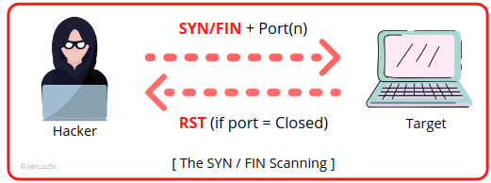
The SYN/FIN Scanning
For a transmission, every TCP header should have the Source & the Destination port for the initial packet. The initialized flags in the next packet allow the remote host to reassemble the packet when received via an Internet Protocol module that detects.
Example of SYN/FIN scanning through NMAP
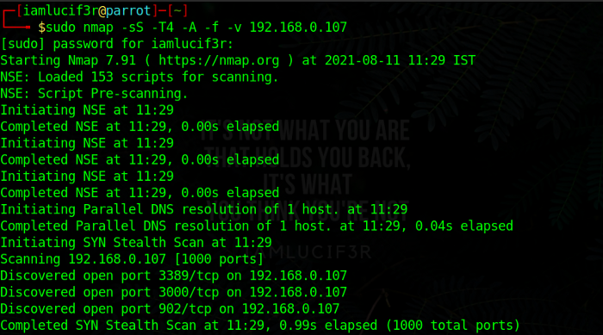
NMAP Command for SYN/FIN Scanning
2. Source Routing
An IP datagram contains several fields which also include the source routing information and a list of IP addresses through which the packet will travel to reach its destination. If you don’t know this already, let me tell you when the packets travel through the different nodes in the network, each router examines the destination IP Address associated with it and chooses the next hop to direct the packet to its destination.
Now comes the question, “How can this help in Firewall/IDS evasion?”. So this is how the firewall or IDS evasion is done by source routing:
When an attacker sends the maliciously crafted packets to a target, these packets usually hop through various routers and gateways to reach their destination. However, in some cases, the path also includes the configured Firewalls and IDS to block such packets. Thus, to avoid them, attackers strict the routing mechanism in such a way that, the packet can reach the destination via some other route such that there is no Firewall or IDS in the path, therefore successfully evades the firewalls and IDS. The whole scenario can be understood as shown in the following figure:
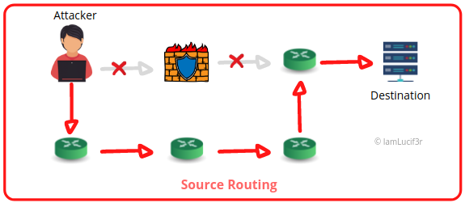
Source Routing Working
3. Source Port Manipulation
Source Port Manipulation is a technique, used for bypassing the Firewalls and IDS, where the actual port numbers are manipulated with common port numbers for evading the IDS and Firewall rules. This is basically masquerading the port that is blocked in configuration rules of IDS or Firewall by the port that is allowed by the framework.
That is why it is advised not to trust the source port numbers blindly, to avoid security misconfiguration. Usually, the commonly used ports such as HTTP, DNS, or FTP are allowed for incoming traffic. The following figure describes how the Firewall allows the manipulated port 80 to the victim.
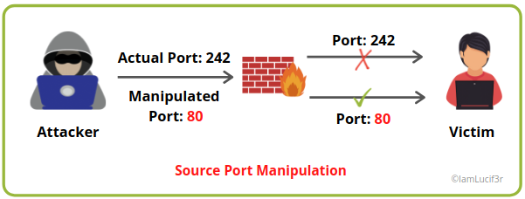
Source Code Manipulation: The Manipulated port 80 is being allowed by the firewall.
In NMAP, the -g or --source-port <port number> option is used to perform the source port manipulation. An example of the command for source code manipulation is shown below:
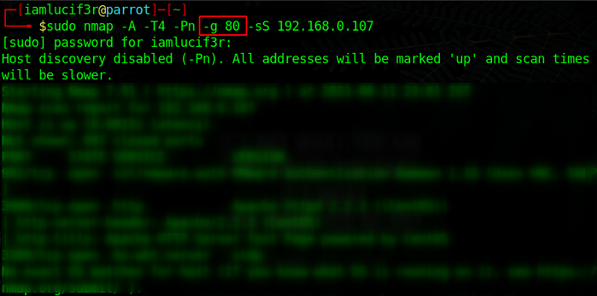
NMAP — Source Port Manipulation for Firewall Evasion
4. IP Address Decoy
This technique refers to generating or manually specifying the IP Addresses of the decoys to evade IDS / Firewalls. It appears to the target as well as the host are scanning the network. This technique makes it really difficult for the IDS / Firewalls to determine which IP Address is actually scanning the network and which IP addresses are a decoy.
We have a built-in scan function in NMAP called a decoy scan, that can be used in this case. This scan generates multiple IP Addresses, thus making it difficult for the target security frameworks to identify the source from the registered logs. The NMAP Decoy Scanning can be done as follows:
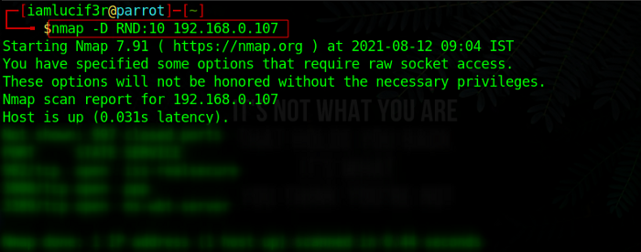
IP Address Decoy
We are also given the option for manually specifying the IP Addresses of the decoys to scan the Victim’s network. All we have to do is to separate each decoy IP with a comma as shown below:
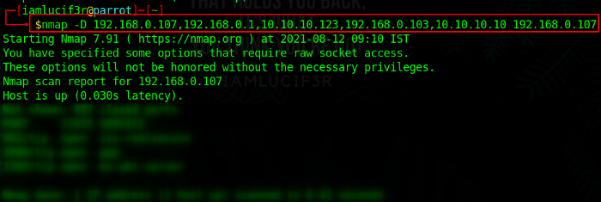
IPs are separated by a comma and the Target is specified in the end.
5. Spoofing the IP Address
Spoofing the IP Address is one of the hijacking techniques, where an attacker obtains a computer’s IP Address alters the packet headers, and then sends the request packets to the target machine, pretending it to be a legitimate host. The packets also appear to be coming from a legitimate source but actually are sent from the attacker’s machine.
Mostly firewalls filter packets based on the source IP Address. The firewalls examine the source IP Address and determine whether the packet is coming from a legitimate source or some other source. When the attackers send a connection request to the target, the target host thus replies to the spoofed IP Address.
IP Spoofing using Hping3
We can use Hping3 to perform the IP Address spoofing. The following example shows how to perform IP Address spoofing:
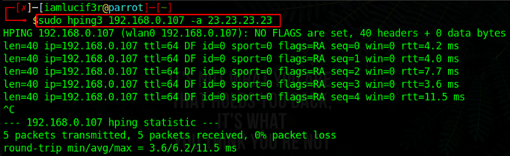
Hping3 — IP Address Spoofing
6. Customizing Packets
An attacker can create and send custom packets to scan the intended target beyond the Firewalls or IDS. This can be done by several methods, a few of them are explained below:

Creating Custom Packets by using Packet Crafting Tools
An attacker creates custom TCP Packets to scan the target by evading the firewalls. Several ‘Packet Crafting Tools’ such as Colasoft Packet Builder or NetScanTools pro can be used to scan the target beyond the defense mechanism. The main aim of the packet crafting tool is to craft and send packet streams using different protocols at different transfer rates.
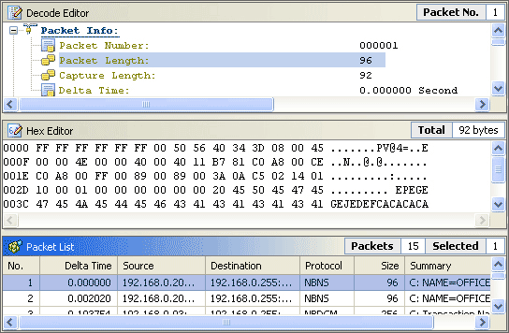

Creating Custom Packets by Appending Custom Binary Data
This method includes sending binary data (0’s and 1’s) as payloads in the packets to the target machine present behind the defense framework of the target. We can use NMAP to customize packets by appending custom binary data. It is important to understand that to perform a byte-order conversion, the specified information should be based on the receiver’s expectation. This is how you can use NMAP in this case:
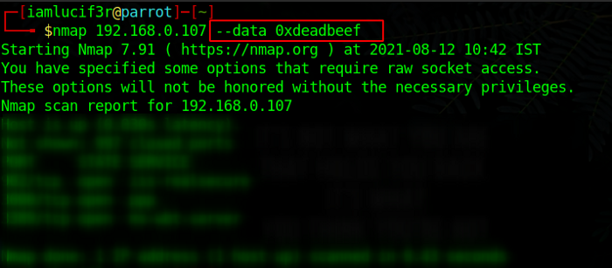
Appending Binary String in NMAP
6.3 Creating Custom Packets by Appending Custom Strings
Crafting packets is not limited to the binary data, but an attacker can send the regular strings as payloads in the packets for scanning beyond the firewall as well.
Examples: --data-string "Scan conducted by Security Ops, extension 7192"
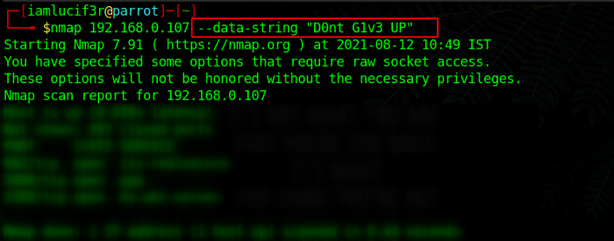
Appending Custom String in NMAP
6.4 Creating Custom Packets by Appending Random Data
An attacker can append several random chunks of data to most packets sent without using and protocol-specific payloads. NMAP provides an option for appending random data to the packet by using --data-length <number>
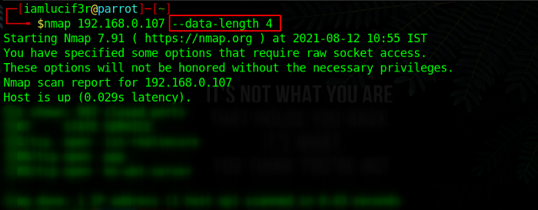
Appending Random Data in NMAP
7. Randomizing the order of Host
The attacker scans the number of hosts in the target network in a random order to scan the intended target that is secured behind the firewall. Our favorite tool NMAP provides us an option of randomizing hosts as well.
This methodology instructs the NMAP to shuffle each group of 16384 hosts before scanning with slow timing options, thus making the scan less notable to the network monitoring systems and firewalls. An example of using NMAP for randomizing the order hosts is shown below:
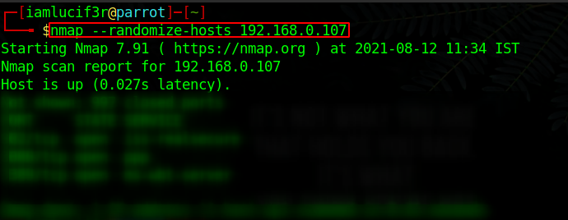
Randomizing Hosts in NMAP
8. Sending the Bad Checksums
The defense frameworks can be bypassed by sending the packets with bad or deceptive TCP/UDP checksums to the intended target. The TCP/UDP checksums are used to ensure data integrity. Thus, when the packets with incorrect checksums are sent, it helps an attacker to acquire the information from improperly configured systems by checking for any response.
If there is any response, then it is most probably from the IDS or Firewall, which did not verify the obtained checksum. If there is no response means the packets are dropped, then it can be inferred that the system is configured. We can see the example below, to understand how to perform scanning by sending a bad checksum.
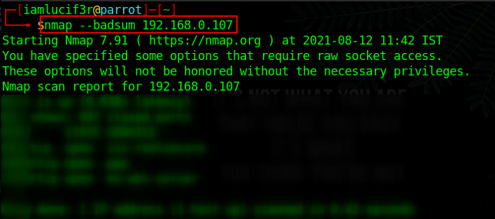
9. Proxy Servers
A proxy server is an application that can serve as an intermediary for connecting with other computers. A proxy server is used to fulfill the various purposes of firewall/IDS evasion, masquerading the original source, remotely accessing intranets, etc. The following image explains the working of a proxy server.
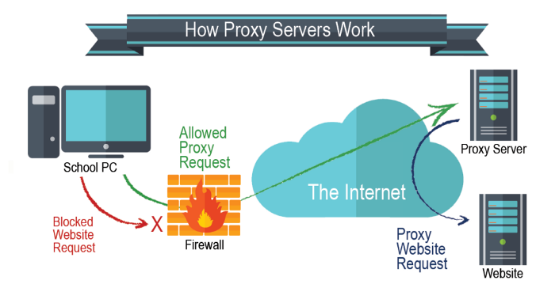
Proxy chaining is also an option that helps an attacker to maintain their Internet Anonymity. Some examples of proxy tools are Proxy Switcher, CyberGhost VPN, Tor, CCProxy, Hotspot Sheild, etc.
10. Anonymizers
This is the last methodology of this article. An anonymizer is an intermediate server that is placed between an attacker and the website to access the website on behalf of an attacker, to make the surfing and other activities untraceable. Most anonymizers usually anonymize the web, file transfer protocols, and similar other services.
An attacker uses the anonymizers to bypass the IDS and Firewall rules, to ensure their privacy, to access the contents that are restricted or not available publicly. There are several types of anonymizers like Networked Anonymizers.

KT1304 IDS/Firewall Evading Tools
Techniques to evade the Firewall or an Intrusion Detection System:
- Packet Fragmentation.
- Source Routing.
- Source Port Manipulation.
- IP Address Decoy.
- Spoofing the IP Address.
- Customizing Packets.
- Randomizing the order of Host.
- Sending the Bad Checksums.

KT1305 Detecting Honeypots
Honeypots Detection Techniques
Honeypot is designed primarily for tracking or attacking attackers during their attempts to break into an organization system. Attackers would try to detect the presence of honeypots on the network by propping services running on the system. These probs would include crafting malicious packets such as HTTPS, SMTPS, etc. For example. Ports that should a running service but deny a three-way handshake might indicate the presence of honeypot.
Attackers can also defeat honeypots by using multi-proxies (TORs) and hiding their conversations using encryption and steganography techniques. However, they are Some techniques used to identify and defeat the honeypots system, as discussed below. (EC-Council, 2020)
· Detecting the presence of Tar Pits :
Tar Pits are security entities similar to honeypots. Tar Pits are designed to respond slowly to incoming requests, which would slow down attacks attempts. Tart Pits might present at Layer7, layer 4, and laye7 based on the attacking vector.
o Layer 7 Tar Pits: Malicious Incoming SMTP/HTTP commands by an attacker, the system would slow down response. Thus Tar Pits could be identified by the latency of the response
o Layer 4 Tar Pits manipulate TCP/IP stack, where the system would accept TCP/IP connection and switch to a zero-windows size. In such a way, the attacker blocked from sending other data.

o Layer 2 Tar Pits: Attack has launched on the same network. The attacker can identify the presence of this daemon by looking at the responses with the unique MAC address 0:0:f:ff:ff:ff, which acts as a kind of black hole. An attacker can also identify the presence of these tar pits by analysing the ARP responses.
Detecting Honeypots Running on VMware:
Attackers can detect instances that are running on the VMWare virtual machine by analysing the MAC address. Referring to IEEE standards for the current range of MAC addresses assigned to VMWare Inc., an attacker can identify the presence of VMWare-based honeypots.
Detecting the presence of Honeyed Honeypot:
Honeyed is a simulator honeypot engine that can create thousands of honeypots easily. The honeyed would respond to received SMTP requests with fake responses. An attacker can identify the presence of honeyed honeypot by performing time-based TCP fingerprinting methods.
Detecting the presence of User-Mode Linux (UML) Honeypot:
Attackers can identify the presence of UML honeypots by analysing files such as /proc/mounts, /proc/interrupts, and /proc/cmdline, which contain UML-specific information.
Detecting the presence of Sebek-based Honeypots:
Attackers can detect the existence of Sebek-based honeypots by analysing the congestion in the network layer, as Sebek data communication is usually unencrypted. Since Sebek logs everything that is accessed via reading () call before transferring to the network, it causes the congestion effect
Detecting the presence of Snort_inline Honeypot:
Attackers can identify these honeypots by analysing the outgoing packets. If an outgoing packet is dropped, it might look like a black hole to an attacker. When the snort inline modifies an outgoing packet, the attacker can capture the modified packet through another host system and identify the packet modification.
Detecting the presence of Fake AP:
Fake access points send only beacon frames but do not produce any traffic on the access points, and an attacker can detect and monitor the network traffic and quickly note the presence of fake AP.
As discussed, upper, the detection of honeypots would depend on analysing responses, and its diversion from a typical system would act. These analyses would take much time for attackers to detect and ensure the existence of a honeypot inside the organization network.

KT1306 IDS/Firewall Evasion Countermeasures
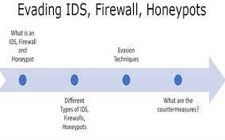
Before the advent of intrusion detection systems (IDS) and intrusion prevention systems (IPS), firewalls served as the primary technology to help organizations block unwanted traffic. With application-layer protocols lacking detection, attackers were able to disguise malicious traffic and remotely exploit applications. To stop these kinds of attacks, the security industry created IPS/IDS technologies to detect these attacks and block connections before any exploitation could occur.
Since the introduction of IPS, attackers have tried to find new ways to evade detections by these systems. One technique is fragmentation: The data that is normally sent in the channel is fragmented and is reconstructed only at the receiver’s end. It is possible to add the malicious traffic as part of the data that gets fragmented. When the data is reconstructed at the receiver, it can exploit the targeted application. Such fragmentation techniques could be applied in various protocols of the application layer.
The focus of IPS vendors recently is to address these issues and also stay ahead of attackers in spite of their obfuscation techniques. These evasions continued to evolve as attackers attacked application-layer protocols. By parsing client application-layer data, IPS can identify any payload that is injected and reduce the number of attacks.
The high number of attacks that the security industry has witnessed in the last few years shows the sophistication involved in writing the exploit code (malware, malicious scripts). Attackers reverse-engineer the workings of IPS detection mechanisms and develop attacks that fully understand the security application, and that take advantage of its features. Evasion has become a key strategy for attackers to avoid detection.

KT1307 Penetration Testing
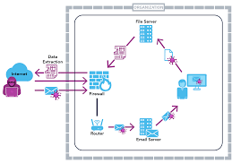
A firewall penetration test assesses how well a firewall protects an organization’s network from unauthorized access. It is a form of security testing used to evaluate a firewall’s effectiveness in blocking unauthorized traffic.
The test is conducted by attempting to access the network from an external location using various methods, such as port scanning and packet sniffing. If the firewall is effective, the tester should not be able to gain access to the network.
Firewall penetration tests can be conducted manually or with the help of automated tools. Manual testing is more time consuming and requires more significant expertise, but it can be more thorough.
Automated tools can be less expensive and can be used to test a more substantial number of targets.
Why Conduct Firewall Penetration Testing?
A firewall penetration test is a critical tool for security teams to identify vulnerabilities and assess the risk of an attack. A firewall test lets you map out your network from the outside to identify potential vulnerabilities in your network architecture.
Knowing where traffic enters and exits your network is essential because it can help you identify any weaknesses in your network architecture that might allow an attacker to gain access.
For example, if you have a wireless Access Point (AP) accessible through the Internet, you need to know where this traffic enters and exits your network.
Types of Firewall Penetration Testing
Firewall penetration testing is of further different types; let’s understand each one of them in detail:
- Man in the Middle (MiTM): In a MiTM test, a security researcher tries to intercept and modify traffic between the firewall and the clients trying to connect to the network. This test is often used against remote users because it could allow attackers to hijack traffic and get into the network without being detected. The attacker would then fully access the remote users and their data.
- Direct Traffic: In a direct traffic test, a security researcher is “directly” connecting to web servers and application servers on the internal network. The attacker would then try to map out the internal network, identify any vulnerabilities and potentially access sensitive data. This is often used against internal employees and is similar to an “internal reconnaissance” test.
- Spoofed Traffic: In a spoofed traffic test, the attacker uses a tool to send a fake, or “spoofed,” source of network traffic that simulates a remote user trying to connect to the internal network. The attacker has full access to the internal network once connected, similar to an “internal reconnaissance” test.
Ways to Perform Firewall Penetration Testing
There are three primary ways to perform firewall penetration testing:
1. Black Box Testing: In black box testing, the tester has no prior knowledge of the firewall system and tests the system from the outside.
2. White Box Testing: In white box testing, the tester has complete knowledge of the firewall system and tests the system from the inside.
3. Gray Box Testing: In gray box testing, the tester has some prior knowledge of the firewall system and tests the system from the outside.
All three types of firewall penetration testing are essential to identify weaknesses in a system. By performing all three testing types, a comprehensive system analysis can be conducted, and potential vulnerabilities can be identified and addressed.

Internal Assessment Criteria and Weight
- IAC1301Risks and mitigation of IDS, Firewall, and Honeypot are interrogated

KM-03-KT14: Hacking Web Servers
Topic elements to be covered include:
- KT1401Web server concepts
- KT1402Web server attacks
- KT1403Attack tools
- KT1404Countermeasures
- KT1405Defense attack mechanisms
- KT1406Security tools
- KT1407Penetration testing and pen testing tools
KT1401 Web server concepts
The term web server can refer to hardware or software, or both of them working together.
- On the hardware side, a web server is a computer that stores web server software and a website's component files (for example, HTML documents, images, CSS stylesheets, and JavaScript files). A web server connects to the Internet and supports physical data interchange with other devices connected to the web.
- On the software side, a web server includes several parts that control how web users access hosted files. At a minimum, this is an HTTP server. An HTTP server is software that understands URLs (web addresses) and HTTP (the protocol your browser uses to view webpages). An HTTP server can be accessed through the domain names of the websites it stores, and it delivers the content of these hosted websites to the end user's device.
At the most basic level, whenever a browser needs a file that is hosted on a web server, the browser requests the file via HTTP. When the request reaches the correct (hardware) web server, the (software) HTTP server accepts the request, finds the requested document, and sends it back to the browser, also through HTTP. (If the server doesn't find the requested document, it returns a 404 response instead.)
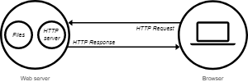
To publish a website, you need either a static or a dynamic web server.
A static web server, or stack, consists of a computer (hardware) with an HTTP server (software). We call it "static" because the server sends its hosted files as-is to your browser.
A dynamic web server consists of a static web server plus extra software, most commonly an application server and a database. We call it "dynamic" because the application server updates the hosted files before sending content to your browser via the HTTP server.
For example, to produce the final webpages you see in the browser, the application server might fill an HTML template with content from a database. Sites like MDN or Wikipedia have thousands of webpages. Typically, these kinds of sites are composed of only a few HTML templates and a giant database, rather than thousands of static HTML documents. This setup makes it easier to maintain and deliver the content.
Deeper dive
To review: to fetch a webpage, your browser sends a request to the web server, which searches for the requested file in its own storage space. Upon finding the file, the server reads it, processes it as-needed, and sends it to the browser. Let's look at those steps in more detail.
Hosting files
First, a web server has to store the website's files, namely all HTML documents and their related assets, including images, CSS stylesheets, JavaScript files, fonts, and video.
Technically, you could host all those files on your own computer, but it's far more convenient to store files all on a dedicated web server because:
- A dedicated web server is typically more available. (up and running)
- Excluding downtime and systems troubles, a dedicated web server is always connected to the Internet.
- A dedicated web server can have the same IP address all the time. This is known as a dedicated IP address. (not all ISPs provide a fixed IP address for home lines)
- A dedicated web server is typically maintained by a third-party.
Communicating through HTTP
Second, a web server provides support for HTTP (Hypertext Transfer Protocol). As its name implies, HTTP specifies how to transfer hypertext (linked web documents) between two computers.

KT1402 Web server attacks
Web Server and its Types of Attacks
Websites are hosted on web servers. Web servers are themselves computers running an operating system; connected to the back-end database, running various applications. Any vulnerability in the applications, Database, Operating system or in the network will lead to an attack on the web server. Vulnerability stack of a web server is given below (source: White hat security)
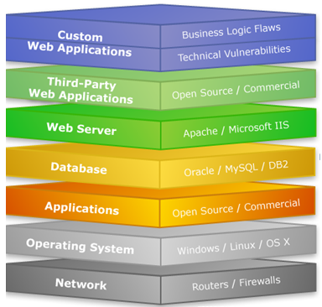
Web Server Attacks types:
DOS attack:
An attacker may cause a denial-of-service attack by sending numerous service request packets overwhelming the servicing capability of the web server, or he may try to exploit a programming error in the application causing a DOS attack.
E.g. buffer overflow attack, SYN flooding, HTTP get Request Flooding, Ping of death.
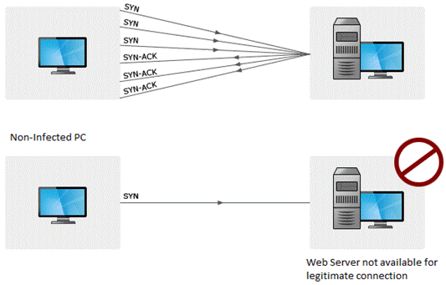
Website Defacement:
SQL injection attacks are used to deface the website. When an attacker finds out that input fields are not sanitized properly, he can add SQL strings to maliciously craft a query which is executed by the web browser. He may store malicious/unrelated data in the database; when the website is requested, it will show irrelevant data on the website, thus displaying a defaced website.

Directory Traversal:
This is vulnerability where an attacker is able to access beyond the web root directory from the application. If he is able to access beyond web root directory, he might execute OS commands and get sensitive information or access restricted directories.
Misconfiguration attacks:
If unnecessary services are enabled or default configuration files are used, verbose/error information is not masked; an attacker can compromise the web server through various attacks like password cracking, Error-based SQL injection, Command Injection, etc.

Phishing Attack:
An attacker may redirect the victim to malicious websites by sending him/her a malicious link by email which looks authentic, but redirects him/her to malicious web page thereby stealing their data.
There are a lot of other web application attacks which can lead to a web server attack- Parameter form tampering, Cookie tampering, unvalidated inputs, SQL injection, Buffer overflow attacks.
Methodology:
Information Gathering:
Information related to the target server is collected from various sources like
- From websites
- WHOIS information
- Netcraft information
- Banner grabbing
- Port scanning with Nmap.
- Mirroring a website using Htttrack.

Vulnerability Scanning:
There are automated tools for scanning a web server and applications running on it. The results may show various threats and vulnerabilities on the target web server; these vulnerabilities may later be exploited using tools or manually.
E.g. Acunetix, Nikto, Vega etc
Password Attacks:
- Guessing/Default passwords
- Brute Forcing
- Dictionary Attacks

KT1403 Attack tools
Web server attack tools
Some of the common web server attack tools include;
- Metasploit– this is an open-source tool for developing, testing and using exploit code. It can be used to discover vulnerabilities in web servers and write exploits that can be used to compromise the server.
- MPack– this is a web exploitation tool. It was written in PHP and is backed by MySQL as the database engine. Once a web server has been compromised using MPack, all traffic to it is redirected to malicious download websites.
- Zeus– this tool can be used to turn a compromised computer into a boat or zombie. A bot is a compromised computer which is used to perform internet-based attacks. A botnet is a collection of compromised computers. The botnet can then be used in a denial-of-service attack or sending spam mails.
- Neosplit – this tool can be used to install programs, delete programs, replicating it, etc.

KT1404 Countermeasures
Countermeasures:
- Update and patch web servers regularly.
- Do not use the default configuration.
- Store configuration files securely.
- Scan the applications running on the web server for all vulnerabilities.
- Use IDS and firewall with updated signatures.
- Block all unnecessary protocols and services.
- Use secure protocols.
- Disable default accounts, follow strict access control policy.
- Install Anti-virus, and update it regularly.
- All OS and software used should be latest and updated.

KT1405 Defense attack mechanisms
Active defense is a term borrowed from security defense to be used. It refers to the actions and steps taken to achieve an advantage over an adversary. When seeking active defense, we look for ways of confusing the adversary or even wasting their time so much as to allow us enough time to properly configure our defenses and thwart the adversary.
The following are some countermeasures that can be put in place:
- Configuring a honeypot to waste an adversary’s time
- Installing an alert system that can alert you to attacks
- Configuring firewalls to detect and block attacks
The intention of the countermeasures above can be to achieve the following:
- Waste the adversary’s time
- Trap the attack to prevent further compromise
- Inform security teams concerning attacks
- Assist in discovering the source of the attack
If active defense is properly executed, then it will be able to thwart the attacker’s campaign plan. Remember, the hacking process begins with reconnaissance, where the attacker attempts to collect as much information on the target as possible. When we limit the hacker’s success within this phase, they are most likely to give up.
Let’s consider a few resources that can come in handy when performing active defense.
Honeypots for web server security
Honeypots can be configured to work as fake services on web servers. The intention is to trick attackers and even alert security personnel concerning incoming attacks.
The following are some tools that can be configured as honeypots:
- Open Canary: This solution runs a daemon of several canary versions of services which will report when these services are either connected to or abused
- Web Trap: This tool allows security teams to clone existing login web pages (portals) and redirect visitors away from real pages
- Honey Badger: This tool takes a geographical location of where the attacker is located and can be used to attribute the attack to an attacker
- BeeF: This framework can be used to “hook” the attacker’s web browser with the intention of discovering the activities which the attacker does on their browser
There are many honeypots that security teams can use on their web servers for active defense. A list of the various honeypots, listed according to their categories, can be found here.
Web Labyrinth for web server security
Web Labyrinth is a tool used to create multiple bogus web pages that can throw an attacker off during a web attack. These web pages are intended to delay a web scanner so that security teams can detect the ongoing scan and block it before any sensitive files can be accessed or scanned. In theory, you can install this tool to confuse the adversary; unfortunately, it is largely outdated and might not work very well with today’s technologies.

KT1406 Security tools


- Wireshark (packet sniffer previously-known as Ethereal)
- Metasploit (exploit)
- Nessus (vulnerability scanner)
- Air crack (WEP and WPA cracker)
- Snort (network intrusion detector)
- Cain and Abel (packet sniffer and password cracker)
- Backtracks (penetration tester)
- Net cat (debugger and exploration tool)

KT1407 Penetration testing and pen testing tools
Best Web Application Penetration Testing Tools In 2022
- AppTrana. Best fully managed web application firewall (WAF) solution.
- Invicti. Configure pre-set scan profiles for less experienced users.
- NMap. Lightweight solution to web application penetration testing.
- Core Impact.
- Metasploit.
- Zed Attack Proxy (ZAP).
- Burp Suite.
- Nessus.

Internal Assessment Criteria and Weight
- IAC1401Risks and mitigation of hacking web servers are interrogated

KM-03-KT15:SQL Injection

Topic elements to be covered include:
- KT1501SQL injection concepts
- KT1502Types of SQL injection
- KT1503SQL injection methodology and tools
- KT1504Evasion techniques
- KT1505Countermeasures
KT1501 SQL injection concepts
What Is SQL Injection?
SQL Injection is a code-based vulnerability that allows an attacker to read and access sensitive data from the database. Attackers can bypass security measures of applications and use SQL queries to modify, add, update, or delete records in a database. A successful SQL injection attack can badly affect websites or web applications using relational databases such as MySQL, Oracle, or SQL Server. In recent years, there have been many security breaches that resulted from SQL injection attacks.

With this basic understanding of ‘what is SQL Injection’, you will now look at the different types of SQL Injection.
Blind SQLi - Here, it does not transfer the data via the web application. The attacker can not see the result of an attack in-band.
- Boolean-based SQL Injection - Here, the attacker will send an SQL query to the database asking the application to return a different result depending on whether the query returns True or False.
- Time-based SQL Injection - In this attack, the attacker sends an SQL query to the database, which makes the database wait for a particular amount of time before sharing the result. The response time helps the attacker to decide whether a query is True or False.
Out-of-bound SQL Injection - Out-of-bound is not so popular, as it depends on the features that are enabled on the database server being used by the web applications. It can be like a misconfiguration error by the database administrator.
Now, it’s time to understand another important topic in this article titled ‘What is SQL Injection’, i.e., how to prevent SQL injection?
How Does SQL Work On a Website?
A website has three major components - Frontend, Backend, and Database.
At the frontend, a website is designed using HTML, CSS, and JavaScript. At the backend, you have scripting languages such as Python, PHP, Perl, etc. The server side has databases such as MySQL, Oracle, and MS SQL Server, to execute the queries.
When you write a query, you generally send a get request to the website. Then, you receive a response from the website with HTML code.

KT1502 Types of SQL injection
Types of SQL Injection
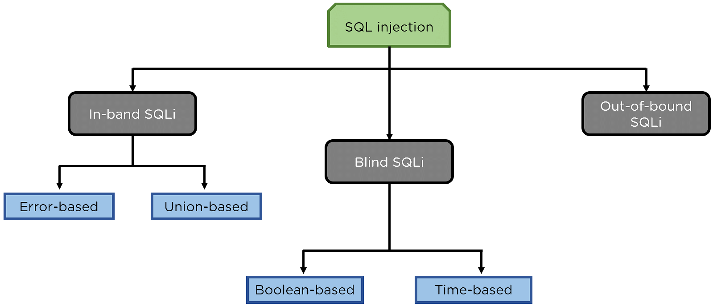
In-band SQLi - The attackers use the same communication channel to launch their attacks and collect results.
The two common types of in-band SQL injections are Error-based SQL injection and Union-based SQL injection.
- Error-based SQL injection - Here, the attacker performs certain actions that cause the database to generate error messages. Using the error message, you can identify what database it utilizes, the version of the server where the handlers are located, etc.
- Union-based SQL injection - Here, the UNION SQL operator is used in combining the results of two or more select statements generated by the database, to get a single HTTP response. You can craft your queries within the URL or combine multiple statements within the input fields and try to generate a response.

KT1503 SQL injection methodology and tools
What Does SQL Injection Tool Mean?
A SQL injection tool is a tool that is used to execute SQL injection attacks. SQL injection is the attempt to issue SQL commands to a database via a website interface. This is to gain stored database information, including usernames and passwords. There are many different SQL injection tools available, which perform different techniques to exploit SQL injection vulnerabilities in webpages and web applications.
Pen testers and Blackhat hackers both make use of these tools to execute privilege escalations, dump data and efficiently control sensitive databases.
Techopedia Explains SQL Injection Tool
SQL injection tools trigger attacks to exploit the security vulnerability available in an application's database layer. Usually, databases comprise things such as (but are not limited to):
- Site content and themes
- Authentication credentials
- Other identification data of the users, such as the IP address
- Site configurations
- Communication between users inside the site
Some popular SQL injection tools are:
- Havij SQL Injection: A popular automated SQL injection tool that helps its users to detect and exploit SQL injection vulnerabilities found on webpages. The intuitive graphical user interface as well as automated detections and settings makes this tool ideal for even novice users.
- Pangolin: An automated SQL injection tool that capitalizes on the SQL injection vulnerabilities found in Web applications.
- The Mole: Another automated SQL injection exploitation tool that can detect and exploit the injection vulnerability by simply using a valid string and a vulnerable URL. The Mole uses either a boolean-query-based technique or the union technique to carry out the injection.
- SQLNinja: The main objective of SQL Ninja is to take advantage of the SQL injection vulnerabilities on Web applications that make use of Microsoft SQL Server as back end.

KT1504 Evasion techniques
SQL injection is one of the biggest challenges for the web application security. Based on the studies by OWASP, SQL injection has the highest rank in the web-based vulnerabilities. In case of a successful SQL injection attack, the attacker can have access to the web application database. With the rapid rise of SQL injection-based attacks, researchers start to provide different security solutions to protect web application against them. One of the most common solutions is the using of web application firewalls.
Usually, these firewalls use signature-based technique as the main core for the detection. In this technique the firewall checks each packet against a list of predefined SQL injection attacks known as signatures. The problem with this technique is that, an attacker with a good knowledge of SQL language can change the look of the SQL queries in a way that firewall cannot detect them but still they lead to the same malicious results. In this paper first we described the nature of SQL injection attack, then we analysed current SQL injection detection evasion techniques and how they can bypass the detection filters, afterward we proposed a combination of solutions which helps to mitigate the risk of SQL injection attack.

KT1505 Countermeasures
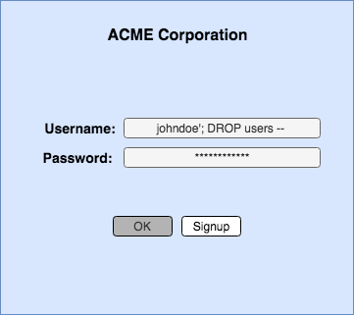
- Use Stored Procedure, Not Dynamic SQL.
- Use Prepared Statements.
- Use Object Relational Mapping (ORM) Framework.
- Least Privilege.
- Input Validation.
- Character Escaping.
- Vulnerability Scanners.
- Use Web Application Firewall.

Internal Assessment Criteria and Weight
- IAC1501Risks and mitigation of SQL injection are interrogated

KM-03-KT16: Hacking Wireless Networks
Topic elements to be covered include:
- KT1601Wireless concepts
- KT1602Wireless encryption
- KT1603Wireless threats
- KT1604Wireless hacking methodology and tools
- KT1605Bluetooth hacking
- KT1606Countermeasures and security tools
- KT1607Wi-Fi Pen Testing

KT1601 Wireless concepts
Computer networks that are not connected by cables are called wireless networks. They generally use radio waves for communication between the network nodes. They allow devices to be connected to the network while roaming around within the network coverage.
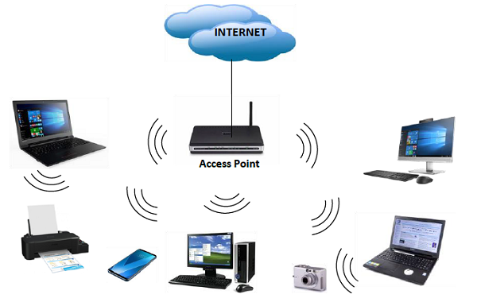
Types of Wireless Networks
- Wireless LANs − Connects two or more network devices using wireless distribution techniques.
- Wireless MANs − Connects two or more wireless LANs spreading over a metropolitan area.
- Wireless WANs − Connects large areas comprising LANs, MANs and personal networks.
Advantages of Wireless Networks
- It provides clutter-free desks due to the absence of wires and cables.
- It increases the mobility of network devices connected to the system since the devices need not be connected to each other.
- Accessing network devices from any location within the network coverage or Wi-Fi hotspot becomes convenient since laying out cables is not needed.
- Installation and setup of wireless networks are easier.
- New devices can be easily connected to the existing setup since they needn’t be wired to the present equipment. Also, the number of equipment that can be added or removed to the system can vary considerably since they are not limited by the cable capacity. This makes wireless networks very scalable.
- Wireless networks require very limited or no wires. Thus, it reduces the equipment and setup costs.
Examples of wireless networks
- Mobile phone networks
- Wireless sensor networks
- Satellite communication networks
- Terrestrial microwave networks

KT1602 Wireless encryption
In general, encryption is the process of transforming the data, into some kind of cyphertext that would be non-understandable for any 3rd party that would intercept the information. Nowadays, we use encryption every single day, without even noticing. Every time you access your web bank or mailbox, most often when you log in to any type of web page, or create a VPN tunnel back to your corporate network.
Some information is too valuable, not to be protected. And, to protect the information efficiently, it must be encrypted in a way that would not allow an attacker to decrypt it. To be honest with you guys - there is no fully secure encryption scheme. All the algorithms that we use every day may be broken, but what is its likelihood of this happening with current technology and time?
For example, it might take around eight years to break encryption "X" using new super-fast computers. Is that risk big enough, to stop using algorithm "X" for encryption? I doubt it, the information to be protected might be outdated at that point of time.
Types of Wireless Encryption
To start speaking about wireless encryption, it is worth saying that there are 2 types of encryption algorithms: Stream Cipher and Block Cipher.
- Stream Cipher − It converts plaintext into cyphertext in a bit-by-bit fashion.
- Block Cipher − It operates on the fixed-size blocks of data.
The most common encryption algorithms are collected in the following table −
Encryption Algorithm | Type of encryption algorithm | Size of data block
RC4 | Stream cipher | ---
RC5 | Block cypher | 32/64/128 bits
DES | Block cypher | 56 bits
3DES | Block cypher | 56 bits
AES | Block cypher | 128 bits
The ones that you will most likely meet (in some form) on the wireless networks are RC4 and AES.
WEP vs WPA vs WPA2
There are three widely known security standards in the world of wireless networking. The biggest difference between those three, are the security model they can provide.
Security Standard | Encryption algorithm user | Authentication methods | Possibility of breaking the encryption
WEP | WEP (based on RC4) | Pre-Shared Key (PSK) | - Initialization Vector (IV) collision attack  - Weak Key Attack  - Reinjection Attack  - Bit flipping attack
WPA | TKIP (based on RC4) | Pre-Shared Key (PSK) or 802.1x | - cracking the password during initial 4-way handshake (assuming that it's relatively short password <10 characters)
WPA2 | CCMP (based on AES) | Pre-Shared Key (PSK) or 802.1x
WEP was the first wireless "secure" model that was supposed to add authentication and encryption. It is based on RC4 algorithm and 24 bits of Initialization Vector (IV). This is the biggest drawback of the implementation that leads to WEP being crack able within a few minutes, using the tools that anyone can have installed on their PCs.
In order to enhance the security, WPA2 was invented with strong encryption model (AES) and a very strong authentication model based on 802.1x (or PSK). WPA was introduced just as a staging mechanism for smooth transition to WPA2. A lot of wireless cards did not support the new AES (at that time), but all of them were using RC4 + TKIP. Therefore WPA was also based on that mechanism, just with a few advancements.
Weak Initialization Vectors (IV)
Initialization Vector (IV) is one of the inputs to the WEP encryption algorithm. The whole mechanism is presented in the following diagram −
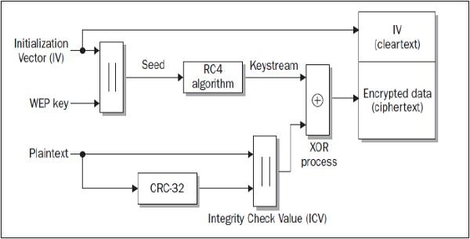
As one can notice, there are two inputs to the algorithm, one of which is a 24-bit long IV (that is also added to the final ciphertext in a clear text) and the other is a WEP key. When trying to crack this security model (WEP), one has to collect a large number of wireless data frames (large number of frames until the frame with duplicate IV vector value is found).
Assuming that for WEP, the IV has 24 bits. This means that it could be any number from two frames (if you are lucky enough) to 2²⁴ + 1 (you collect every single possible IV value, and then, the very next frame must be a duplicate). From the experience, I can say that, on a rather crowded wireless LAN (around 3 clients sending the traffic all the time), it is a matter of 5-10 minutes to get enough frames, to crack the encryption and derive the PSK value.
This vulnerability is only present in WEP. WPA security model uses TKIP that solved weak IV by increasing its size from 24 bits to 48 bits, and making other security enhancements to the diagram. Those modifications made the WPA algorithm much more secure and prone to this type of cracking.

KT1603 Wireless threats
Some of the common network attacks have been outlined below.
- Rogue access points. A rouge access point is basically an access point that has been added to one's network without one's knowledge.
- Jamming/Interference.
- Evil twin.
- War driving.
- Bluejacking.
- Bluesnarfing.
- War chalking.
- IV attack.

KT1604 Wireless hacking methodology and tools
Wi-Fi Discovery
Wi-Fi discovery is a process used to learn about WLAN's presence in the environment. WiFi discovery process is not against any law, since you are not acting offensively at any point, you are simply, passively listening to the Wi-Fi frequency bands, using your wireless client.
In order to discover what type of WLAN networks are present, you need to use specific tools that uses wireless hardware and listens on either a 2.4GHz or a 5GHz band. Some of them are built-in to the operating system (they are most often very ineffective for detailed WLAN analysis), and other ones are simple tools, which you can find on the internet. There are hundreds or thousands of tools out there in the market.
I will present to you 2 of them, that I really enjoyed due to its simplicity. What you will discover, while going through these chapters (or you already know it from your experience), the tools delivered for Windows OS have better graphics and some fancy graphical features, opposite to what Linux-based tools provide. But I can promise you, the ones based on Linux provide exactly the same information (just in more text-like format). On the other hand, it is a bit easier to write scripts, that takes outputs of one tools as the input to other ones.
For Windows users, you should have a look at the Xirrus Wi-Fi Inspector (it can be used for free). This is a simple tool that identifies WLANs present in the nearby vicinity. Another tool that performs the same functions in the Windows environment is Net Stumbler.
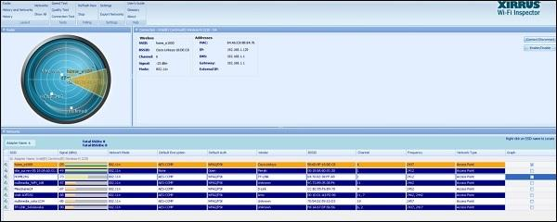
The information which you can extract from the table at the bottom of the above screenshot provides everything you may look for, like SSID name, received signal strength, 802.11 standard used, encryption and authentication set on WLAN, BSSID (MAC address of the AP, in case you would like create a fake AP with the same MAC address) and what channel it operates on. This is a lot of! You can also see, very fancy graphical "radar" showing, how far particular networks are, from your current location - the same information may be read from Signal (dBm) field.
On the other side, when using Linux (I use Kali distribution for penetration testers - you should try as well), the equivalent of that would be a tool called airodump-ng. The set of information, that air dump-ng output to the user is shown in the following screenshot. Also, we have another well-known tool called as Kismet.
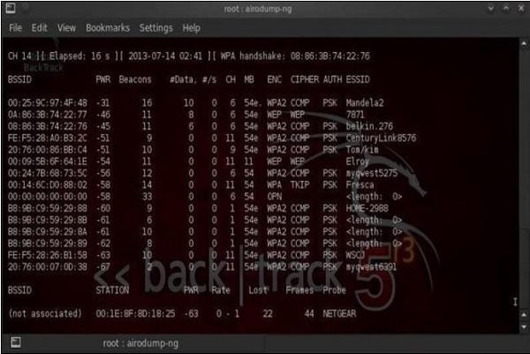
Wardriving
Wardriving is the process of finding a Wireless Network (wireless network discovery) by a person in a car using their personal laptop, smartphone or other wireless client tools. Basically, the intention is to find some free-access wireless network, that malicious user can use without any legal obligations. Examples might be some market, that offer free Wi-Fi, without registration or some hotel that you can just register with fake data.
The method of finding those WLAN's are exactly the same as described above in this wireless discovery section.
GPS Mapping
There is a number of satellites that orbit the globe, each of them sending a low-power radio signal towards the piece of earth it covers. The GPS device that you use, it may be for example a smartphone with google maps application started, receives that signal from multiple satellites at the same time. The device itself combines those signals together and calculate current geographical location on earth.
The idea of GPS mapping is to map a wireless network that the user encounters on the global map of wireless network in reference to its geographical location. One may use the already mentioned Kismet tool to map its wireless network to the geographical location, and then put its coordinates on the google earth map.

KT1605 Bluetooth hacking

A wireless technology that enables individuals to be hands-free while connected to their mobile devices for audio, navigation, and more. Bluetooth is enabled on many devices such as mobile phones, laptops, iPads, headphones, etc. which can be an invitation for hackers to compromise this functionality.
Most people leave their Bluetooth enabled all the time when they should only really enable it when needed. Of course, this is much easier said than done, and therefore unlikely to be followed. To showcase some of the dangers of careless Bluetooth usage, here are five common vulnerabilities that when exploited can allow hackers to hack Bluetooth devices.
Common Bluetooth Hacks and Vulnerabilities:
- BlueBorne
- Bluesnarfing
- Bluejacking
- Bluetooth Impersonation Attacks (BIAS)
- BlueBugging
1. BlueBorne
The name BlueBorne was derived from the fact that it can “spread through the air (airborne) and attack devices via Bluetooth” (Armis). When this vulnerability has been exploited, hackers can “leverage Bluetooth connections to penetrate and take complete control over targeted devices” (Armis).
Which devices does this vulnerability affect?
- Computers
- Mobile phones
- IoT devices
How to Prevent BlueBorne Attack?
- Turn off Bluetooth when not used
- Update your devices system software to make sure it is on its latest version
- Do not use public Wi-Fi and make sure to use VPN an additional security measure
2. Bluesnarfing
Bluesnarfing attack is a type of network attack that occurs when a hacker “pairs with your Bluetooth device without your knowledge and steals or compromises your personal data” (Globalsign).
This attack occurs without the victim’s knowledge and will only work when the device has Bluetooth turned on their device. Bluesnarfing allows hackers to take information which could lead to a more harmful cyberattack.
How To Prevent Bluetooth Hacks via Bluesnarfing?
- Turn off Bluetooth when not in use
- Do not pair with untrusted devices
- Do not keep sensitive information on a Bluetooth device
- Use strong password/PIN
3. Bluejacking
Bluejacking happens when “one Bluetooth device hijacks another with spam advertising and usually has a broadcasting range of ten meters or about thirty feet” (AT&T Cybersecurity).
This means that the hacker could possibly be in the same room as you. This specific attack does not give attackers access to your device or the information on it, rather it's used to spam users' devices and to be annoying. The attack is performed without the user’s knowledge.
How To Prevent Bluejacking?
- Turn off Bluetooth when not in use
- Ignore spam messages if you receive them
4. Bluetooth Impersonation Attacks (BIAS)
Another way for bad actors to hack Bluetooth devices is through Bluetooth impersonation attacks. Attackers target the “legacy secure connection authentication procedure during the initial secure connection establishment” (h-isac).
The primary exploit in BIAS attacks is that the “Bluetooth standard does not require the use of legacy authentication procedure mutually during secure connection establishment” (h-isac).
If the exploit is successfully executed then the hacker can act as a man-in-the-middle to intercept sensitive data shared between the two connected devices.
How To Prevent BIAS?
The Bluetooth Special Interest Group (SIG) introduced “mutual authentication requirements along with checking for connection types to prevent connection downgrade attacks” (CPO Magazine).
5. BlueBugging
This exploit was developed after hackers realized how easy Bluejacking and Blue Snarfing Bluetooth hacks could be conducted.
BlueBugging uses “Bluetooth to establish a backdoor on a victim’s phone or laptop” (AT&T Cybersecurity). Not only can the attacker hack Bluetooth devices, but they can also view all data on your device.
How To Prevent Bluebugging?
- Turn off Bluetooth function when it is not needed
- Do not accept pair requests from unknown devices
- When you are pairing with a device for the first time, do it at home
- Make sure you always have the latest system software
Bluetooth Safety Tips
Two devices can be paired when they are relatively close in distance which gives hackers the opportunity to intervene.
These are a few safety tips that individuals should follow:
- Turn off Bluetooth function when it is not needed
- Do not accept pair requests from unknown devices
- Make sure you always have the latest system software
- Ensure that your purchased device has adequate security features
Final Thoughts on Preventing Bluetooth Hacks
Bluetooth is a popular functionality on most devices today which is a reason why attackers are so interested in hacking these devices.
The five hacks that were discussed above were only a few attack methods that I found important to discuss, but there are definitely more vulnerabilities that exist. If you pay close attention to each hack, the ways to prevent each one is almost all the same.
Bluetooth products are used on a daily basis whether it is to connect to the speakers in your car or your headsets. Therefore, it is very important to educate individuals and companies about Bluetooth safety to prevent such attacks from occurring.
When attackers successfully gain access to your device, they have the capability to spy on your communications, manipulate and steal sensitive information. Bluetooth attacks will continue to occur either with existing attacks or from zero-day vulnerabilities. People are addicted to their phones and tend to keep all kinds of information on there, so do your part to make sure that attackers cannot easily hack your Bluetooth device.

KT1606 Countermeasures and security tools

Vulnerabilities and Attacks on Wireless Networks
Denial of service: DoS is a common network security problem, and it refers to an attempt to disrupt the function of a service. This attack occurs when an attacker continually bombards a targeted AP (Access Point) or network with bogus requests, premature successful connection messages, failure messages, and other commands.
DOS attacks rely on the abuse of protocols such as the Extensible Authentication Protocol (EAP). Attacks that use the consumer-grade 802.11 cards are much easier to carry out. Several DoS attacks can target particular stations or networks. We can use an adapter that supports the CW Tx mode, with the low-level utility to invoke continuous transmissions.
Evil Twin Attack: it is a wireless AP that pretends to be a legitimate AP by imitating its SSID. The attacker sets up a rogue AP outside the network perimeter and lures the users to sign in to this AP. This fools unsuspecting users into connecting with the evil twin signal and allows data to be read or sent over the internet. The attacker uses tools such as KARMA that monitors station probes to create an evil twin.
Rogue (or Unauthorized/Ad-Hoc) Access Points: The idea is to ‘fool’ some of the authorized devices in the area to associate with the false access point rather than the legitimate one. Any group of users agreed on an SSID, and a channel can form a network without an Access Point
The security implications are potentially serious, as each user can be attacked by any of the other users connected to the network. Many default operating system configurations allow ad-hoc networking. For example, Windows XP allows connections to both AP and ad-hoc networks by default, so a user could inadvertently join an ad-hoc network and be open to attack.
Man-in-the-middle: it is a type of confidentiality attack. The attacker attempts to intercept the confidential information sent over a wireless network. Attacker entices computers to log into a computer set up as a soft AP (Access Point). Once this is done, the hacker connects to a real access point through another wireless card, offering a steady flow of traffic to the entire network through the transparent hacking computer.
KRACK (Key Reinstallation Attack): exploits the flaws in implementing the four-way handshake in the WPA2 authentication protocol. But not all parts of that handshake are required. To speed up re-connections, the third part is retransmitted. That third part of the handshake may be repeated several times, and it is this step could be used in a wireless network attack. This attack works against all modern protected Wi-Fi networks; any device that runs Android, Linux, Windows, Apple Open BSD, or Media Tek is vulnerable to KRACK.
Countermeasures
1. Wireless security has layers that increase the scope of preventing an attack.
- Wireless signal security: The network and the RF spectrum within the environment must be continuously monitored and managed to identify the threats and awareness capability.
- Connection security: Per frame/packer authentication protects against MITM attacks.
- Device security: Vulnerability and patch management are crucial components of security infrastructure.
- Data protection: Encryption algorithms such as WPA3, WPA2, and AES can be utilized to protect data.
- Network protection: Strong authentication processes such as passphrases instead of password and alphanumeric ensure that only authorized users gain access to the network.
- End-user protection: personal firewalls installed on the end-user systems prevents the attacker from accessing the data.
2. The use of public networks must be avoided. Even if the public network is used, it is necessary to use Trusted VPNs to access the private network to maintain the integrity and confidentiality of the data.
3. DNS must be preferred over TLS (Transport Layer Security) and DTLS ( datagram TLS) to encrypt the DNS traffic for integrity protection. This also defends against the ALTEr attacks.
4. Implementation of RFC 7858/RFC 8310 to prevent DNS spoofing attacks. It also increases the encryption and intelligent policies for name resolution.

KT1607 Wi-Fi Pen Testing
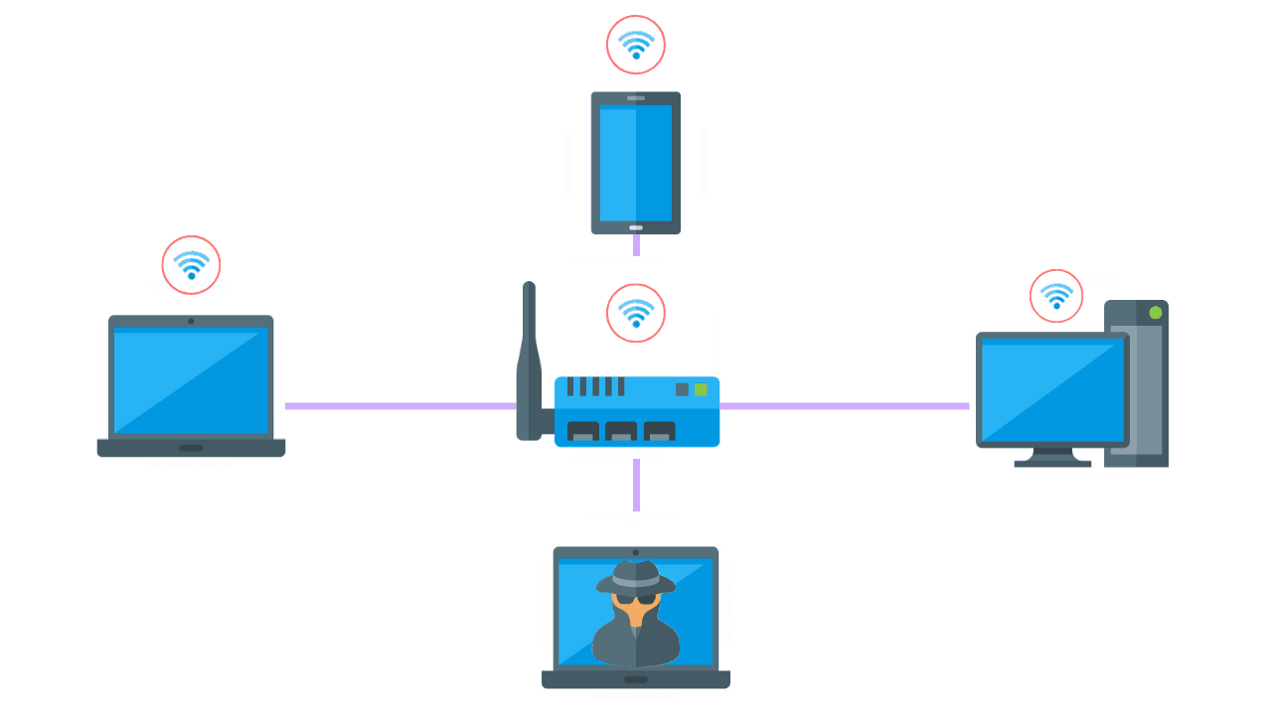
The term WiFi refers to wireless network technology that uses radio waves to establish wireless network connections. Due to the nature of WiFi and its methods for providing network access, malicious hackers often choose to penetrate a company by compromising its WiFi network and corresponding infrastructure devices. Homes are also at risk, especially due to the rise of IoT connected devices and appliances.

Wireless penetration testing is comprised of six main steps including reconnaissance, identifying wireless networks, vulnerability research, exploitation, reporting, and remediation. These tests are performed primarily to maintain secure software code development throughout its lifecycle. Coding mistakes, specific requirements, or lack of knowledge in cyber attack vectors are the main purpose of performing this type of penetration test.

Internal Assessment Criteria and Weight
- IAC1601Risks and mitigation of hacking wireless networks are interrogated

KM-03-KT17: Hacking Mobile Platforms
Topic elements to be covered include:
- KT1701Mobile platform attack vectors
- KT1702Hacking android OS
- KT1703Hacking iOS
- KT1704Mobile spyware
- KT1705Mobile device management
- KT1706Mobile security guidelines and tools
- KT1707Mobile pen testing

KT1701 Mobile platform attack vectors
By definition, an Attack Vector is a method or technique that a hacker uses to gain access to another computing device or network in order to inject a “bad code” often called payload. This vector helps hackers to exploit system vulnerabilities. Many of these attack vectors take advantage of the human element as it is the weakest point of this system. Following is the schematic representation of the attack vectors process which can be many at the same time used by a hacker.
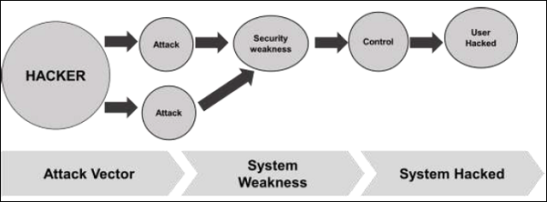
Some of the mobile attack vectors are −
- Malware
  - Virus and Rootkit
  - Application modification
  - OS modification
- Data Exfiltration
  - Data leaves the organization
  - Print screen
  - Copy to USB and backup loss
- Data Tampering
  - Modification by another application
  - Undetected tamper attempts
  - Jail-broken devices
- Data Loss
  - Device loss
  - Unauthorized device access
  - Application vulnerabilities
Consequences of Attack Vectors
Attack vectors is the hacking process as explained and it is successful, following is the impact on your mobile devices.
- Losing your data − If your mobile device has been hacked, or a virus introduced, then all your stored data is lost and taken by the attacker.
- Bad use of your mobile resources − Which means that your network or mobile device can go in overload so you are unable to access your genuine services. In worse scenarios, to be used by the hacker to attach another machine or network.
- Reputation loss − In case your Facebook account or business email account is hacked, the hacker can send fake messages to your friends, business partners and other contacts. This might damage your reputation.
- Identity theft − There can be a case of identity theft such as photo, name, address, credit card, etc. and the same can be used for a crime.
Anatomy of a Mobile Attack
Following is a schematic representation of the anatomy of a mobile attack. It starts with the infection phase which includes attack vectors.
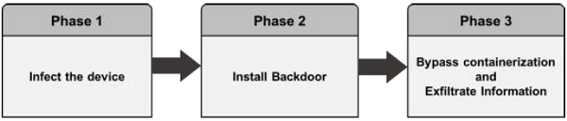
Infecting the device
Infecting the device with mobile spyware is performed differently for Android and iOS devices.
Android − Users are tricked to download an app from the market or from a third-party application generally by using social engineering attack. Remote infection can also be performed through a Man-in-the-Middle (MitM) attack, where an active adversary intercepts the user’s mobile communications to inject the malware.
iOS − iOS infection requires physical access to the mobile. Infecting the device can also be through exploiting a zero-day such as the Jailbreak ME exploit.
Installing a backdoor
To install a backdoor requires administrator privileges by rooting Android devices and jailbreaking Apple devices. Despite device manufacturers placing rooting/jailbreaking detection mechanisms, mobile spyware easily bypasses them −
Android − Rooting detection mechanisms do not apply to intentional rooting.
iOS − The jailbreaking “community” is vociferous and motivated.
Bypassing encryption mechanisms and exfiltrating information
Spyware sends mobile content such as encrypted emails and messages to the attacker servers in plain text. The spyware does not directly attack the secure container. It grabs the data at the point where the user pulls up data from the secure container in order to read it. At that stage, when the content is decrypted for the user’s usage, the spyware takes controls of the content and sends it on.
How Can a Hacker Profit from a Successfully Compromised Mobile?
In most cases most of us think what can we possibly lose in case our mobile is hacked. The answer is simple - we will lose our privacy. Our device will become a surveillance system for the hacker to observer us. Other activities of profit for the hacker is to take our sensitive data, make payments, carry out illegal activities like DDoS attacks. Following is a schematic representation.
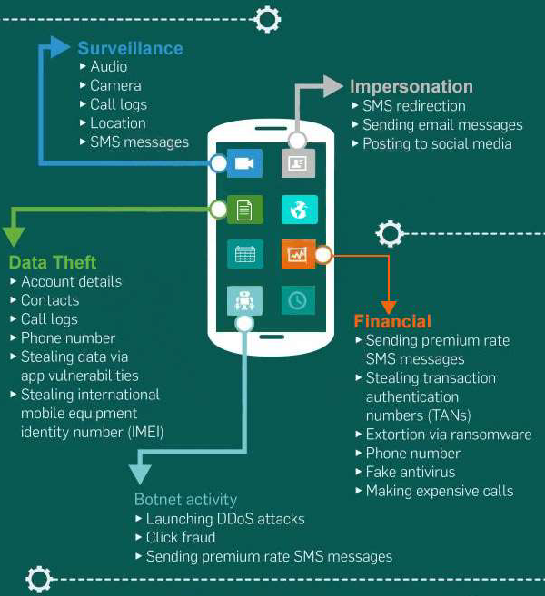
OWASP Mobile Top 10 Risks
When talking about mobile security, we base the vulnerability types on OWASP which is a not-for-profit charitable organization in the United States, established on April 21. OWASP is an international organization and the OWASP Foundation supports OWASP efforts around the world.
Vulnerability classifications.
M1-Improper Platform Usage
This category covers the misuse of a platform feature or the failure to use platform security controls. It might include Android intents, platform permissions, misuse of Touched, the Keychain, or some other security control that is part of the mobile operating system. There are several ways that mobile apps can experience this risk.
M2-Insecure Data
This new category is a combination of M2 and M4 from Mobile Top Ten 2014. This covers insecure data storage and unintended data leakage.
M3-Insecure Communication
This covers poor handshaking, incorrect SSL versions, weak negotiation, clear text communication of sensitive assets, etc.
M4-Insecure Authentication
This category captures the notions of authenticating the end user or bad session management. This includes −
- Failing to identify the user at all when that should be required
- Failure to maintain the user's identity when it is required
- Weaknesses in session management

M5-Insuficient Cryptography
The code applies cryptography to a sensitive information asset. However, the cryptography is insufficient in some way. Note that anything and everything related to TLS or SSL goes in M3. Also, if the app fails to use cryptography at all when it should, that probably belongs in M2. This category is for issues where cryptography was attempted, but it wasn't done correctly.

M6-Insecure Authorization
This is a category to capture any failures in authorization (e.g., authorization decisions in the client side, forced browsing, etc.) It is distinct from authentication issues (e.g., device enrolment, user identification, etc.)
If the app does not authenticate the users at all in a situation where it should (e.g., granting anonymous access to some resource or service when authenticated and authorized access is required), then that is an authentication failure not an authorization failure.
M7-Client Code Quality
This was the "Security Decisions Via Untrusted Inputs", one of our lesser-used categories. This would be the catch-all for code-level implementation problems in the mobile client. That's distinct from the server-side coding mistakes. This would capture things like buffer overflows, format string vulnerabilities, and various other code-level mistakes where the solution is to rewrite some code that's running on the mobile device.
M8-Code Tampering
This category covers binary patching, local resource modification, method hooking, method swizzling, and dynamic memory modification.
Once the application is delivered to the mobile device, the code and data resources are resident there. An attacker can either directly modify the code, change the contents of memory dynamically, change or replace the system APIs that the application uses, or modify the application's data and resources. This can provide the attacker a direct method of subverting the intended use of the software for personal or monetary gain.
M9-Reverse Engineering
This category includes analysis of the final core binary to determine its source code, libraries, algorithms, and other assets. Software such as IDA Pro, Hopper, otool, and other binary inspection tools give the attacker insight into the inner workings of the application. This may be used to exploit other nascent vulnerabilities in the application, as well as revealing information about back-end servers, cryptographic constants and ciphers, and intellectual property.
M10-Extraneous Functionality
Often, developers include hidden backdoor functionality or other internal development security controls that are not intended to be released into a production environment. For example, a developer may accidentally include a password as a comment in a hybrid app. Another example includes disabling of 2-factor authentication during testing.

KT1702 Hacking android OS

Since its release in 2008, adoption of Android has soared, and it is now by far the most common mobile operating system.
The reasons for Android's success are tied to its release as open source software, which allows application developers much better insight into its inner workings. The robust set of applications and extensions to Android translates to Android appearing on many different types of hardware.
In fact, Android has been so successful that it already captures more than 80% of the market share for mobile operating systems, with that number expected to climb to nearly 90% by 2022, according to Statista.
The same openness that makes Android appealing to mobile developers also makes it attractive to hackers. The open platform makes it easy to hack on. Of course, while most hackers simply enjoy experimenting with hardware and software, there are always going to be attackers who seek to exploit vulnerabilities.
Android Hacking Resources
There are hundreds of resources on the internet for people who want to get involved in Android hacking, from communities to lists of tools and guidebooks.
Here are a few places to get started:
- Veracode Community - Chat with security experts, hackers, and developers about all things application development, including security and modification.
- Android-Exploits - This is an open source guide on Android exploits and hacks from GitHub user sundaysec, with links to additional resources and tools.
- Hacking Android: 80 Pages of Experts' Tutorials - You'll find code and tutorials on Android security, hacking, and exploits from monthly hacking and cybersecurity magazine Hakin9.
- XDA Developers forum - This is an Android development and hacking community with millions of users.

KT1703 Hacking iOS
IOS
IOS uses proprietary software. The attacks on these phones are limited since they are not open source systems.

Types of IOS Attacks:
Jailbreaking:
Jailbreaking may put the device at risk. It is done to gain administrative privileges and to download third-party application extensions, etc. Though, the device may lose its warranty, get infected with malware, drop in performance, etc. There are three ways jailbreaking can be done-
Tethered:
After a device is jailbroken, it will no longer have a patched kernel; it might go to a partially functioning state and requires re-jailbreaking using the same computer.
Semi-tethered:
When the device is turned off and on, it will no longer be jailbroken. The device can be used for normal functions.
Untethered:
The device once jailbroken remains jailbroken, and the kernel will be patched completely after reboot.
Countermeasures:
- Do not jailbreak the device.
- Apply strong encryption.
- Always connect to safe networks.
- Follow common security guidelines.
- Do not open links/attachments from unknown sources.

KT1704 Mobile spyware

Mobile spyware
Short bio
Mobile spyware hides in the background (no shortcut icon is created) on a mobile device and steals information such as incoming/outgoing SMS messages, incoming/outgoing call logs, contact lists, emails, browser history, and photos. They can also potentially record inputted keystrokes, record anything within the distance of the device’s microphone, secretly take pictures in the background, and track the device’s location using GPS. In some cases, spyware apps can even control devices via commands sent by SMS messages and/or remote servers. Stolen information can be sent via data transfer to a remote server or through email.
History
Mobile spyware has been around since mobile devices became mainstream. With mobile devices being small and users not being able to see activity, these behaviours can run behind the scenes.
Common infection method
Infection occurs when an app with malicious code is installed. These apps vary from legitimate apps recompiled with malcode, straight up malicious apps with a fake name, and apps with fake download links. Apps can also be installed onto devices by abusers who want to stalk unsuspecting victims.
Associated families
- Spyware.Flexispy
- Spyware.Gizmo
- Spyware.GoldenEagle
- Spyware.GoneSixty
- Spyware.Gugespy
- Spyware.Krysanec
- Spyware.MobiStealth
- Spyware.Mspy
- Spyware.NickiSpy
- Spyware.Spyera
Remediation
These apps can be uninstalled using the mobile device's uninstall functionality, the tricky part is identifying the offending behaviour and app. That is where anti-malware software can help by identifying and removing these apps.
Aftermath
A victim’s stolen private information could be used for identity theft, or be used to be stalk them. In severe cases, spyware apps have been used by domestic violence abusers to locate victims who are under protective services.
Avoidance
Stick to trusted sources for mobile apps and avoid any third-party apps. If you suspect you are being stalked, run anti-malware software on your device to identity any spyware.

KT1705 Mobile device management
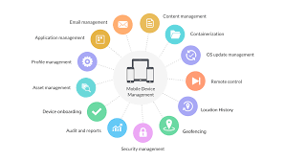
Mobile Device Management is any software that allows IT to automate, control, and secure administrative policies on laptops, smartphones, tablets, or any other device connected to an organization’s network.
Employees have become increasingly accustomed to using the device, operating system, and application of their choice. Because of the diversity of mobile devices, IT departments face a unique set of challenges while deploying and connecting internal content and resources.
Typically, mobile device management deploys an aggregate of corporate guidelines and certificates, on-device configurations, apps, backend software, and hardware to manage end-user devices. The goal of mobile device management is to maximize device support, organizational functionality, and security while allowing a degree of user flexibility, such as the use of BYOD.
Segmentation allows IT departments to seamlessly enforce security settings and compliance for specified users, groups, or geographic locations within an organization. To reduce costs, improve operational efficiency, and mitigate risks, including data and security breaches, organizations must implement a robust mobile device management framework.
Attention to mobile device management has intensified as the use of mobile devices has increased and grown more complex.

Why Mobile Device Management is Important?
Many factors have elevated mobile device management's importance to the C-suite. These include:
- Massive deployment of mobile applications requires tools to protect and manage assets.
- Growing concerns over security breaches stemming from employee mobile device usage.
- Standardization of mobile device management practices and processes.
Since employees now perform many if not most of their duties on mobile devices, organizations require enterprise mobility. Mobile device management facilitates remote work capabilities, tapping into the cloud for data access.
Employees’ mobile devices have become targets of malware, hackers, and exploitation due to the large amounts of data that is stored and transferred on each device. Organizations recognize their responsibility to secure and protect this data from loss while enabling their workforce to access fundamental resources.
As part of this responsibility, mobile device management delivers critical updates and patches for necessary apps and firmware, not only for functionality but also for security. Device management supports employee work and productivity with real-time data backups.
Too, the focus of mobile device management has turned toward a comprehensive view of device management, including desktops and laptops, and away from an emphasis on mobile platforms.

Mobile Device Management Features
Mobile device management allows network segregation—dividing the corporate network into subnets. Along with improved performance, network segregation delivers more secure connectivity since each subnet is dedicated to specific needs and functions. Only those with "a need to know" can access specified domains, protecting data and processes from both internal and external intruders.
Another feature mobile device management offers is application management - delivering an enterprise app catalogue to employees. An app catalogue is a virtual company "play store" that makes secure and compliant apps available for download. They can be accessed on a restricted basis, bypassing IT installation, and automatically updated with new versions that bolster functionality or security.
A related functionality is application monitoring—packet scanning of I/O requests in real-time across a cloud network. Mobile device management enables IT support to remotely administer devices, either to correct malfunctions or—should a security breach occur—lock and wipe the device of critical data. IT admins can monitor and audit devices for usage patterns and security vulnerabilities as well as balance loads and perform detailed analytics.
If a disaster event occurs, an organization must be prepared to restore backup data across a variety of devices and platforms. Mobile device management facilitates this process, plus restores corrupted or lost data should a system crash.
How Mobile Device Management Works?
Mobile device management solutions are typically administered with the use of servers and clients through centralized remote management. Mobile device management software platforms automatically identify network devices, manage their configurations, and support ease of use. The process is completely automated and easily allows for scalability.
A mobile device management software suite is configured using organizational management policies for apps and content and is device-OS specific. Basic functions include:
- OS configuration management
- Application inventory
- Hardware inventory
- Content management
- Admin remote actions (e.g., remote data wipe, troubleshooting, device lockout, etc.)

KT1706 Mobile security guidelines and tools
Mobile Device Security Best Practices
- Enable user authentication.
- Always run updates.
- Avoid public wifi.
- Use a password manager.
- Enable remote lock.
- Cloud backups.
- Use MDM/MAM.

KT1707 Mobile pen testing
Mobile apps are the next big thing in the world of software. As the number of smart devices continues to increase, likely, the number of mobile applications will also continue to grow. While the latest innovations in mobile devices have made many tasks quicker and easier, there’s no denying that the security of these problem-solving applications is not an easy task.
Mobile apps are a part of a larger mobile ecosystem that interacts with everything from the mobile device, network infrastructure, servers, and data centers. This gives rise to a complex attack surface. The attack surface is further expanded with the increased use of mobile devices with advanced capabilities such as sensors, global positioning systems (GPS), and near-field communication (NFC). With the increasing sophistication of cyber-attacks and the million-dollar bounties being offered for bugs in mobile apps, organizations have begun investing in mobile application penetration testing.
Recent examples of mobile app data leaks/hacks
The latest data surveyed by “report” shows that the data breaches have dramatically increased in the past few years. Hackers are developing new methods to access your personal information by compromising the applications installed on your mobile devices.
Here are some examples of recent data breaches via mobile app compromise:
- LinkedIn: In June 2021, LinkedIn encountered a vast data breach due to which data scraped from the 700 million users who appeared on a dark web forum earlier this year, impacting more than 90% of LinkedIn’s total user base.
- Pixlr: Pixlr is a general and free online photo editing software that suffered a data breach of 1.9M users. The records include name, email, password (hashed), gender, country, IP address
- Clubhouse: The clubhouse is a social audio app that suffered a data breach in April 2021. database containing 1.3 million scraped Clubhouse user records were leaked for free on a popular hacker forum.
What are the different types of Mobile apps organizations use?
In the mobile app industry, there are three main types of apps developers or organizations use to cater to their customers. Each class runs code on a different kind of device. Let’s take a look at these basic types and what they involve.
1. Native Mobile Apps
Native mobile apps are the ones that are downloaded on mobile devices. These kinds of apps are usually created for a specific platform like Android or iOS. There are many different types of programming languages that are used to build native applications such as Java, Kotlin, Python, Swift, Objective-C, C++, and React.
2. Hybrid Apps
Hybrid mobile apps are a relatively new concept for mobile development. The idea is to combine the best of both worlds: iOS and Android applications. They run on a mobile operating system and can be downloaded from the Google Play Store or the Apple App Store. Flutter is a UI software development kit created by Google to develop cross-platform applications for Android, iOS, Linux, Mac, Windows, Google Fuchsia, and the web from a single codebase.
3. Progressive Web Apps (PWA)
A Progressive Web App is a software app based on the web that will install on a system. In a nutshell, PWA is a web app but looks similar to regular (native) mobile apps. The primary purpose of PWA is to bring the best of the web to the app world and eliminate the hassles and limitations of traditional apps. A PWA works like a regular website and can be opened and used by any browser (including mobile browsers), but the main difference is that PWA apps also function as mobile apps and can be added to the home screen to be accessed like a native app.
Top 5 mobile app security risks
1. Insecure Data Storage: Data storage is one of the most important aspects of any application or device. If the application stores, transmit or process sensitive information, they need to keep it secure. This usually occurs when developers incorrectly assume users or malware cannot access specific device or system files. Hackers can access your device’s data or steal your information if you fail to store it securely.
2. Untrusted Inputs: The concept of trusted user input is not new. However, most developers are not aware of how it works, what problems it might cause and how to protect themselves from it. This is especially important for mobile applications, as most of their source code is available online, so there is no point in hiding it.
3. Insecure Communication: Insecure communication is a threat that can never be underestimated. When mobile applications are not developed carefully, they can leave their backend systems exposed to hackers. When mobile apps transmit data over the public Internet, mobile carrier networks disclose sensitive data to attack.
4. Insufficient Cryptography: If there is one thing that the world knows about cryptography, it is essential to keep our data safe. Insufficient cryptography can be caused by many reasons, including the lack of knowledge of the developers on a good encryption process or the inability to implement good encryption on the software.
5. Code Obfuscation: Code obfuscation is the process of transforming the source code of a software application to hinder attempts at reverse engineering or decomplication. Attackers use reverse engineering to understand how an app works to formulate exploits.

Internal Assessment Criteria and Weight
- IAC1701Risks and mitigation of hacking mobile platforms are interrogated

KM-03-KT18: IoT Hacking
Topic elements to be covered include:
- KT1801IoT concepts
- KT1802IoT attacks
- KT1803IoT hacking methodology and tools
- KT1804Countermeasures
- KT1805IoT pen testing

KT1801 IoT concepts
What is IoT?

The IoT is the network of physical devices, vehicles, home appliances, and other items embedded with electronics, software, sensors, actuators and connectivity which enables these things to connect and exchange data. The term “Thing” in “Internet of Things” is used quite broadly. For example, a thing within the IoT could be a person with a heart monitor implant, a pet with a biochip transponder, a vehicle that has built-in sensors to alert the driver when tire pressure is low — or any other natural or man-made object that an IP address can be assigned to, thus gaining the ability to transfer data over a network. As a result, it is becoming increasingly easy to create opportunities to directly integrate the physical world into computer-based systems which results in improvements, efficiency, economic benefits and reduced human exertion.
The definition of the IoT has evolved due to a convergence of multiple technologies such as wireless technology, machine learning, automation, micro-electromechanical systems, and the internet. This convergence has facilitated the bridging of the gap between operational technology and information technology, allowing unstructured machine-generated data to be analysed for insights that will drive innovation. The concept of a network of smart devices has been around since 1982. A modified Coke machine at Carnegie Mellon University became the first internet-connected appliance. The Coke Machine was able to report its inventory and whether newly loaded drinks were cold. The contemporary vision that we have of the IoT today, is in large part due to the efforts of Mark Weiser’s paper, “The Computer of the 21st Century.” His paper talked about ubiquitous computing, and how eventually technology would become so intertwined with our lives to the point where we couldn’t even imagine how life would be otherwise. In his book “Emerging Technologies for Learning,” David Becta describes ubiquitous computing as “ a vision of computing power ‘invisibly’ embedded in the world around us and accessed through intelligent interfaces: ‘Its highest ideal is to make a computer so embedded, so fitting, so natural, that we use it without even thinking about it.’ This is about a shift to human-centered computing, where technology is no longer a barrier, but works for us, adapting to our needs and preferences and remaining in the background until required. This implies a change in our relationship with ICT [Information and Communications Technology] to a much more natural way of interacting and using the power of networked computing systems which will be connected not just to the internet or other computers, but to places, people, everyday objects and things in the world around us.”
Practical Applications of IoT
In his 1999 presentation to Procter & Gamble, Kevin Ashton, the co-founder of the Auto-ID Center at the Massachusetts Institute of Technology, explained the potential of IoT: “Today computers — and, therefore, the internet — are almost wholly dependent on human beings for information. Nearly all of the roughly 50 petabytes (a petabyte is 1,024 terabytes) of data available on the internet were first captured and created by human beings by typing, pressing a record button, taking a digital picture or scanning a bar code. The problem is, people have limited time, attention and accuracy — all of which means they are not very good at capturing data about things in the real world. If we had computers that knew everything there was to know about things — using data they gathered without any help from us — we would be able to track and count everything and greatly reduce waste, loss and cost. We would know when things needed replacing, repairing or recalling and whether they were fresh or past their best.” Practical application of IoT technology can be seen in numerous industries, but I’ll focus on transportation and building management for this article.
IoT Example: Autonomous Vehicles
An autonomous vehicle, sometimes referred to as self-driving cars or driverless cars, is a vehicle that uses a combination of sensors, camera, radar and artificial intelligence (AI) to travel between destinations without a human operator. In order to qualify as being completely autonomous, a vehicle must be able to navigate without needing human intervention to a predetermined destination via roads that have not been adapted for its use.

AI technologies power self-driving car systems. Developers of autonomous vehicles use vast amounts of data from image recognition systems along with neural networks and machine learning. The intersection of these various fields results in being able to build systems that can drive autonomously. Neural networks identify patterns in the data, obtained through sensors and various other hardware, which is passed on to the machine learning algorithms. One prominent example is Google’s self-driving car which uses a mix of sensors and then combines all of the data generated by those systems in order to identify objects around the vehicle.
IoT Example: Smart Homes
Smart Home technology, also known as home automation is a classic example of the IoT in practice. Home automation provides home owners with comfort, security, convenience and improves energy efficiency by affording them the ability to control other smart devices, usually via a smart home app on their smartphone or a different networked device. Smart home systems and devices operate together and share consumer usage data among themselves in order to automate actions based on the owner’s preferences.

Today, almost every appliance associated with domestic life has a smart home option. A few examples:
- Smart TVs connect to the internet to access content through applications, such as on-demand video and music. Some smart TVs also include voice or gesture recognition.
- Using smart locks and garage-door openers, users can grant or deny access to visitors. Smart locks can also detect when residents are near and unlock the doors for them.
- Pet care can be automated with connected feeders. Houseplants and lawns can be watered by way of connected timers.
Concerns Associated with IoT
Invasion of Privacy & Unlawful Surveillance
As I mentioned earlier in the article, a thing is essentially any object that can be assigned an IP address. Unfortunately, as technology advances, so too does the potential for unethically using that technology increase. Briefly returning to our smart home example, and internet-connected door lock could possibly be used to monitor when a person enters or leaves their home. TVs with voice control capability could potentially be used as a listening device to eavesdrop on conversations. One potential defense against IoT attacks is to segment your network. This means creating two distinct networks in your house: one network houses mobile devices and personal computers while the other is reserved for IoT devices.
Network Security
One fundamental concern regarding IoT is the fact that the more devices you have, the more data you have to protect. A decade ago, most people just had to worry about protecting their personal computers. A few years later, we had to worry about protecting our smartphones as well. Now, there’s a plethora of “things” that we need to protect. The bottom line is that any device with built-in network connectivity is a potential security risk because hackers have more points within the network to exploit. Additionally, not only do we have to be concerned about where our data is stored, we also have to be wary of what data IoT devices transmit and where they ultimately end up.

KT1802 IoT attacks
IoT devices usually come with embedded sensors and various other technologies that allow them to collect data from the physical environment and pass it to the base station, where people monitor the situation and perform actions accordingly.
What are IoT attacks?
IoT devices are manufactured to fulfil the general needs of an organization; therefore, they lack strict security protocols. Attackers have been using this advantage to break into the system of an organization through any of the weak IoT devices.
IoT attacks are cyber-attacks that gain access to users' sensitive data with the help of any IoT device. Attackers usually install malware on the device, harm the device, or gain access to further personal data of the company.
For instance, an attacker may gain access to an organization's temperature control system through a security loophole in any IoT device. He can then influence the temperature of the rooms connected to the appropriate device.
What are the IoT attack surface areas?
As discussed, IoT devices are not built with proper security protocols. Hence, they are one of an organization's weakest links and pose a huge security threat. Following are the attacking zones where the attacks originate and compromise sensitive data:
Devices
Various parts of a device raise security threats for an organization, such as the memory, firmware, web interface, physical interface, and networking service of a device. Attackers can take advantage of these and initiate an IoT attack by finding a loophole in the device, such as an outdated component.
Communication channels
Channels that connect IoT devices to one another need to be secured; otherwise, an IoT attack can be easily initiated.
Applications and software
Applications and software connected to IoT devices also pose a threat to the security of the system. It is easy to access the IoT device by compromising the application or the software of the device.

KT1803 IoT hacking methodology and tools
Hacking tools make ethical hacking convenient because they help in automating the steps involved. Certified hackers can use them to perform certain functions that aid in finding loopholes in a device. Knowledge of existing flaws can then be shared with the manufacturers to help fortify their defenses better.
With that in mind, here’s a look at some of the popular IoT hacking tools that are capable of making every ethical hacker’s job easier.
Wireshark
Because IoT devices rely on networks to communicate with each other and with external routers, it’s crucial to find a way to capture packets and debug network information in order to find vulnerabilities. That’s where Wireshark comes in handy. Using the Export Objects feature within the tool, you can extract all of the network communication from the collected pcap data to see if an attacker is attempting to sniff the traffic generated by the IoT device.
Ethical hackers can also leverage the TCP handshake to set up a TCP communications channel in Wireshark for TCP reflection and DDoS amplification. As targets, TCP reflections DDoSing applications can be identified by programs within the network, especially those transmitting large quantities of SYN/ACK packets but receiving no response.
Fiddler
Fiddler is an open-source tool that enables users to track, manipulate and reuse HTTP requests. Many utilize it for debugging to see the HTTP requests their system is sending to a site or a service. What a lot of ethical hackers don’t know is that it can actually be used as an HTTP proxy.
In Fiddler’s settings, there’s a “Connections” tab that lets users choose a “Remote Connections” option. After that option has been selected, you can go to an IoT device that lets you configure a proxy and tell it to use your computer’s IP address as the HTTP proxy. By performing these steps, you will ensure that all types of activities performed on that device are routed via Fiddler.
As a result, you can scan the traffic going on between the server and the IoT device to look for issues like cleartext (which was found on the Nest thermostat).
Binwalk
Binwalk is a firmware extraction tool developed by Craig Heffner. It helps ethical hackers understand and analyse an IoT device’s firmware. Running binwalk on the firmware file of an embedded device will enable you to retrieve the contents of the file system and other data that is saved inside the firmware.
Once extracted, the tool can be used to analyse any version of common binaries to see if there is a corresponding exploit present in firmware images. Binwalk utilizes libmagic library, so it’s also compatible with magic signatures made for Unix file utilities. More details on Binwalk’s availability can be found here.
Firmwalker
Firmwalker is a bash script that scans the files extracted from the IoT firmware to see if they’re vulnerable. The only requirement is that the tool and the extracted firmware file should be in the same folder.
Once you put them in the same location, the output file generated by Firmwalker — Firmwalker.text — will highlight a list of potential issues, which can be any of the following:
- etc/ ssl directory
- etc/passwd and etc/shadow
- configuration, script and other .bin files
- Keywords like remote, admin, password, etc.
- Common binaries like dropbear, tftp and ssh
- Common web servers present on IoT devices
- Random IP addresses, email IDs, and URLs
- Experimental ability to use Shodan CLI for making a call to Shodan API
All the IoT devices facing any of these issues are vulnerable and can be attacked.
SAINT
It’s crucial to ensure that the cloud-facing interface of an IoT device is not susceptible to XSS, CSRF and SQLi. This is where SAINT – a static taint analysis program — shines.
Essentially, SAINT tracks the flow of information from sensitive sources (like internet connections) to discover sensitive data flows in IoT applications. It then conducts static taint analysis that monitors how source data propagates in the sink, e.g., network interface.
All of that is done by extracting an IR (immediate representation) from the source code of the IoT app. Run the SAINT analyser to get started and then wait for the IR to construct event handlers, call graphs and entry points.
SAINT does not say whether the data flows and potential leaks are harmful or malicious; however, an ethical hacker can further analyse SAINT’s output to learn whether an IoT app abides by its ethics and alert users to make an informed decision about app-related privacy risks, such as when the user location is transmitted.
OWASP ZAP (Zed Attack Proxy)
The web interfaces on some IoT devices don’t sign users out of their accounts after multiple failed login attempts, as well as offering inadequate protection against SQL injections and XSS. Fortunately, tools like Zed Attack Proxy allow ethical hackers to perform proxying, spidering and fuzzing in order to attack the web interface and find potential vulnerabilities.
Upon launching ZAP, the right-hand section will provide you with a URL section for specifying the target to scan. The tool also allows ethical hackers to launch their preferred browser for manual testing. Detected issues are transferred to the bottom section, where an “Alert” tab provides more information on the vulnerabilities discovered.
ZAP can be used to check if operating system commands have been abused to spy on the files present in the web app’s server hosting, whether proper input sanitization was applied on the input field with the help of malicious payloads like /etc/passwd& and more.
Metasploit
This is a suite of tools that can be used to perform attacks on IoT apps. Metasploit comes with a range of modules (software components that perform a certain attack on a chosen target) that can test the app for common vulnerabilities black-hat hackers exploit. Once launched, you can execute commands that use a module with an exploit that you want to run against the app to try and break it.
To give an example, several REST APIs are increasingly dependent on SSL. With Metasploit’s modules, you can test the system to see how it responds to SSL vulnerabilities like the popular Heartbleed flaw. Overall, the IoT hacking tool has hundreds of exploits that you can test the apps against.

KT1804 Countermeasures
How to prevent IoT attacks?
IoT devices are manufactured to perform basic organizational tasks. However, the organization implementing and incorporating these devices into their networks should be highly cautious of their security. Following measures can be taken to ensure device security:
- Have strong passwords for all IoT devices. Regularly change and update them.
- Configure the users and give access to the essential users only.
- Enable a two-factor authentication method to prevent any unauthorized access.
- Back up data regularly to a secondary device.
- Encrypt data between the IoT devices and the server.
- Place the device in a safe location to prevent any unauthorized access. We should not leave it unguarded.
- Give users limited data and device access, as per their requirements, to ensure data confidentiality.
- Regularly update software, application, and your operating system so that attackers cannot find a gap in your devices.
- Schedule regular security audits to discover any potential loopholes that can compromise security.
- Configure and detect all the devices, as well as the users connected to the devices. This ensures that the data is accounted for and prevents unwanted traffic.
- Companies should have recovery procedures and policies that can be immediately implemented if any device is compromised.

KT1805 IoT pen testing
What is IoT pen-testing?
An IoT penetration test is the assessment and exploitation of various components present in an IoT device solution to help make the device more secure.
These how typical penetration testing engagement looks.
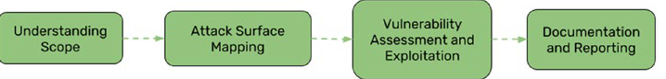
IoT penetration testing methodology overview
The first step of IoT pentesting is to map the entire attack surface of the solution, followed by identifying vulnerabilities and performing exploitation, which is then followed by post exploitation. The testing concludes with an in-depth technical report.
Attack Surface Mapping
Attack surface mapping means mapping out all the various entry point and exit point that attacker can potentially abuse in an IoT device solution. This the is the most important step in entire IoT pentesting methodology. It also involves creating an architecture diagram of the entire product from a pentesters perspective. Most pentester spend their time on this phase for entire day. In a case where the exploit is extremely easy and leads to successful compromise and retrieval of sensitive data from the device, that would be classified as a high-priority, high-criticality vulnerability. By contrast, something that is difficult to execute — with output obtained during the test that is not that useful — would be categorized as a low-criticality, low-priority vulnerability.
Now we will understand how we can perform attack surface mapping
When you get new device take time to understand the target starting with partial and incomplete information is the biggest mistake a pentester makes. Collect as much as information you can, you can collect information like device documentation and manuals, online resources and posts about the product, and any available content or prior research about the device.
Take notes of various components used in the device like CPU architecture type, communication protocols used, mobile application details, firmware upgrade process, hardware ports, external media support on devices, and pretty much anything else that you can find.
The architecture of the device can be broadly divided into three categories
- Embedded device.
- Firmware, software, and applications.
- Radio communications.

Internal Assessment Criteria and Weight
- IAC1801Risks and mitigation of IoT hacking are interrogated

KM-03-KT19: Cloud Computing
Topic elements to be covered include:
- KT1901Cloud computing concepts
- KT1902Cloud computing threats and attacks
- KT1903Cloud security
- KT1904Cloud security tools
- KT1905Cloud penetration testing

KT1901 Cloud computing concepts
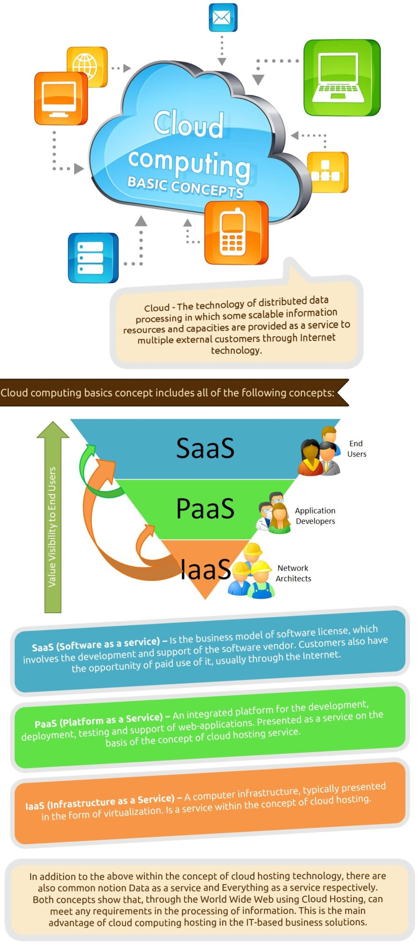
Cloud – The technology of distributed data processing in which some scalable information resources and capacities are provided as a service to multiple external customers through Internet technology.
Cloud computing basics concept includes all of the following concepts:
IaaS (Infrastructure as a Service) – A computer infrastructure, typically presented in the form of virtualization. Is a service within the concept of cloud hosting.
PaaS (Platform as a Service) – An integrated platform for the development, deployment, testing, and support of web-applications. Presented as a service on the basis of the concept of cloud hosting.
SaaS (Software as a service) – This is the business model of the software license, which involves the development and support of the software vendor. Customers also have the opportunity of paid use of it, usually through the Internet.
DaaS (Desktop as a Service) – Another business model license the software, which is a slightly improved model of SaaS, mostly involving the use of multiple services at the same time necessary to complete the work. Was first introduced in the early 2000s.
In addition to the above within the concept of cloud hosting technology, there are also common notions of Data as a service and Everything as a service respectively. Both concepts show that, through the World Wide Web using Cloud Hosting, can meet any requirements in the processing of information. This is the main advantage of cloud computing hosting in IT-based business solutions.

KT1902 Cloud computing threats and attacks
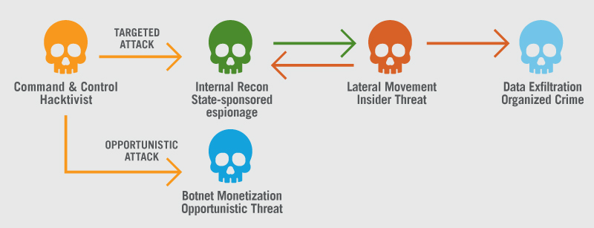
Almost every organization has adopted cloud computing to varying degrees within their business. However, with this adoption of the cloud comes the need to ensure that the organization’s cloud security strategy is capable of protecting against the top threats to cloud security.
Misconfiguration
Misconfigurations of cloud security settings are a leading cause of cloud data breaches. Many organizations’ cloud security posture management strategies are inadequate for protecting their cloud-based infrastructure.
Several factors contribute to this. Cloud infrastructure is designed to be easily usable and to enable easy data sharing, making it difficult for organizations to ensure that data is only accessible to authorized parties. Also, organizations using cloud-based infrastructure also do not have complete visibility and control over their infrastructure, meaning that they need to rely upon security controls provided by their cloud service provider (CSP) to configure and secure their cloud deployments. Since many organizations are unfamiliar with securing cloud infrastructure and often have multi-cloud deployments – each with a different array of vendor-provided security controls – it is easy for a misconfiguration or security oversight to leave an organization’s cloud-based resources exposed to attackers.
Unauthorized Access
Unlike an organization’s on-premises infrastructure, their cloud-based deployments are outside the network perimeter and directly accessible from the public Internet. While this is an asset for the accessibility of this infrastructure to employees and customers, it also makes it easier for an attacker to gain unauthorized access to an organization’s cloud-based resources. Improperly-configured security or compromised credentials can enable an attacker to gain direct access, potentially without an organization’s knowledge.
Insecure Interfaces/APIs
CSPs often provide a number of application programming interfaces (APIs) and interfaces for their customers. In general, these interfaces are well-documented in an attempt to make them easily-usable for a CSP’s customers.

However, this creates potential issues if a customer has not properly secured the interfaces for their cloud-based infrastructure. The documentation designed for the customer can also be used by a cybercriminal to identify and exploit potential methods for accessing and exfiltrating sensitive data from an organization’s cloud environment.
Hijacking of Accounts
Many people have extremely weak password security, including password reuse and the use of weak passwords. This problem exacerbates the impact of phishing attacks and data breaches since it enables a single stolen password to be used on multiple different accounts.

Account hijacking is one of the more serious cloud security issues as organizations are increasingly reliant on cloud-based infrastructure and applications for core business functions. An attacker with an employee’s credentials can access sensitive data or functionality, and compromised customer credentials give full control over their online account. Additionally, in the cloud, organizations often lack the ability to identify and respond to these threats as effectively as for on-premises infrastructure.
Lack of Visibility
An organization’s cloud-based resources are located outside of the corporate network and run on infrastructure that the company does not own. As a result, many traditional tools for achieving network visibility are not effective for cloud environments, and some organizations lack cloud-focused security tools. This can limit an organization’s ability to monitor their cloud-based resources and protect them against attack.
External Sharing of Data
The cloud is designed to make data sharing easy. Many clouds provide the option to explicitly invite a collaborator via email or to share a link that enables anyone with the URL to access the shared resource.

While this easy data sharing is an asset, it can also be a major cloud security issue. The use of link-based sharing – a popular option since it is easier than explicitly inviting each intended collaborator – makes it difficult to control access to the shared resource. The shared link can be forwarded to someone else, stolen as part of a cyberattack, or guessed by a cybercriminal, providing unauthorized access to the shared resource. Additionally, link-based sharing makes it impossible to revoke access to only a single recipient of the shared link.
Malicious Insiders
Insider threats are a major security issue for any organization. A malicious insider already has authorized access to an organization’s network and some of the sensitive resources that it contains. Attempts to gain this level of access are what reveals most attackers to their target, making it hard for an unprepared organization to detect a malicious insider.

On the cloud, detection of a malicious insider is even more difficult. With cloud deployments, companies lack control over their underlying infrastructure, making many traditional security solutions less effective. This, along with the fact that cloud-based infrastructure is directly accessible from the public Internet and often suffers from security misconfigurations, makes it even more difficult to detect malicious insiders.
Cyberattacks
Cybercrime is a business, and cybercriminals select their targets based upon the expected profitability of their attacks. Cloud-based infrastructure is directly accessible from the public Internet, is often improperly secured, and contains a great deal of sensitive and valuable data. Additionally, the cloud is used by many different companies, meaning that a successful attack can likely be repeated many times with a high probability of success. As a result, organizations’ cloud deployments are a common target of cyberattacks.
Denial of Service Attacks
The cloud is essential to many organizations’ ability to do business. They use the cloud to store business-critical data and to run important internal and customer-facing applications.
This means that a successful Denial of Service (DoS) attack against cloud infrastructure is likely to have a major impact on a number of different companies. As a result, DoS attacks where the attacker demands a ransom to stop the attack pose a significant threat to an organization’s cloud-based resources.

KT1903 Cloud security
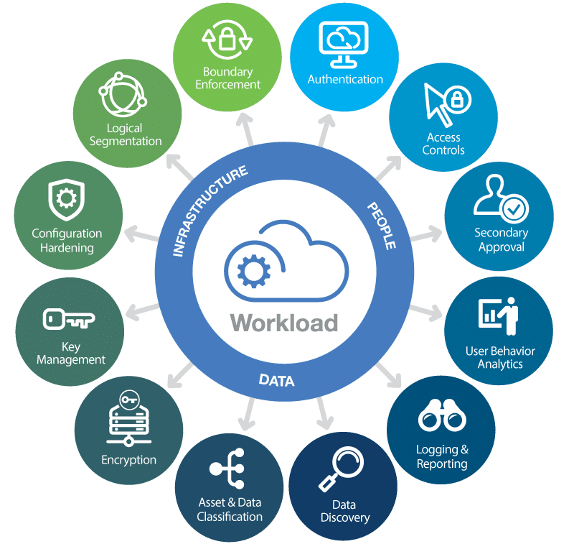
Why is cloud security important?
In modern-day enterprises, there has been a growing transition to cloud-based environments and IaaS, Paas, or SaaS computing models. The dynamic nature of infrastructure management, especially in scaling applications and services, can bring a number of challenges to enterprises when adequately resourcing their departments. These as-a-service models give organizations the ability to offload many of the time-consuming, IT-related tasks.
As companies continue to migrate to the cloud, understanding the security requirements for keeping data safe has become critical. While third-party cloud computing providers may take on the management of this infrastructure, the responsibility of data asset security and accountability doesn't necessarily shift along with it.
By default, most cloud providers follow best security practices and take active steps to protect the integrity of their servers. However, organizations need to make their own considerations when protecting data, applications, and workloads running on the cloud.
Security threats have become more advanced as the digital landscape continues to evolve. These threats explicitly target cloud computing providers due to an organization's overall lack of visibility in data access and movement. Without taking active steps to improve their cloud security, organizations can face significant governance and compliance risks when managing client information, regardless of where it is stored.
Cloud security should be an important topic of discussion regardless of the size of your enterprise. Cloud infrastructure supports nearly all aspects of modern computing in all industries and across multiple verticals.
However, successful cloud adoption is dependent on putting in place adequate countermeasures to defend against modern-day cyberattacks. Regardless of whether your organization operates in a public, private, or hybrid cloud environment, cloud security solutions and best practices are a necessity when ensuring business continuity.

What are some cloud security challenges?
Lack of visibility
It's easy to lose track of how your data is being accessed and by whom, since many cloud services are accessed outside of corporate networks and through third parties.
Multitenancy
Public cloud environments house multiple client infrastructures under the same umbrella, so it's possible your hosted services can get compromised by malicious attackers as collateral damage when targeting other businesses.
Access management and shadow IT
While enterprises may be able to successfully manage and restrict access points across on-premises systems, administering these same levels of restrictions can be challenging in cloud environments. This can be dangerous for organizations that don't deploy bring-your-own device (BYOD) policies and allow unfiltered access to cloud services from any device or geolocation.
Compliance
Regulatory compliance management is oftentimes a source of confusion for enterprises using public or hybrid cloud deployments. Overall accountability for data privacy and security still rests with the enterprise, and heavy reliance on third-party solutions to manage this component can lead to costly compliance issues.
Misconfigurations
Misconfigured assets accounted for 86% of breached records in 2019, making the inadvertent insider a key issue for cloud computing environments. Misconfigurations can include leaving default administrative passwords in place, or not creating appropriate privacy settings.

KT1904 Cloud security tools

- CrowdStrike Falcon. CrowdStrike Falcon is a sophisticated cloud security platform that detects and prevents security attacks using modern artificial intelligence and machine learning technologies.
- Pentera.
- Lookout.
- Centrify.
- Zerospam.
- Barracuda CloudGen Firewall.
- CyberArk.
- Silver Sky.

KT1905 Cloud penetration testing
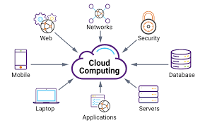
Cloud Penetration Testing is the process of detecting and exploiting security vulnerabilities in your cloud infrastructure by simulating a controlled cyber-attack. Cloud pentest is performed under strict guidelines from the cloud service providers like AWS, and GCP.
How Does Cloud Penetration Testing Differ from Penetration Testing?
In layman’s terms, penetration testing is the process of performing offensive security tests on a system, service, or network to find security weaknesses in it. So, when it comes to cloud penetration testing, it is just performing a simulated attack on your cloud services to test their security.
What is the Purpose of Cloud Penetration Testing?
The prime purpose of this is to find security issues in your cloud service before hackers do. Different types of manual methods and cloud penetration testing tools may be used depending on the type of your cloud service and the provider. However, since you do not own the cloud infrastructure/platform/software as an entity but rather as a service, there are several legal and technical challenges to performing cloud penetration tests. We shall read about them later in this article.
Most Common Cloud Vulnerabilities
There are quite a few vulnerabilities that can lead to a compromised cloud account. Mentioning each one is beyond the scope of this article so, the most prominent ones are mentioned below:
1. Insecure APIs
APIs are widely used in cloud services to share information across various applications. However, insecure APIs can also lead to a large-scale data leak as was seen in the case of Venmo, Airtel, etc. Sometimes using HTTP methods like PUT, POST, DELETE in APIs improperly can allow hackers to upload malware on your server or delete data. Improper access control and lack of input sanitization are also the main causes of APIs getting compromised which can be uncovered during cloud penetration testing.
2. Server misconfigurations
Cloud service misconfigurations are the most common cloud vulnerability today (misconfigured S3 Buckets, in particular). The most famous case was that of the Capital One data leak which led to the compromise of the data of roughly 100 million Americans and 6 million Canadians. The most common cloud server misconfigurations are improper permissions, not encrypting the data and differentiation between private and public data.
3. Weak credentials
Using common or weak passwords can make your cloud accounts vulnerable to brute force attacks. The attacker can use automated tools to make guesses thereby making way into your account using those credentials. The results could be disastrous leading to a complete account takeover. Since people tend to reuse passwords and use easily rememberable passwords, these attacks are fairly common. This fact can be verified during cloud penetration testing.
4. Outdated software
Outdated software contains critical security vulnerabilities that can compromise your cloud services. Most of the software vendors do not use a streamlined update procedure or the users disable automatic updates themselves. This makes the cloud services outdated which hackers identify using automated scanners. As a result, cloud services using outdated software are compromised by a large number.
5. Insecure coding practices
Most businesses try to get their cloud infrastructure built for as cheaply as possible. So, due to poor coding practices, such software often contains bugs like SQLi, XSS, CSRF. The ones which are most common among them are labeled as OWASP top 10. It is these vulnerabilities that are the root cause for the majority of cloud web services being compromised.

Internal Assessment Criteria and Weight
- IAC1901Risks, threats and vulnerabilities and mitigation of cloud computing are interrogated

KM-03-KT20: Cryptography
Topic elements to be covered include:
- KT2001Cryptography concepts and objectives
- KT2002Types of cryptography
- KT2003Encryption algorithms
- KT2004Cryptography tools
- KT2005Types of encryption
- KT2006Cryptanalysis
- KT2007Countermeasures

KT2001 Cryptography concepts and objectives
Cryptography is the art and science of keeping data secure. Cryptographic services help ensure data privacy, maintain data integrity, authenticate communicating parties, and prevent repudiation (when a party refutes having sent a message). Three major areas of concern: privacy, authentication, and integrity are addressed using Cryptography.
Basic encryption allows you to store information or to communicate with other parties while preventing non-involved parties from understanding the stored information or understanding the communication. Encryption transforms understandable text (plaintext) into an unintelligible piece of data (ciphertext). Decryption restores the understandable text from the unintelligible data. Both functions involve a mathematical formula (the algorithm) and secret data (the key).
Cryptographic Algorithms

There are two types of cryptographic algorithms:
Symmetric key algorithm
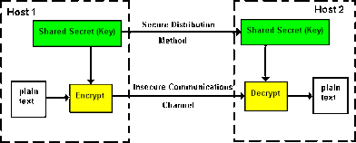

With a secret or symmetric key algorithm, the key is a shared secret between two communicating parties. Encryption and decryption both use the same key. The Data Encryption Standard (DES) and the Advanced Encryption Standard (AES) are examples of symmetric key algorithms and typical key sizes are 64, 128, or 192 bits.
There are two types of symmetric key algorithms:
- Block ciphers: In a block cipher, the actual encryption code works on a fixed-size block of data. Normally, the user's interface to the encrypt/decrypt operation will handle data longer than the block size by repeatedly calling the low-level encryption function. If the length of data is not on a block size boundary, it must be padded.
- Stream ciphers: Stream ciphers do not work on a block basis, but convert 1 bit (or 1 byte) of data at a time.
Asymmetric key algorithm
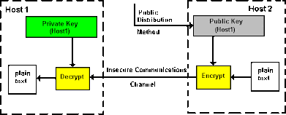

With a public key (PKA) or asymmetric key algorithm, a pair of keys is used. One of the keys, the private key, is kept secret and not shared with anyone. The other key, the public key, is not secret and can be shared with anyone. The keys share a special mathematical property when data is encrypted by one of the keys, it can only be decrypted and recovered by using the other key. The two keys are mathematically related, but it is virtually impossible to derive the private key from the public key. The RSA (after the inventors Rivest, Shamir, and Adelman) algorithm is an example of a public key algorithm.

Typical key sizes for public-key systems are 512 bits, 1,024 and increasingly 2048 bits, or even higher. Public key algorithms are slower than symmetric key algorithms. Applications typically use public key algorithms to encrypt symmetric keys (for key distribution) and to encrypt hashes (in digital signature generation).
Together, the key and the cryptographic algorithm transform the data. All of the supported algorithms are in the public domain. Therefore, it is the key that controls access to the data. You must safeguard the keys to protect the data.

Cryptographic Operations

Different cryptographic operations may use one or more algorithms. You choose the cryptographic operation and algorithm(s) depending on your purpose. For example, for the purpose of ensuring data integrity, you might want to use a MAC (message authentication code) operation with the AES algorithm. Crypto APIs provide access to the various cryptographic operations.
Data Privacy
Cryptographic operations for the purpose of data privacy (confidentiality) prevent an unauthorized person from reading a message. The following operations are included in data privacy:
Encryption/Decryption
The encrypt operation changes plaintext data into ciphertext through the use of a cipher algorithm and key. To restore the plaintext data, the decrypt operation must employ the same algorithm and key (in case of asymmetric keys, the other key). Encryption/decryption may be employed at any level of the operating system. Basically, there are three levels:

Field/Message level encryption: With field/message level encryption, the user application explicitly requests cryptographic services. The user application completely controls key generation, selection, distribution, and what data to encrypt. Web Service message level security is such an example.

Session level encryption: With encryption at the session layer, the system requests cryptographic services instead of an application. The application may or may not be aware that encryption is happening. SSL or HTTPS is such sesion level encryption.

Link Level encryption: Link level encryption is performed at the lowest level of the protocol stack, usually by specialized hardware. Bank ATM networks may implement hardware encryption.
Translate
The translate operation is used to decrypt data from encryption under one key to encryption under another key. This is done in one step to avoid exposing the plaintext data within the application program.

KT2002 Types of cryptography
Cryptography is technique of securing information and communications through use of codes so that only those people for whom the information is intended can understand it and process it. Thus, preventing unauthorized access to information. The prefix “crypt” means “hidden” and suffix graphs means “writing”. In Cryptography the techniques which are use to protect information are obtained from mathematical concepts and a set of rule-based calculations known as algorithms to convert messages in ways that make it hard to decode it. These algorithms are used for cryptographic key generation, digital signing, verification to protect data privacy, web browsing on internet and to protect confidential transactions such as credit card and debit card transactions.
Techniques used For Cryptography: In today’s age of computers cryptography is often associated with the process where an ordinary plain text is converted to cipher text which is the text made such that intended receiver of the text can only decode it and hence this process is known as encryption. The process of conversion of cipher text to plain text this is known as decryption.
Features Of Cryptography are as follows:
- Confidentiality: Information can only be accessed by the person for whom it is intended and no other person except him can access it.
- Integrity: Information cannot be modified in storage or transition between sender and intended receiver without any addition to information being detected.
- Non-repudiation: The creator/sender of information cannot deny his intention to send information at later stage.
- Authentication: The identities of sender and receiver are confirmed. As well as destination/origin of information is confirmed.
Types Of Cryptography: In general, there are three types of cryptography:
- Symmetric Key Cryptography: It is an encryption system where the sender and receiver of message use a single common key to encrypt and decrypt messages. Symmetric Key Systems are faster and simpler but the problem is that sender and receiver have to somehow exchange key in a secure manner. The most popular symmetric key cryptography system is Data Encryption System (DES).
- Hash Functions: There is no usage of any key in this algorithm. A hash value with fixed length is calculated as per the plain text which makes it impossible for contents of plain text to be recovered. Many operating systems use hash functions to encrypt passwords.
- Asymmetric Key Cryptography: Under this system a pair of keys is used to encrypt and decrypt information. A public key is used for encryption and a private key is used for decryption. Public key and Private Key are different. Even if the public key is known by everyone the intended receiver can only decode it because he alone knows the private key.
Applications Of Cryptography:
- Computer passwords
- Digital Currencies
- Secure web browsing
- Electronic Signatures
- Authentication
- Cryptocurrencies
- End-to-end encryption

KT2003 Encryption algorithms
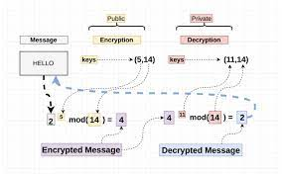
What is an encryption algorithm?
An encryption algorithm is the method used to transform data into ciphertext. An algorithm will use the encryption key in order to alter the data in a predictable way, so that even though the encrypted data will appear random, it can be turned back into plaintext by using the decryption key.
What are some common encryption algorithms?
Commonly used symmetric encryption algorithms include:
- AES
- 3-DES
- SNOW
Commonly used asymmetric encryption algorithms include:
- RSA
- Elliptic curve cryptography
What is a brute force attack in encryption?
A brute force attack is when an attacker who does not know the decryption key attempts to determine the key by making millions or billions of guesses. Brute force attacks are much faster with modern computers, which is why encryption has to be extremely strong and complex. Most modern encryption methods, coupled with high-quality passwords, are resistant to brute force attacks, although they may become vulnerable to such attacks in the future as computers become more and more powerful. Weak passwords are still susceptible to brute force attacks.

KT2004 Cryptography tools

- Security Tokens. A security token is a physical device that holds information that authenticates a person's identity.
- Key-Based Authentication.
- Docker.
- Java Cryptography Architecture.
- SignTool.
- Quantum Computers and Cryptography.
- Cloud Computing.
- Blockchain.

KT2005 Types of encryption
There are two types of encryptions in widespread use today: symmetric and asymmetric encryption. The name derives from whether or not the same key is used for encryption and decryption.
What is symmetric encryption?
In symmetric encryption the same key is used for encryption and decryption. It is therefore critical that a secure method is considered to transfer the key between sender and recipient.
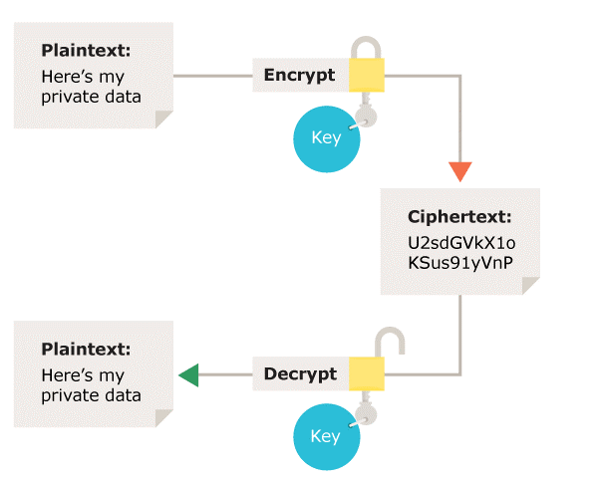
Symmetric encryption – Using the same key for encryption and decryption
What is asymmetric encryption?
Asymmetric encryption uses the notion of a key pair: a different key is used for the encryption and decryption process. One of the keys is typically known as the private key and the other is known as the public key.
The private key is kept secret by the owner and the public key is either shared amongst authorised recipients or made available to the public at large.
Data encrypted with the recipient’s public key can only be decrypted with the corresponding private key. Data can therefore be transferred without the risk of unauthorised or unlawful access to the data.
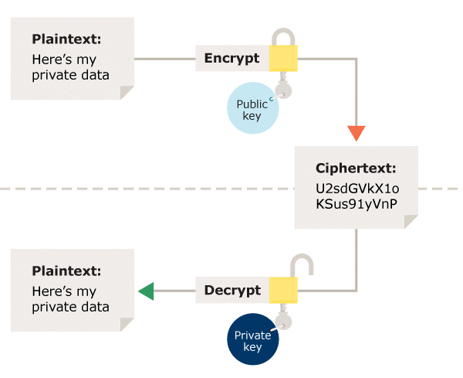
Asymmetric encryption – Using a different key for the encryption and decryption process
What about hashing?
Hashing is a technique that generates a fixed length value summarising a file or message contents. It is often incorrectly referred to as an encryption method.
Hash functions are used with cryptography to provide digital signatures and integrity controls but as no secret key is used it does not make the message private as the hash can be recreated.

KT2006 Cryptanalysis
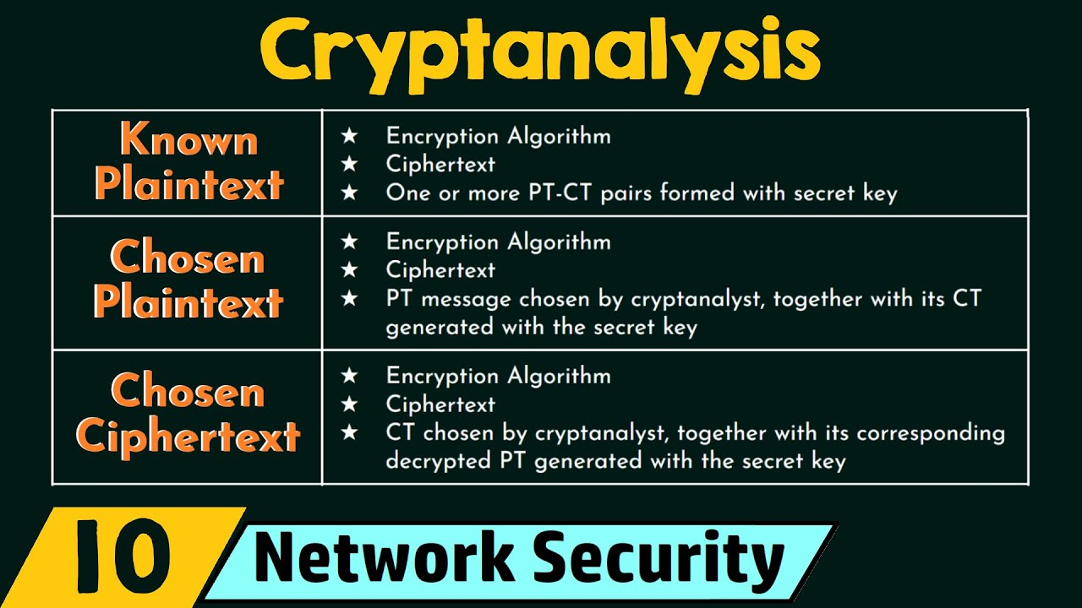
What is Cryptanalysis?
Cryptanalysis is the study of methods for obtaining the meaning of encrypted information, without access to the secret information that is typically required to do so. Typically, this involves knowing how the system works and finding a secret key. Cryptanalysis is also referred to as codebreaking or cracking the code. The ciphertext is generally the easiest part of a cryptosystem to obtain and, therefore, is an important part of cryptanalysis. Depending on what information is available and what type of cipher is being analysed, cryptanalysts can follow one or more attack models to crack a cipher.
Historical Ciphers
Historical pen and paper ciphers used in the past are sometimes known as classical ciphers. They include:
- Substitution Cipher: The units of plaintext are replaced with ciphertext (Caesar cipher and One-time pad)
- Transposition Cipher: The ciphertext is a permutation of the plaintext (Rail fence cipher)
- Polyalphabetic substitution Cipher: a substitution cipher using multiple substitution alphabets (Vigenère cipher and Enigma machine)
- Permutation Cipher: a transposition cipher in which the key is a permutation
Historical ciphers are not generally used as a standalone encryption solution because they are quite easy to crack. Many of the classical ciphers can be broken using brute force or by analysing the only ciphertext except the one-time pad.
KT2007 Countermeasures
To prevent people with malicious intent from breaking into a secure device, the device must be designed with features that not only provide security but also protect the device from attacks. Maxim’s secure devices have robust countermeasures to protect against all these attacks. Here are some of the implemented features:
- Patented physically unclonable function (PUF) technology to secure device data.
- Actively monitored die shield that detects and reacts to intrusion attempts.
- Cryptographic protection of all stored data from discovery.
Security Planning
Depending on the application need, the user must decide which cryptographic features are appropriate to deploy. Table 1 shares some examples of application needs and the resultant measures that need to be applied.
Table 1. Security Planning Based on Application Security Needs
 | Authenticity | Confidentiality | Integrity
Against Counterfeiting | X
Against Eavesdropping |  | X
Against Malware Injection | X |  | X
Against Calibration Data Change | X |  | X
For example, if someone is trying to prevent a medical surgical tool from being counterfeited, they must ensure that every time a tool is connected to the host controller (Figure 4), the tool’s authenticity is checked. It will also need protection against any malware from being installed in the tool, which could potentially harm the patient. The need to protect any calibration data that was stored is paramount as well. But as the possibility of snooping between the tool and the host controller is next to impossible due to closed system connectivity, this system will not need protection against eavesdropping. Thus, in this case, the system designer needs to plan for all the protections under the “Authenticity” column but can skip unnecessary protection listed under the “Confidentiality” column.
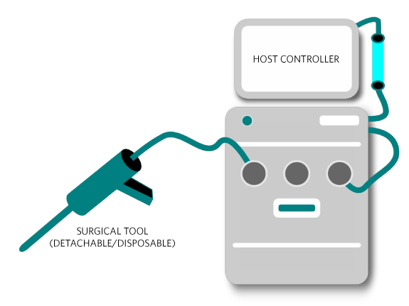
Security planning should include counterfeit prevention for medical devices like surgical tools.
Example System—Security Planning
Thus, in conclusion, threats to ICs are ever present and from many sources. A system designer needs to be aware of the types of threats and plan accordingly. This article gave you some simple insights into how that can be achieved. But if you are a busy product developer with a tight deadline, do you really have the time to be an expert in this field as well as complete your design on time? Probably not. That’s where the use of a secure authenticator designed and built by industry experts may be a good option. The next instalment in this series of cryptography tutorials will discuss secure authenticators.

Internal Assessment Criteria and Weight
- IAC2001Risks and mitigation of cryptography are interrogated

KM-03-KT21: Cyber incident response and management
Topic elements to be covered include:
- KT2101Incident response plan
- KT2102Incident response process
- KT2103Incidence response phases
    - Preparation
    - Detection and analysis
    - Containment and quarantine
    - Eradication
    - Recovery (return to production, data)
- KT2104Post-incident activity (Lessons Learned)
    - Identify changes to security
    - Employee training
    - Weaknesses in the security system
    - Updates

KT2101 Incident response plan
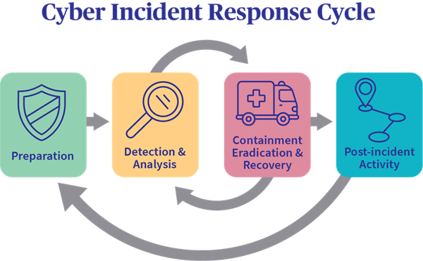

Incident Response
Incident response (IR) is a set of information security policies and procedures that you can use to identify, contain, and eliminate cyberattacks. The goal of incident response is to enable an organization to quickly detect and halt attacks, minimizing damage and preventing future attacks of the same type.
In this page you will get an in-depth understanding of incident response processes, people and tools:
Incident Response Steps: 6 Phases of the Incident Response Lifecycle
There are six steps to incident response. These six steps occur in a cycle each time an incident occurs. The steps are:

- Preparation of systems and procedures
- Identification of incidents
- Containment of attackers and incident activity
- Eradication of attackers and re-entry options
- Recovery from incidents, including restoration of systems
- Lessons learned and application of feedback to the next round of preparation

KT2102 Incident response process
Some of the most commonly used incident response technologies include:
- SIEM (security information and event management): SIEM aggregates and correlates security event data from disparate internal security tools (e.g. firewalls, vulnerability scanners, threat intelligence feeds) and from devices on the network. SIEM can help incident response teams fight ‘alert fatigue’ by indicators of actual threats from the huge volume of notifications these tools generate.
- SOAR (security orchestration, automation and response): SOAR enables security teams to define playbooks—formalized workflows that coordinate different security operations and tools in response to security incidents—and to automate portions of these workflows where possible.
- EDR (endpoint detection and response): EDR is software designed to automatically protect an organization's end users, endpoint devices and IT assets against cyberthreats that get past antivirus software and other traditional endpoint security tools. EDR collects data continuously from all endpoints on the network; it analyzes the data in real time for evidence of known or suspected cyberthreats, and can respond automatically to prevent or minimize damage from threats it identifies.
- XDR (extended detection and response): XDR is cybersecurity technology that unifies security tools, control points, data and telemetry sources, and analytics across the hybrid IT environment (endpoints, networks, private and public clouds) to create a single, central enterprise system for threat prevention, detection and response. A still-emerging technology, XDR has the potential to help overextended security teams and security operations centers (SOCs) do more with less by eliminating by eliminating silos between security tools and automating response across the entire cyberthreat kill chain.
- UEBA (user and entity behavior analytics): (UEBA) uses behavioral analytics, machine learning algorithms, and automation to identify abnormal and potentially dangerous user and device behavior. UEBA is particularly effective at identifying insider threats—malicious insiders or hackers using compromised insider credentials—that can elude other security tools because they mimic authorized network traffic. UEBA functionality is often included SIEM, EDR, and XDR solutions.
- ASM (attach surface management): ASM solutions automate the continuous discovery, analysis, remediation, and monitoring of the vulnerabilities and potential attack vectors across all the assets in an organization's attack surface. ASM can uncover previously unmonitored network assets, map relationships between assets,

KT2103 Incidence response phases
    - Preparation
    - Detection and analysis
    - Containment and quarantine
    - Eradication
    - Recovery (return to production, data)

Most IRPs also follow the same general incident response framework based on incident response models developed by the SANS Institute, the National Institute of Standards and Technology (NIST), and the Cybersecurity and Infrastructure Agency (CISA).
Preparation. This first phase of incident response is also a continuous one, to make sure that the CSIRT always has best possible procedures and tools in place to respond to identify, contain and recover from an incident as quickly as possible and within minimal business disruption.
Through regular risk assessment the CSIRT identifies network vulnerabilities, defines the various types of security incidents that pose a risk to the network, and prioritizes each type according to its potential impact on the organization. Based on this risk assessment, the CSIRT may update existing incident response plans or draft new ones.
Detection and Analysis. During this phase, security team members monitor the network for suspicious activity and potential threats. They analyze data, notifications and alerts gathered from device logs and from various security tools (antivirus software, firewalls) installed on the network, filtering out the false positives and triage the actual alerts in order of severity.
Today, most organizations use one or more security solutions—such as SIEM (security information and event management) and EDR (endpoint detection and response)—to help security teams monitor and analyze security events in real time, and automate incident detection and response processes. (See “Incident response technologies,” below for more.)
The communication plan also comes into play during this phase. Once the CSIRT has determined what kind of threat or breach they're dealing with, they'll notify the appropriate personnel before moving to the next stage of the incident response process.
Containment. The incident response team takes steps to stop the breach from doing further damage to the network. Containment activities can be split into two categories:
- Short-term containment measures focus on preventing the current threat from spreading by isolating the affected systems, such as by taking infected devices offline.
- Long-term containment measures focus on protecting unaffected systems by placing stronger security controls around them, such as segmenting sensitive databases from the rest of the network.
At this stage, the CSIRT may also create backups of affected and unaffected systems to prevent additional data loss, and to capture forensic evidence of the incident for future study.
Eradication. Once the threat has been contained, the team moves on to full remediation and complete removal of the threat from the system. This involves actively eradicating the threat itself—e.g., destroying malware, booting an unauthorized or rogue user from the network—and reviewing both affected and unaffected systems to ensure no traces of the breach are left behind.
Recovery. When the incident response team is confident the threat has been entirely eradicated, they restore affected systems to normal operations. This may involve deploying patches, rebuilding systems from backups, and bringing remediated systems and devices back online.
Post-incident review. Throughout each phase of the incident response process, the CSIRT collects evidence of the breach and documents the steps it takes to contain and eradicate the threat. At this stage, the CSIRT reviews this information to better understand the incident. The CSIRT seeks to determine the root cause of the attack, identify how it successfully breached the network, and resolve vulnerabilities so that future incidents of this type don't occur.
The CSIRT also reviews what went well and looks for opportunities to improve systems, tools, and processes to strengthen incident response initiatives against future attacks. Depending on the circumstances of the breach, law enforcement may also be involved in the post-incident investigation.

KT2104 Post-incident activity (Lessons Learned)
    - Identify changes to security
    - Employee training
    - Weaknesses in the security system
    - Updates

Lessons Learned Benefits
Lessons learned sessions offer a variety of benefits for the incident response team, the organization as well as existing and future incidents. A properly executed lessons learned exercise can help organizations:
- Learn from mistakes. Especially during a security incident, organizations tend to operate in crisis mode and are too overwhelmed to execute all steps flawlessly. Identifying where mistakes have been made will help self-evaluate performance and set the tone for continuous improvement.
- Understand where problems occurred. Despite its negative impact, a security incident can represent a valuable opportunity to dig deeper into where exactly errors were made, which vulnerabilities led to the incident, whether security controls were effective and whether there are any security gaps in the organization that could be fixed. Getting all relevant parties together during this exercise will help understand the problems from a 360-degree view.
- Recognize success. Too often, organizations tend to forget about what actually went well during a security incident. In addition to analyzing what didn’t go well, it is equally important to recognize what went well – whether it relates to employee performance, effective processes in place, crisis communications etc. Identifying success stories will encourage positive performance and leverage exemplary behaviour for future incidents.
- Retain organizational knowledge. During a crisis, documentation is often the last thing on the mind of those who are dealing with the crisis. Keep in mind that it is crucial to document the good, the bad and the ugly to retain this knowledge and make it available for future use.
- Reduce future risk. If similar security incidents occur in the future, a lesson learned session can help prevent similar mistakes and thereby reduce the risk to the organization as a whole.
- Improve future performance. By analysing how an organization dealt with a security incident, it can optimize its incident response performance for future similar scenarios. In addition to having an Incident Response Plan in place, lessons learned sessions contribute to adapting and improving this plan so that the organization can be better prepared.

Internal Assessment Criteria and Weight
- IAC2101Concepts and principles of Cyber incident response and management are explained

References
https://codered.eccouncil.org › course › network-defens..
https://www.checkpoint.com › Secure The Network
https://www.sciencedirect.com › topics › computer-science
https://www.forcepoint.com › cyber-edu › defense-depth
https://www.cisco.com › Products & Services › Security
https://www.techtarget.com › searchsecurity › definition
https://www.itgovernance.co.uk › what-is-cybersecurity
https://www.gartner.com › topics › cybersecurity
https://www.ibm.com › za-en › topics › mobile-security
https://www.archonsecure.com › mobile-device-guide
https://preyproject.com › blog › what-are-cyber-threats-h..
https://emeritus.org › learn › different-types-of-cyber-s
https://www.simplilearn.com › cyber-security-tutorial

